Tension Fabric Membrane Roof Tent Resort for Primitive Forest Tourism
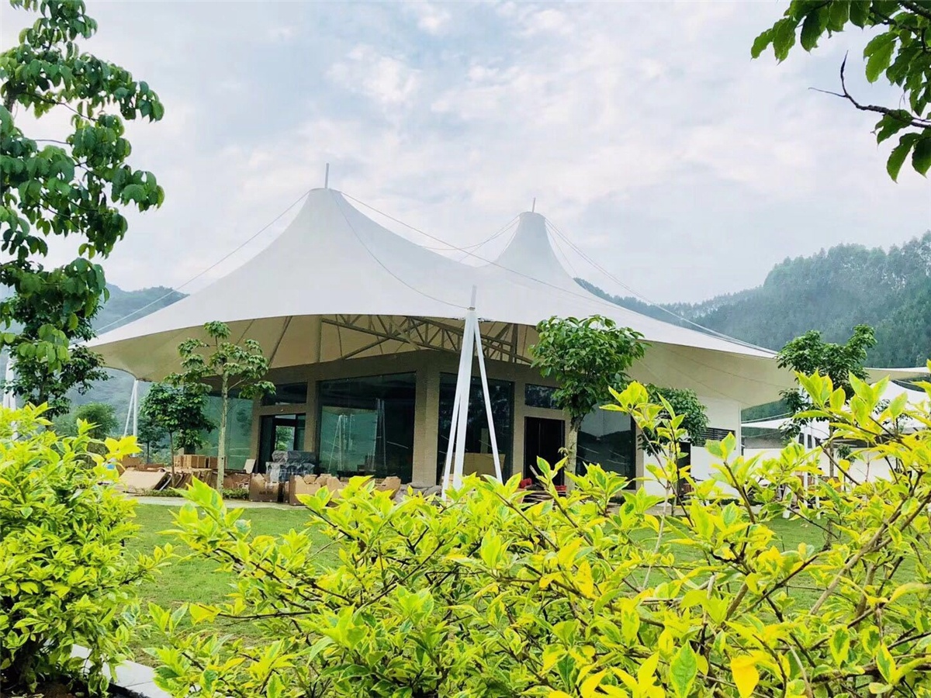
Shuanglonggou Scenic Area is a tourist attraction featuring the original deep mountain wild forest adventure. Shuanglonggou Scenic Spot is located in the northwest of Rongshui County. There are about 6,300 acres of virgin forest in the scenic area. The forest is covered with trees, the ancient trees are
towering, and many waterfalls flow straight down. The air is fresh and can be called a veritable natural big "Oxygen bar". There are two rivers flow in the forest, and the trickle is looming, as if the two dragons swim in the forest, so it is called "Shuanglonggou".
In 2017, BDiR Inc. Designed & built the hotel tent project. The hotel tent resort is inspired by the outdoor luxury travel that blend modern civilization with the original nature Scenery. Enjoying the gift of nature while enjoying the stylish style of home. The tent hotel allows people who live in busy cities to find a nature and the luxury relax holiday. The 10 tent villas are built on the top of the mountain. They are based on reinforced concrete. They use PVDF waterproof fabric as the roof and 360° glass floor-to-ceiling windows. They can enjoy the luxury and comfortable accommodation in the tent rooms as well as the tranquility of the lake view. Shuanglonggou Tented Hotel has a total of 56 rooms, which includes special single tented room, standard double bed tented room, standard twin tent room, deluxe view twin tent room, deluxe view queen tent room, deluxe tent villa, duplex suite tented house, etc.
Living in the Shuanglonggou tent hotel, the outside the tent house is the original forest, so we can have a wonderful night to get in touch with nature.
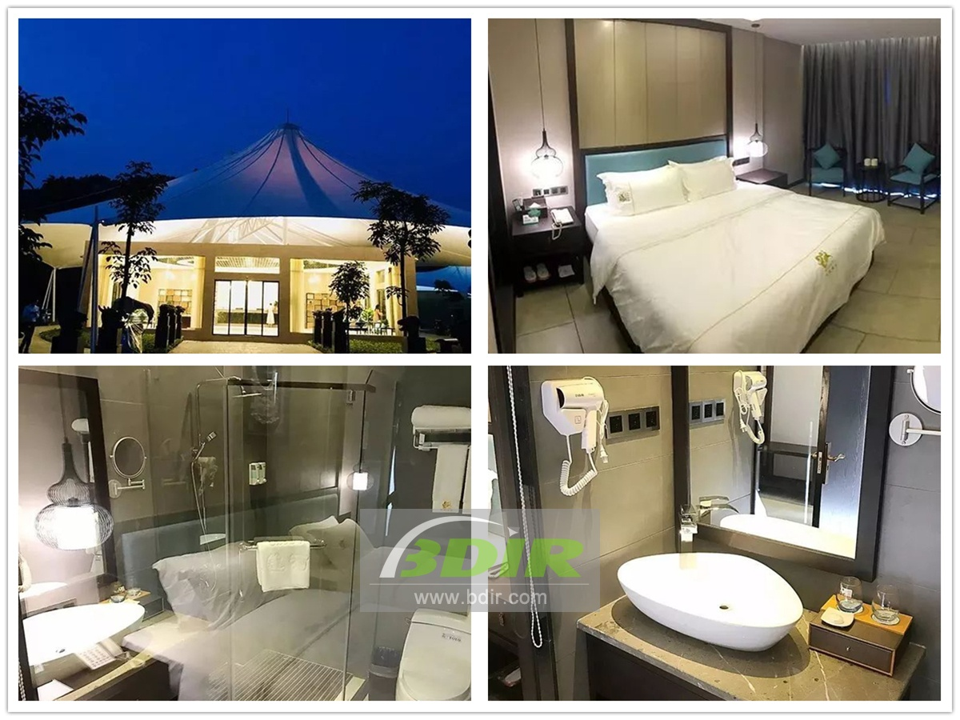
Technical advantages:
The Outdoor Luxury Tent Hotel not only allows visitors to experience the beauty of nature, but also has the comfort of home. The luxury tent house belongs to a semi-permanent new architectures and is easy to install. The fabric structure tent is safe and strong, which can resistant to wind and rain; the internal living environment is spacious and comfortable.

Reviews:
The head of the scenic spot, Huang Zhao Said: BDiR Inc. completed the design and construction of all the tent villas before the construction period. Our tent rooms were officially opened before the peak season! BDiR Inc. uses high-end and eco-friendly materials to ensure a safe and comfortable stay!

