Tensile PVDF Membrane Roof Structures Tent Hotel Resort

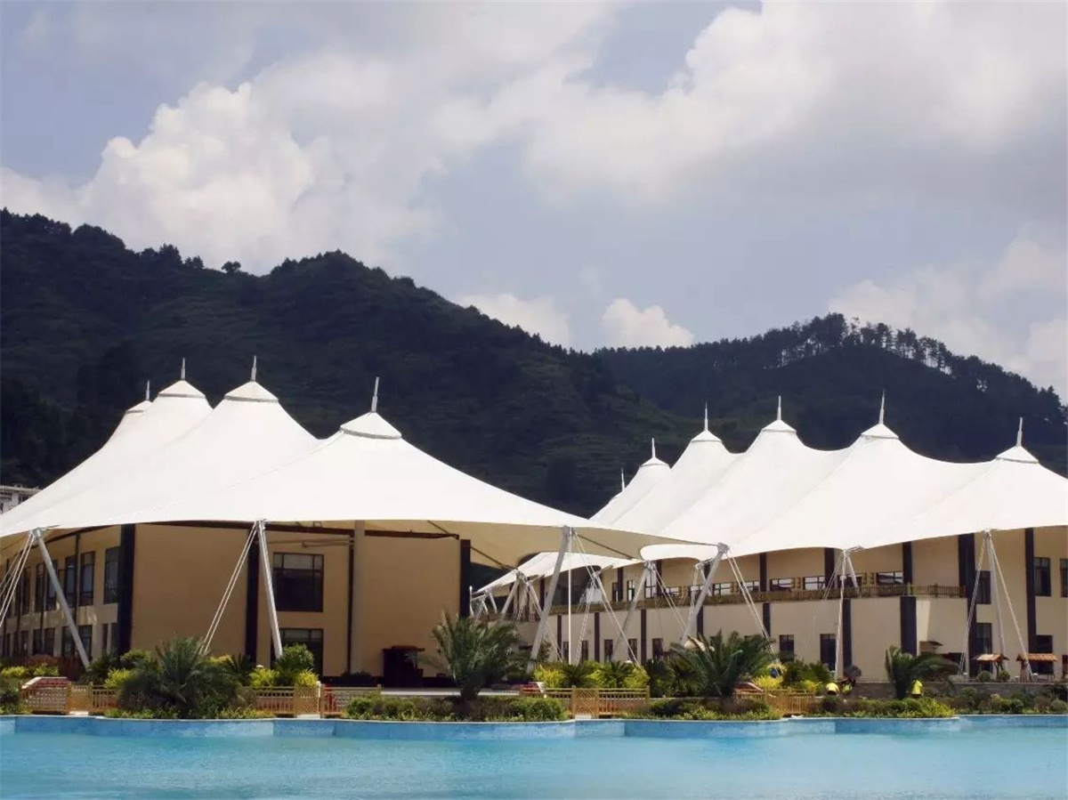
Duofangge tent hotel resort is located in the beautiful Taoyuan River Scenic Area in Guiyang, there is no cold in winter and no heat in summer. Duofangge • Taoyuanhe Hotel Tent is the biggest single-person tent hotel in the china. The tent resort has an 8D motion cinema, indoor tennis tent room, yoga and fitness center, coffee bar. Visitors to the Taoyuanhe Scenic Area, in addition to a comfortable hotel experience,which can also experience the Natural scenery of the Taoyuanhe and the wonderful rafting of the water world.
The membrane structure of Duofangge Resort Hotel in Guiyang is located in Taoyuanhe Scenic Area. BDiR Inc. is built according to the requirements of the tent hotel project. The roof is used to double-layer membrane structure. The PVDF membrane roofing has a total unfolded area of 13,000 square meters. As far as the peaks are competing, it is the largest tent hotel group in China, not only the landmark building of the local scenic spot, but also greatly enhanced the popularity of the tensile membrane tent hotel.
Each single membrane structure roof has a length of 151m and a short width of 42m. Considering the thermal insulation requirements, the double-layer membrane design is adopted, and the total expansion area of the inner and outer membranes is about 13,000 square meters. To support the top of the cap for the middle column and the surrounding tensioned membrane structure. The design has a height of 25m and a top surface height of 22m.
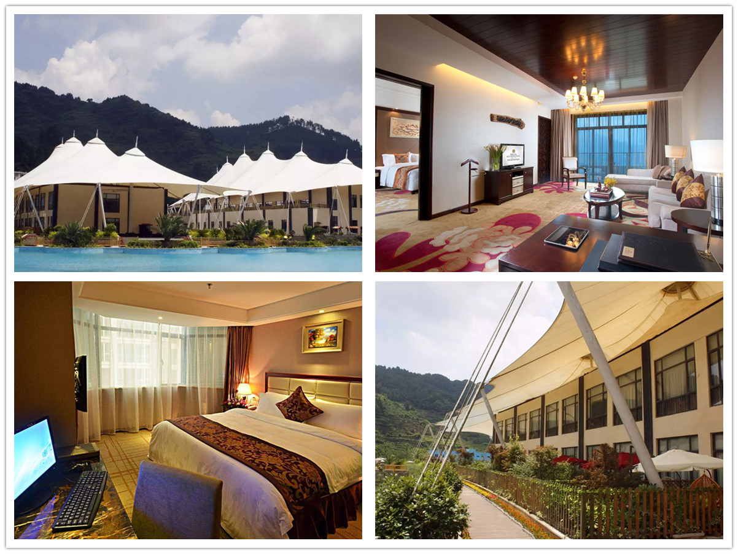

Technical advantages:
The hotel is built according to a 5-star hotel, and the top is covered with a double-layer membrane structure, which is a double-layer PVDF membrane top with a total unfolded area of 13,000 square meters. The steel structure and steel cable of the main structure of the membrane structure engineering are processed and manufactured at the factory, and assembled and spliced on site. The membrane cutting and welding process of the membrane structure is realized in the factory which can be carried out simultaneously with the main construction period. After the processed film is put into the field, it is installed with the steel structure and the steel cable. The installation process is simpler and faster than the traditional building installation process, which greatly shortens the construction period.

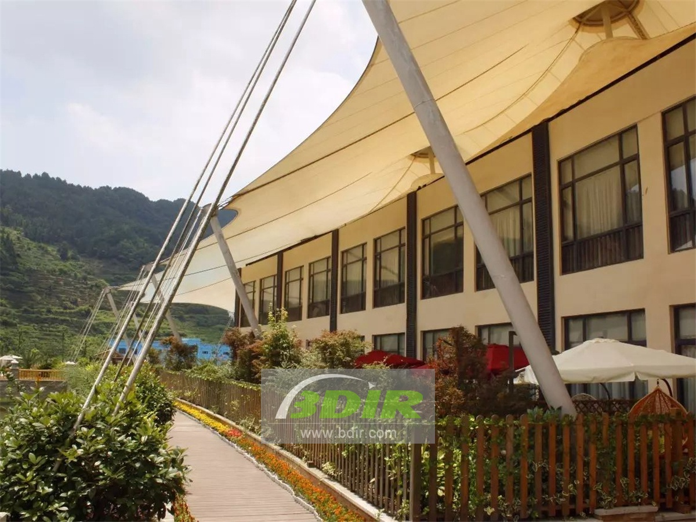
Reviews:
The person in charge of hotel construction said: BDiR Inc. has perfected the construction of such a large project with exquisite design and construction technology! BDiR Inc. strived for excellence in every step, every detail, this craftsmanship is worthy of praise!

