PVDF Fabric Roofing Tent House for Luxury Camping Resort Accommodation
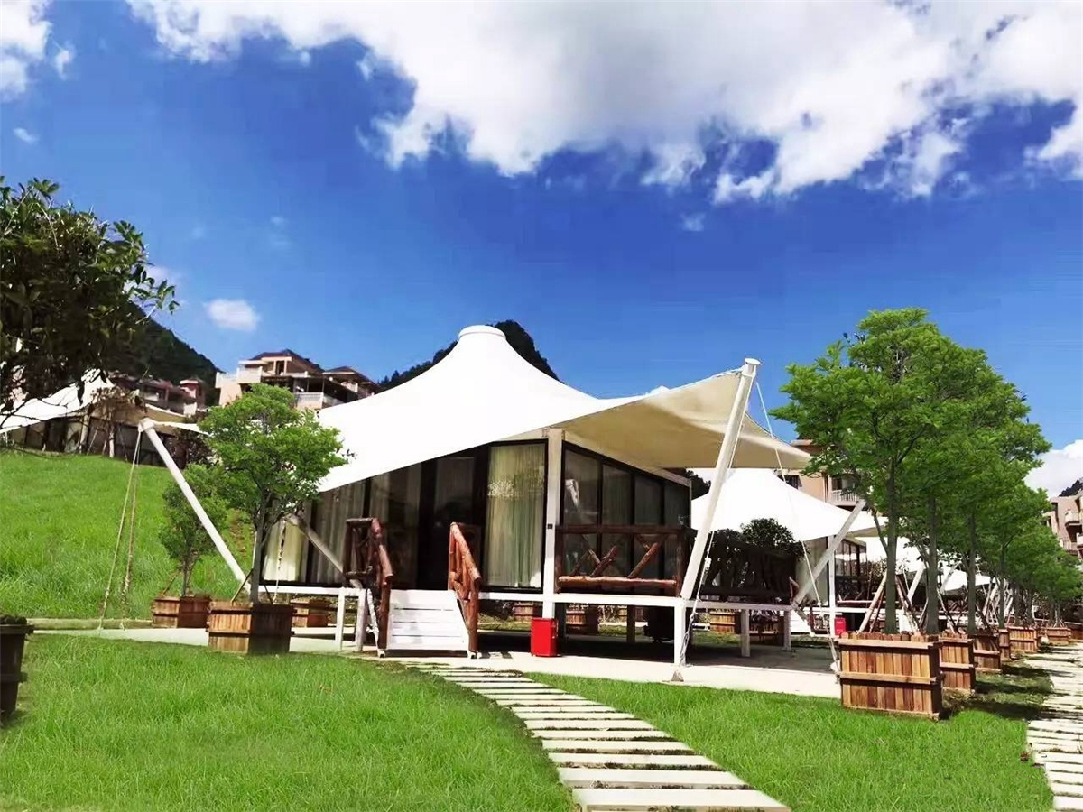
The Guyu RV Camp Hotel Tent is located in the Bajiao Town of Heishan, Wansheng Economic Development Zone, Chongqing, which adjacent to the Black Valley Visitor Center. Focusing on creating a new modern leisure resort experience, the innovative combination of RV camp and tent hotel which provides visitors with a variety of personalized options.
YongShan is a valley with the same altitude and temperature as the Heishan •Guyu RV Camp/Tent Hotel. The natural scenery is also very beautiful. The distance between the two is only a few minutes driving. There are full of forests in the depths of the Black Valley. The average elevation is 1,100 meters, the average temperature in summer is 23 °C, the forest coverage rate is as high as 97%; the 3 km forest viewing trail overlooks the Heishan valley canyon and overlooks the green hills of Tonglu, Guizhou.
In July 2017, BDiR Inc. was commissioned by Chongqing Heishan • Guyu RV Camp designed and built 10 tent houses. Each luxurious hotel room draws on the shape of the tent. The white PVDF fabric roof and the streamlined canvas roof are exceptionally suspended from the middle.Which with a beautiful natural and eye-catching environment, which combined with modern hotel room design, it is simple and avant-garde. The tent room is composed of three floor-to-ceiling glass windows. Every morning, the beautiful scenery of the clouds steaming is unobstructed. The luxury tent room is equipped with double bed, separate toilet, TV, air conditioning, WiFi, machine linen and other facilities. Visitors who enjoy the natural beauty of the day can also spend a comfortable, warm and luxurious night in the tent house.
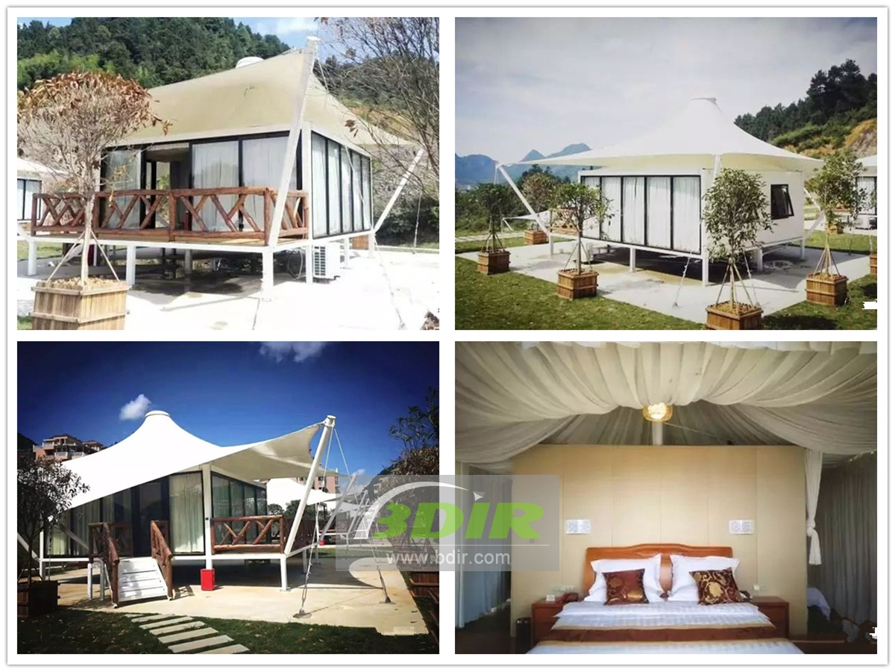

Technical advantages:
The tent hotel is made of high-strength aluminum alloy structure, which can resist the wind of 8-10 level outdoors. The double-layer covered tarpaulin of the tent is also resistant to wind and water, and it is UV-resistant. Therefore, it can be safe and comfortable without being affected by various weather conditions during camping.

Reviews:
With its superb expertise, BDiR Inc. builds a perfect campsite with 25 tents in just 25 days! We are very pleasant surprise!

