Membrane Structure Roof | Tent Cottage | Fabric House – Maldives

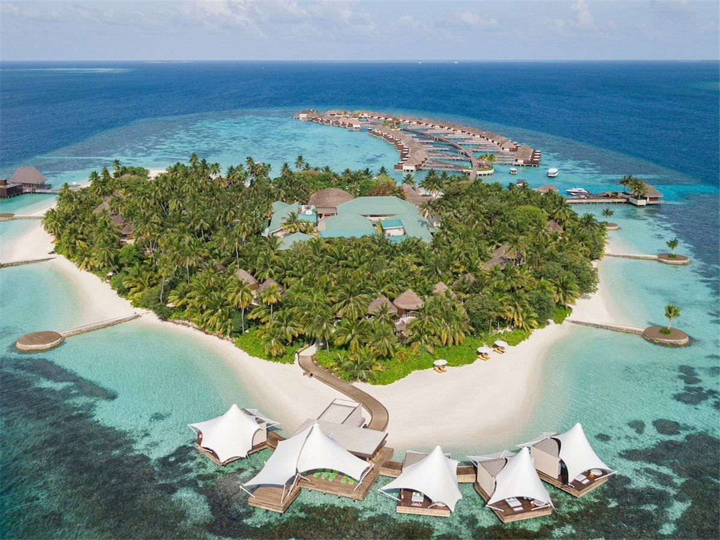
A private island and luxury playground, which is nestled among the white sands, turquoise lagoons and stunning coral reefs.Maldives offers luxurious accommodation including beachfront bungalows and water villas. There are many dining options on the island to show a variety of cuisines. You can relax in the AWAY®Spa or WET® swimming pool or take part about energy training. The resort offers countless activities including water sports, yacht cruises and a secluded private island holiday.
Indulge in the ultimate relaxation of the AWAY® Spa on the water. The luxury treatment villa was designed and built by BDiR Membrane Structure Company,which based on its location on the beach and the builders wish to build on the surface of the sea. The tent villa adopts Q235 steel as the main body and has high strength. The earthquake-resistant and typhoon can resist the typhoon of 10-12 level, and prevent seawater corrosion and insects from cracking and deforming. The house roof is made of ultra-light PVDF and it has good waterproof, UV-resistant, tear-resistant properties and B1/M2 fire resistance.
AWAY® Spa has 4 luxury treatment villas with the membrane structure roof. The 66 m2 indoor treatment area is completely private. Visitors can take natural treatments in 4 luxury treatment villas or massage under a membrane-structured umbrella, including facials. Ice tea and a variety of fresh fruit sorbets can be enjoyed on the sundeck. Private yoga classes in the gazebo of the wrap-around sundeck.And campers can enjoy the panoramic horizon, including water bathing, outdoor rainforest showers and large sofa beds for sunbathing, relaxation and treatments.
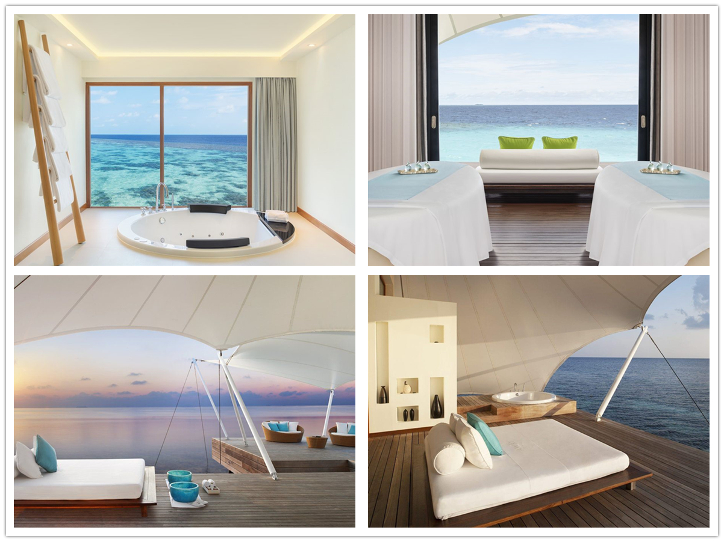
Technical advantages:
How to solve the problem of typhoon and seawater corrosion by setting up a tent spa cabin at sea?
The tent house is made of high-strength aluminum alloy and reinforced carbon steel (hardness up to 15HW, surface anti-corrosion and anti-rust film ≥10μm-15μm) as the main body. Double-layer PVDF waterproof tarpaulin is roofing, which is windproof, rainproof, warm and resistant. Performance advantages such as burning and sound insulation. The maximum resistance to wind of 12 level, which with more than 15 years of service life.

Reviews:
Jordi Farell Said: BDiR Inc. designed the stylish and comfortable Luxurious Treatment Villas. They were very satisfied with the way they worked during the construction process, the operation specification, the process was tight,and the evidence was available, and they took times to optimize the construction quality of the entire structure.

