Luxury Tent House, Eco Tented Lodges - Designer & Manufacturer
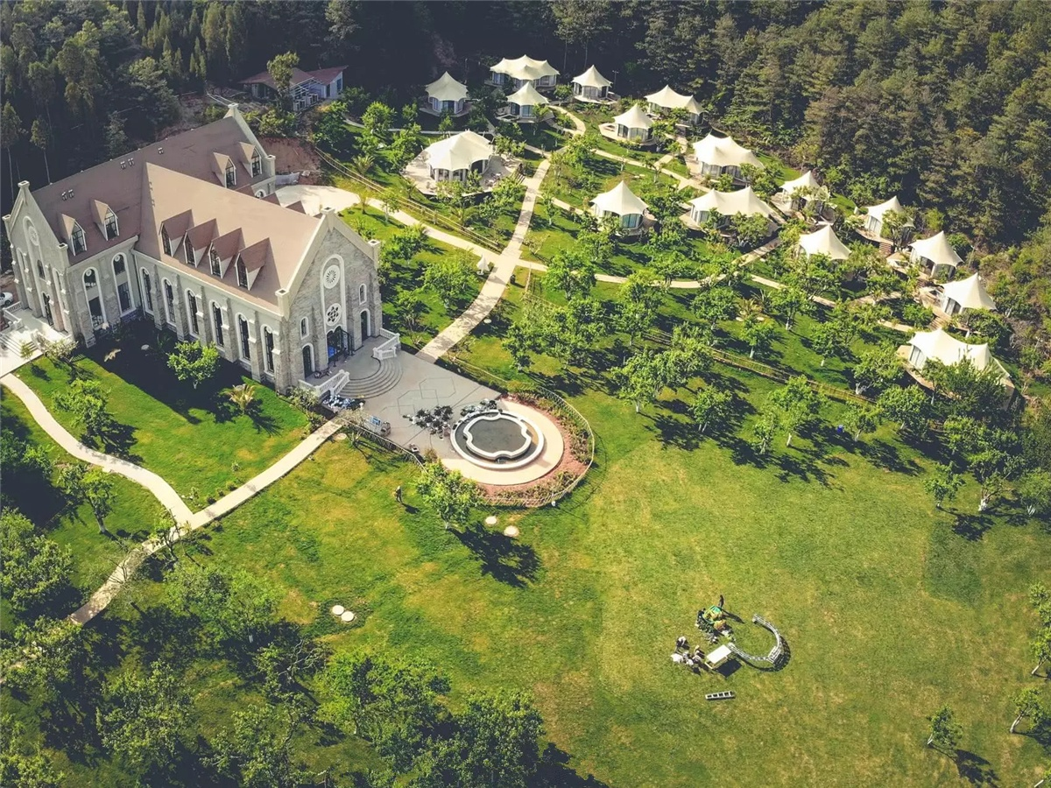
The Baozhu Pear Manor is located in Qiumuyu Community, Majinpu Street, High-tech Zone, Kunming City. The manor covers an area of 100 mu. It is a characteristic agricultural recreation area with Baozhu pear industry and culture as the main line. As the latest leisure farmhouse of Qiutian, the Baozhu Pear Manor has become more and more business-oriented. It has Baozhu Pear Picking Area, Pear garden Restaurant, luxury eco friendly Tent Hotel, Open-air Hot Spring, Wedding Palace, Leisure Lawn, etc. The air is fresh and away from the dust, which makes people feel like they are mistaken into the "Oz of Oz."
In order to maximize the integration of tourists into the natural environment, the luxury tent hotel concept was born. The owner of the estate began to contact BDiR in January 2018. Through communication and field visits, the final design draft was determined and BDiR Inc. to build the luxury hotel tent.
BDiR Inc. built 18 tent-themed hotels for the manor resort. The tent rooms (single peak tent rooms, double-peak tent lodges, luxury four-peak tent villa) are scattered in the green space. The façade of tent house is made of glass, which is close to nature and sleeps in the luxury hotel rooms. You can look up at the stars and have a private hot spring pool, which is a true wild luxury experience. Entering the room, it will be amazing: on the roofing, it gently draped the gauze, grayish green or gray orange in the main color interspersed with romantic purple, so that the whole tent room is fresh and temperament. Each tent room has floor-to-ceiling windows, it is with plenty of natural light and 360° views. Each eco-friendly tent cabins has an independent hot spring pool. Let visitors experience different comfortable&luxurious accommodation while staying close to nature.
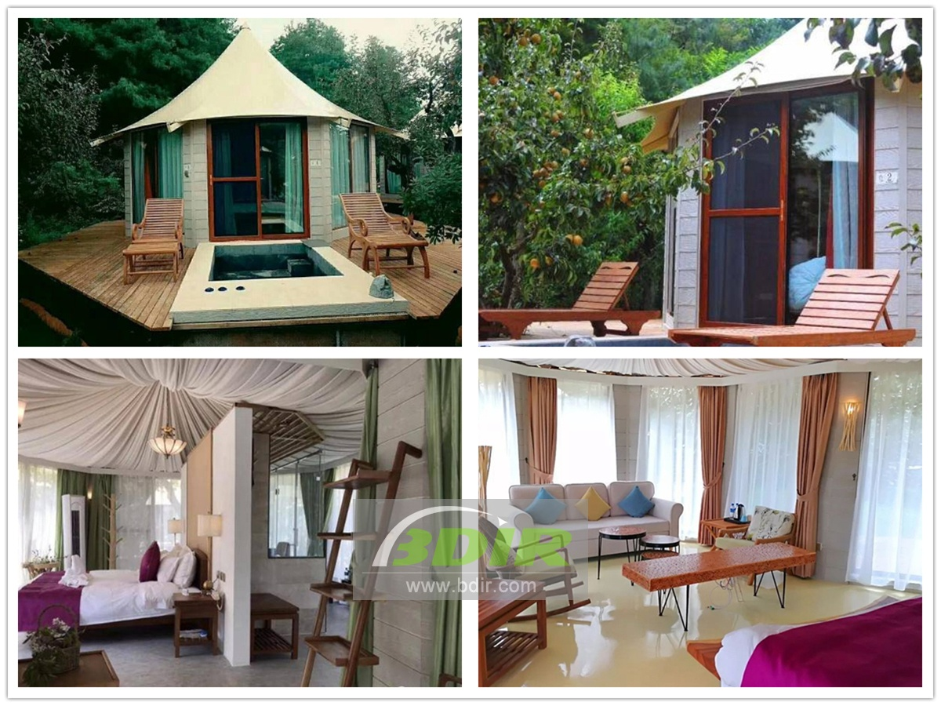

Reviews:
BDiR Inc. quickly designed and built such a beautiful 18 seats hotel tents. They exceled at every step of the work, focusing on every detail, so that the whole project is perfectly presented to the tourists! Working with such a professional company, we are very relieved and happy!

