Luxury Eco Friendly Tent Structures Lodges For Tea Garden Holiday Hotel
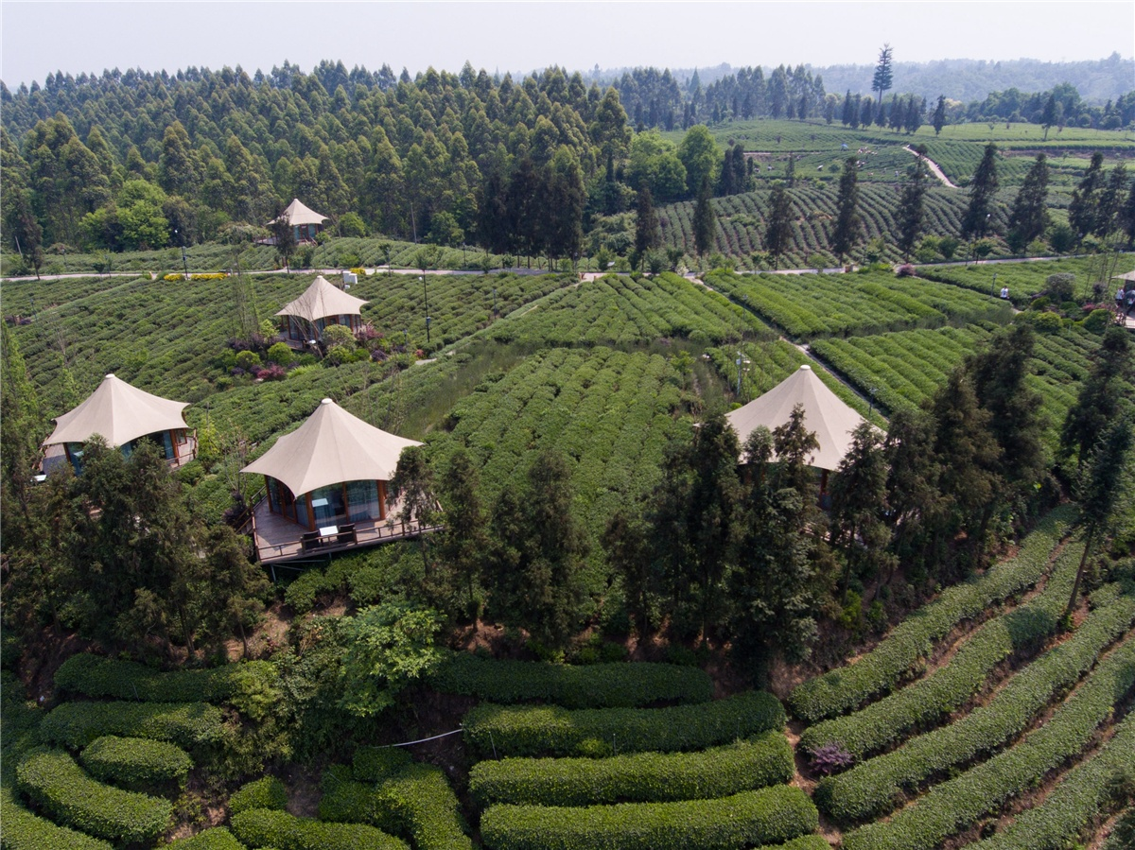
Sichuan Ya'an Mingshan has unique ecological advantages. Mingshan is a mid-latitude inland subtropical monsoon humid climate zone with abundant rainfall, annual precipitation of 1000-1800 mm, mild climate, and forest coverage rate of 48.1%. It is a veritable “green world”, “natural oxygen bar” and “ecology”, which is a typical ecological livable city. The history and culture of Mingshan is profound. Mingshan is the birthplace of the world tea culture.
Niunianping Million acres Tourist Tea Garden is located on the four major tourist lines of the Glacier Tour, Panxi Sunshine Tour, Sichuan Tourism West Ring Line and Sichuan Cultural Tourism Circle. The landscape of the 16700 acres tea garden scenic spot is dominated by hills, and the tea garden contiguous is stepped, green and sturdy.
In order to make the tourists who come to vacation not only can enjoy the beauty of nature, but also enjoy the tea garden and have a comfortable accommodation at night. The tea factory owner let BDiR Inc. to design and built the 16 tent houses in the tea garden for people to have rest. The tent cabins is located at the highest point of the tea garden, and the viewing effect is excellent. The tent lodges with the design of the 360° glass window, you can feel different paintings at every angle. Each tent house is a single-family home. The tent room is raised in wood and surrounded by glass. The interior of the tented room is neat and exquisite. There are toilets, air conditioners, electric appliances, tea sets, etc., and the tea garden can be viewed 360 degrees.
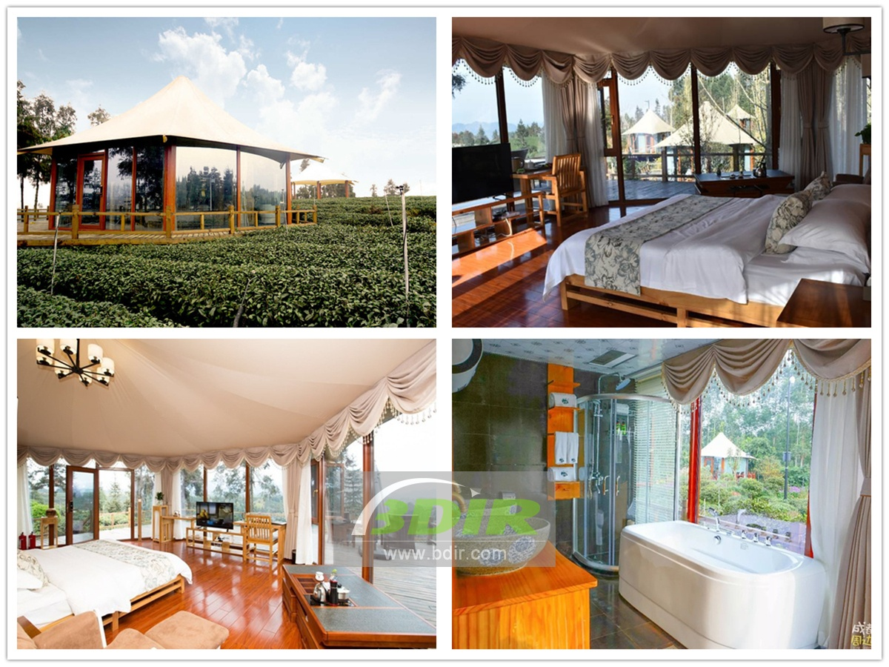
Technical advantages:
The high-strength steel frame is used to raise the tent villas, and each tent villa has a viewing deck. During the construction process, the natural environment of the tea garden is rarely excavated and destroyed, and the ecological environment can be better integrated. Tea trees can also be grown around tents or under tents, so that the entire tent is filled with the fragrance of tea.
Reviews:
BDiR Inc. designed and built the entire project at an alarming rate within 30 days. The entire hotel was opened to visitors in advance, which had improved our efficiency! Working with such a professional company, we are very relieved and happy!

