Luxury Beach Tent, Glamping Tent, Beach Camping Tent – Greece

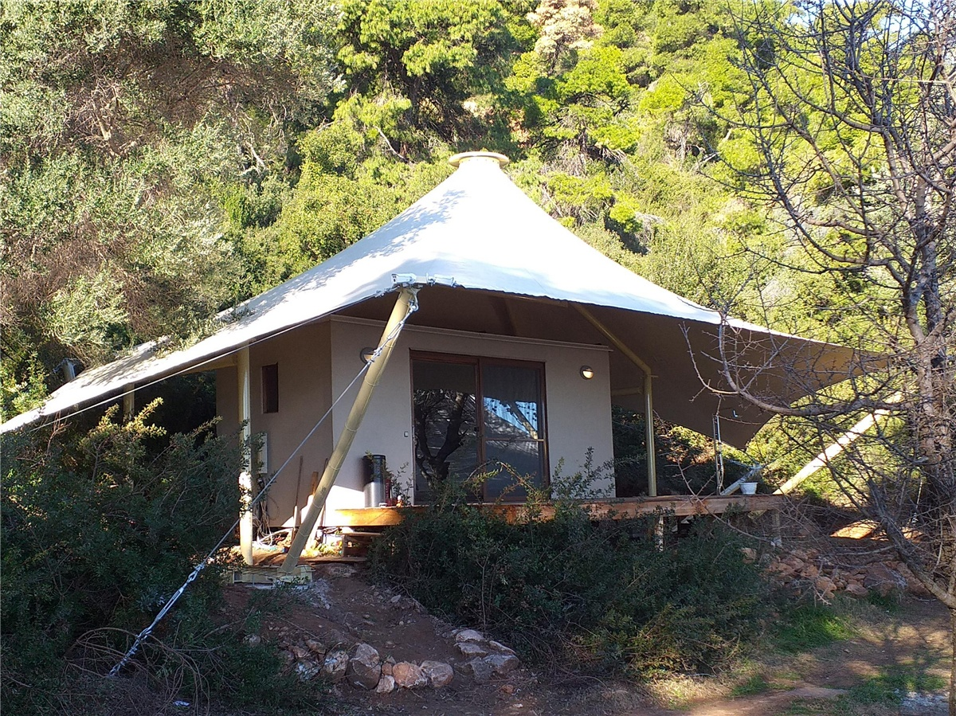

This charming beachfront luxury resort is the perfect place for a holiday. It is situated in the beautiful Halkidiki region, one of the most popular areas in Greece, with its stunning beaches and warm climate. There is no doubt that one of the main highlights of this tent hotel is its private beach, which means guests can relax in true privacy.

BDiR Inc. designed and built the tent hotel. The tent house offers a comfortable double bed and a double sofa bed for 4 guests. Beds are decorated with lovely linens to ensure a restful night’s sleep. Camping visitors will enjoy a private bathroom with a large shower in the tent. There is sleeping area where campers can enjoy the shade during the day or relax after a busy day exploring the private beach. The outdoor tent cabins features a private deck and which can let people to relax under the stars and admire the stunning views.

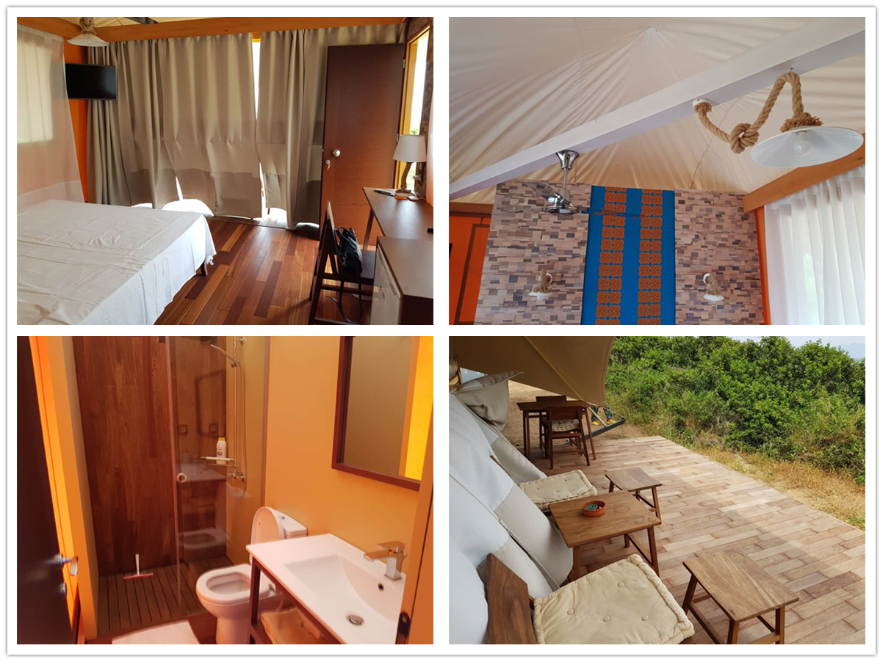
Technical advantages:
How to build a luxury hotel for campers on uneven mountains without damaging the local environment?
Customers choose to set up hotel tents. The luxury accommodation tented cabins built on special outdoor terrain which is the natural advantage of modular building structure. It can be quickly built in any terrain, and it has a good combination with the local natural scenery. It is truly achieves the design concept of being close to nature and integrating with nature.
Reviews:
Leonidas Μavrides said : BDiR inc. Completed the project very punctually and perfectly. Thanks to BDiR Inc. for bringing such a comfortable stay for campers.

