High-end Tents Resort for Outdoor Camping Accommodation - Design & Manufacturing
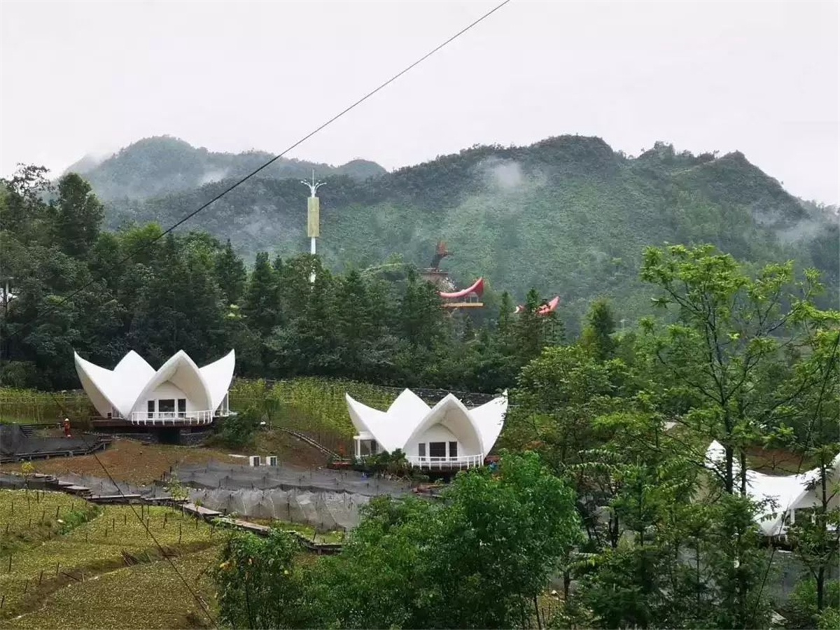
Aogehe Tent Resort is located in Ziyun County, 103 kilometers from Anshun and 164 kilometers from the main city of Guiyang. In addition to being a national-level scenic spot, it is the only provincial-level climbing sports base awarded in Guizhou Province and an activity site for the International Rock Climbing Festival. The resort is the essence of the combination of karst, mountain, water, cave, stone and forest. It is a combination of glory, strangeness, danger, urgency, secluded and ancient. It is no exaggeration to say that the Aogehe is fresh, Pure, primitive, ecological, natural, and beautiful in modern civilization.
The Aogehe Tent Hotel, built by BDiR Inc., is a karst landform that constructs a tent hotel community like a hide-away hidden in the depths of Ziyun. This is located in the Bajiao Village, Aogehe Town. This project covers an area of about 360 acres and has a total construction area of about 9,880 square meters. The tent house looks like a white pigeon dotted in the mountains. The first phase of the camp site has 17 tent hotels, which includes 13 tent houses built on the mountainside, 4 restaurant kitchens, SPA, landscape terrace, logistics area, Chinese herbal medicine garden base, folk experience hall, multi-function hall small square, Miao culture, farmland experiences etc.. allow modern culture to blend seamlessly with the native environment.
BDiR Inc. designs concept with wild design style, It is to let the customers who enter the tent hotel to achieve a combination of Luxury accommodation and the original ecology camping.
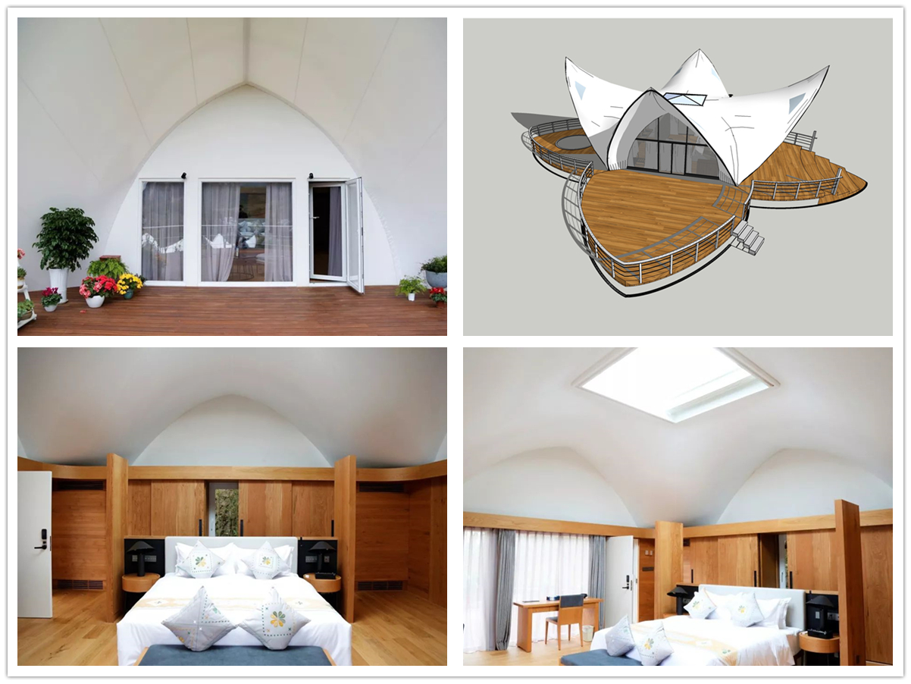

Technical advantages:
BDiR overcome many factors such as frequent design changes, rainy weather in Guizhou, etc., where was planned and construction,and strengthen project management, and carried out construction as planned. Which added a beautiful stroke to the beautiful scenery of Ziyun within the specified time nodes.

Reviews:
Said: BDIR, the head of the Ziyun County tent hotel in Anshun Ziyun County, after three months of hard work, which ensured that all tents can be completed before the travel conference in September, and the restaurant can meet the dining conditions. The appearance of greening can reach the conditions of appreciation.

