Geodesic Dome Tent Hotel for The Prairie Camping Site – BDiR Inc.
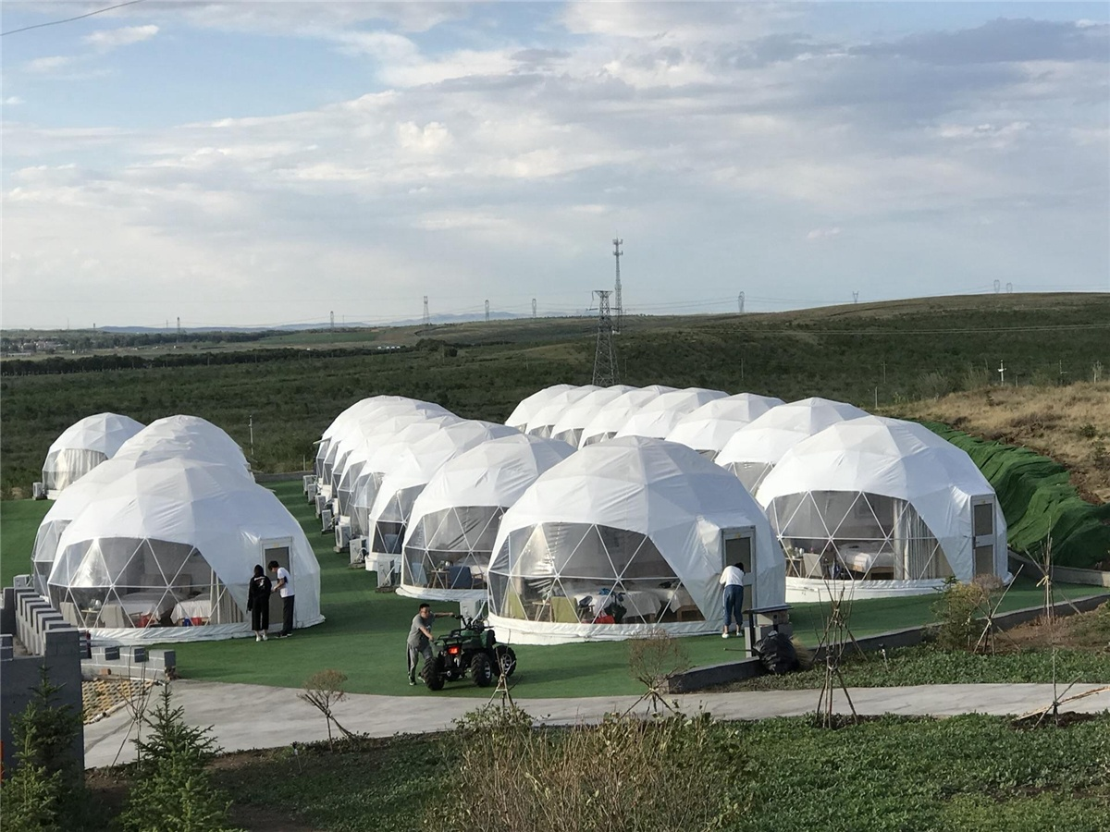
Mongolia grassland scenery is the most beautiful place, which with grassland more than 100 million acres , and forest with more than 200 million acres,and there are more than 500 lakes and 3000 rivers, vast expansive grassland like a sky-woven green giant carpet. Ergun City is a county-level city under the Hulunbeier City of Inner Mongolia Autonomous Region. The geodesic dome tent resort is located in the northwest of Daxing'anling, Hulunbeier City, Inner Mongolia Autonomous Region, at the northern end of Hulunbeier Grassland, on the right bank of the Ergun River.
DBiR Inc. installed 12 dome Glamping tents for the gendesic dome Hotel in Hulunbuir. The dome tent adopts modular design, convenient transportation, quick construction, no need for secondary construction, no damage to the environment, and which can be put into used quickly. The eco friendly dome tent is in line with the construction requirements of the grassland and meets the demand for green tourism in harmony with nature. The main frame of the spherical dome tent house is made of galvanized pipe. The fabric covering of tent is anti-corrosive and painted. The color of the fabric membrane can be customized to make the overall frame more beautiful and practical. About one-third of the transparent fabric covering design allows visitors to enjoy the beauty of the grasslands and the tranquility of the wilderness without leaving home. Grasslands, forests, wetlands, rivers, horseback riding, trekking, racing, watching the sunrise, taking pictures of the sunset.
The spherical dome tent is covered by a tarpaulin of 850g/m2 PVC fabric membrane to protect it from rain, snow, wind and ultraviolet rays. The inherent triangular steel frame of the tent make the whole structure durable. The age of use will reach more than 10 years! The spherical dome tent has a separate bathroom system after the internal partition, which solves the problem of not being able to bathing and use the public toilet in traditional camping accommodation.
Although you are outdoors, you don't have to worry about mosquitoes, because the tent windows have gauze designs. About one-third of the fabric covering is transparent PVC membrane, so guests can always enjoy the view from the window. If the sun is too strong or you are worried about privacy issues, you can also pull the curtains.
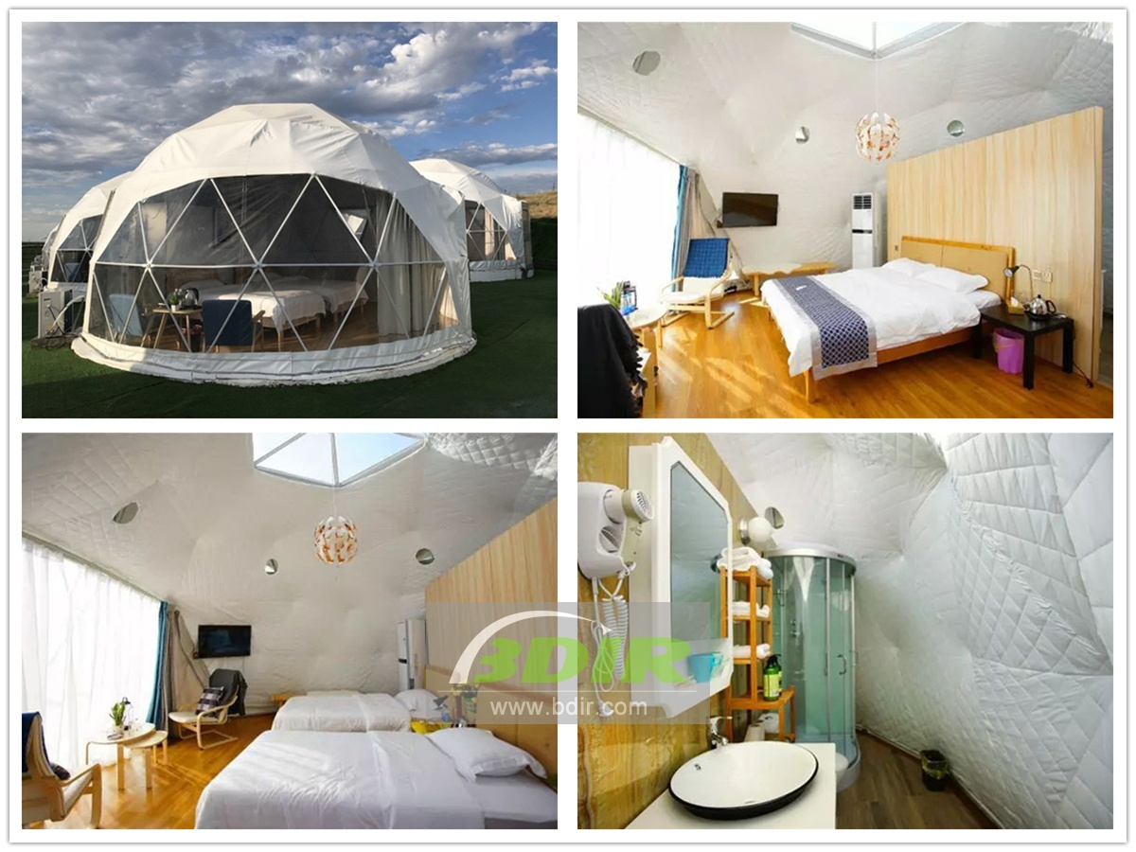

Technical advantages:
The design and construction of the Hulunbeier Erguna grassland tent camp is very green. The dome structure is all prefabricated. It does not need to be bricks and watts. It can be removed and installed. It does not need to change the topography and vegetation landscape. The ecological destruction is minimized and it is the best carrier to pursue green tourism.

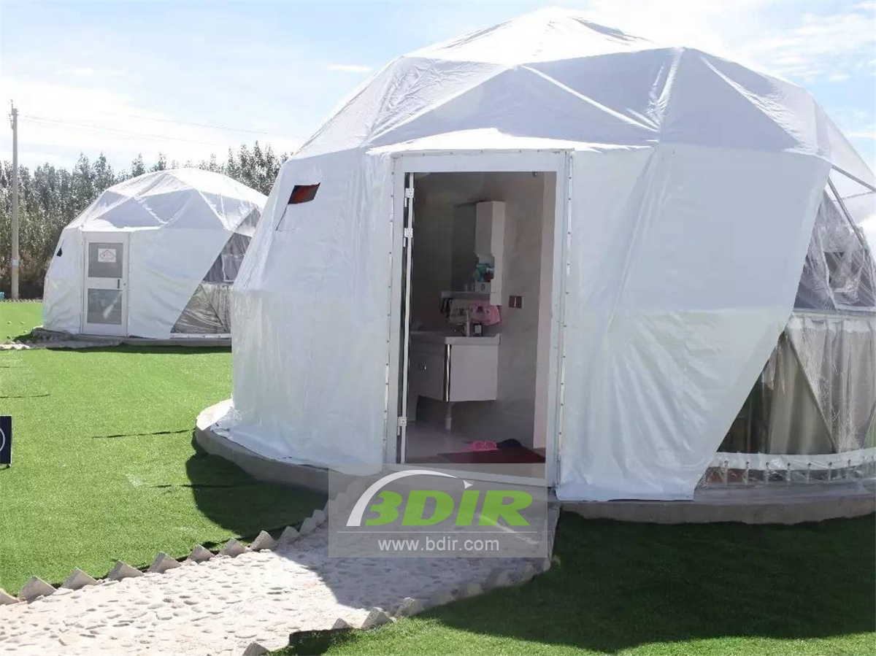
Reviews:
Camp owner said : BDiR inc. Completed the project very punctually and perfectly. Spherical tents are made of high quality galvanized steel and imported PVC. Thanks to BDiR Inc. for bringing such a great and comfortable experience to campers!

