5 White PVC Fabric Geodesic Dome Tent Houses at Yulong Mountain Resort
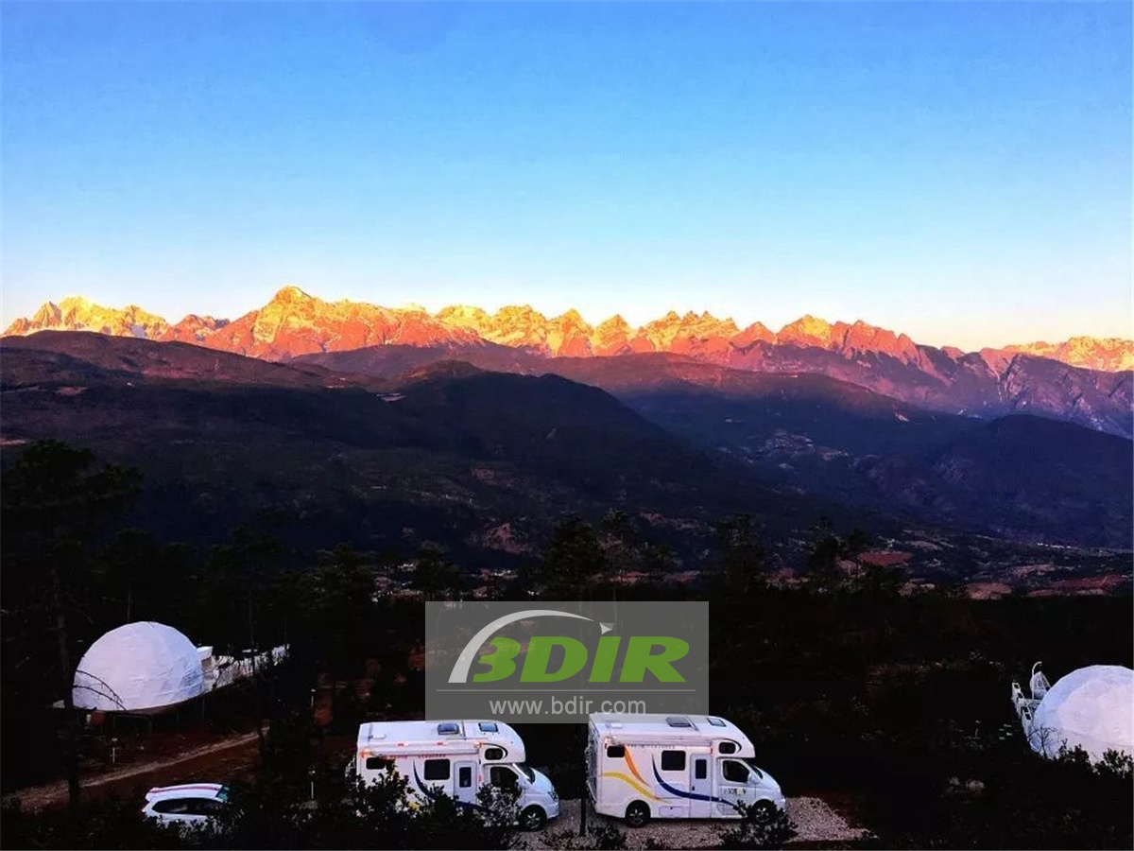
Lijiang Yulong Snow Mountain Scenic Spot is a 5A national scenic spot officially approved by the National Tourism Administration. Located in the Yulong Naxi Autonomous County, it is the southernmost snowy mountain in the northern hemisphere. It is 35 kilometers long from north to south, 13 kilometers wide from east to west, and covers an area of 960 square kilometers. The main peak fan is 5596 meters above sea level. The scenery of the alpine snowy area is more than 4,000 meters above sea level. It’s with a dangerous, strange, beautiful scenery. Yulong Haoran Wild Luxury Tent Hotel was designed and built by BDiR Inc. in April 2018.
At the sea level above 2800 meters , Yulong Haoran Luxury Tent Hotel has 5 sets for white PVC fabric roofing tent houses. Each dome tent room features an bathroom, five-star bedding, heated heating, solid wood furniture, ornate carpets. Each tent cottage with its own small terrace and an exciting open-air bath. There is a small range of activity space on the geodesic dome tent terrace, which is perfect for drinking tea, reading books, listening to music.
At the beginning , BDiR Inc. designers fully considered the perfect protection of the natural ecological environment and flowers and plants in the opposite land. The bottom of the dome tent cottage is made of round wood with small wooden planks and which is made into a transparent square platform. Effectively isolates ground moisture. it can also prevent the sudden rain and other conditions at night. The maximum coefficient guarantees the comfort and health of the visitors.
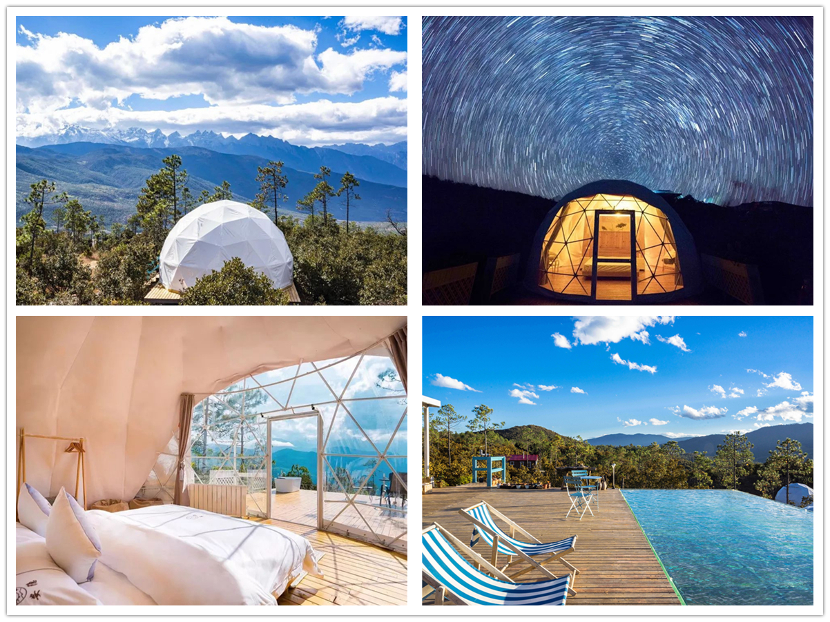
Technical advantages:
The spherical dome shaped tent uses a modular assembly structure, which is manufactured in the factory. During the construction process, the surrounding natural environment is rarely excavated and destroyed, which can be better integrated into the ecological environment. At the same time, flora and fauna can coexist unrestricted under the wooden base of each eco tent structure.
Reviews:
Through the multi-faceted communication with BDiR Inc., the final design not only protects the ecological environment of our camp, but also allows customers to experience luxury, comfort and comfortable star tent accommodation! Very happy and perfect to complete this project! Thanks to BDiR Inc.!

