Luxury Dome Tent Lodges, Luxurious Red Desert Eco Dome Camping Site
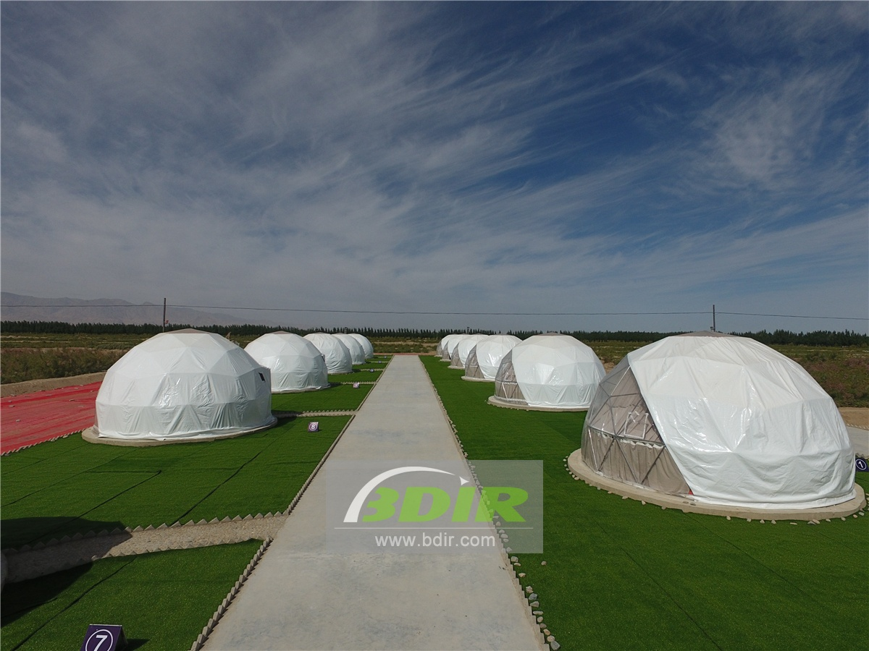
In June 2017, BDiR Inc. received a project to build a dome tent hotel in Qinghai Resort. Through field trips, which combined with the local desert environment, 12 semi-permanent spherical dome tents were designed and built. Because of the temperature difference between day and night, the spherical dome tents are selected to match the elastic cloth and insulation cotton to improve the warmth of the tents and ensure that the temperature inside the tent is moderate.
12 geodesic domes tent rooms are scattered in the red desert area of 2800 meters above sea level. Each luxury dome tent has a private independent bathroom. Open the dome door, there is the vision, there is the mind, you can feel the blue sky and white clouds in the distance in Kunlun Snow Mountain. The 6-meter-diameter spherical hotel tent has an open and bright space. The tent cabins is equipped with floor, wall,platform desk and other perfect camping functions. It can be equipped as a five-star outdoor luxury membrane structure tent hotel with big bed, cloth, air conditioner, lighting, exquisite home, bathroom equipment, etc. The design of the dome tent hotel is in line with the sustainable development concept. In many areas where there are restrictions on the construction of hard buildings, the tent hotel is a best building because of its convenient features. There are not many restrictions on the construction of tent hotels. They can be set in different terrains such as mountains, beaches and deserts.
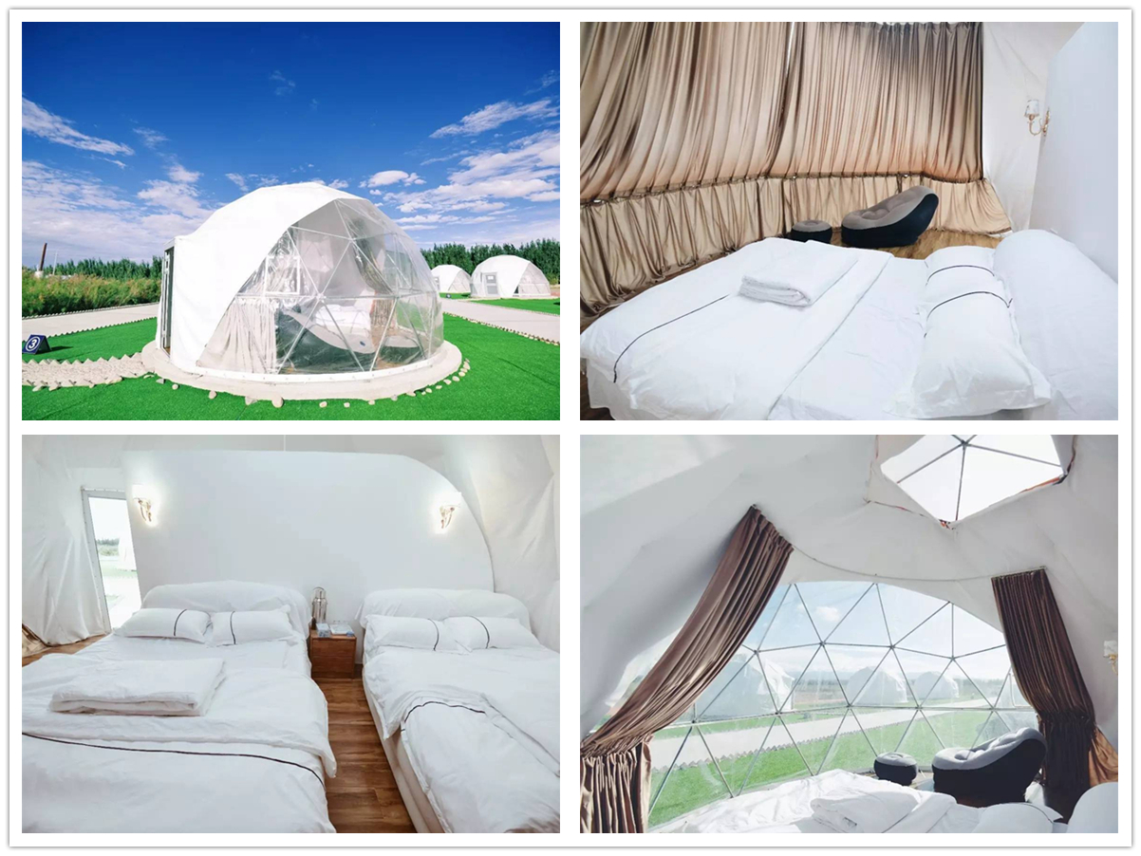

Technical advantages:
Because it is in the desert, BDiR Inc. chose a spherical dome tent with strong geographical ability as a residential room. In the desert area, the temperature difference between day and night is large. The dome tent cabin is designed with elastic cloth and insulation cotton to improve the warmth of the tent, which ensurs the temperature inside the tent is moderate and comfortable.

Reviews:
After receiving the project request, BDiR Inc. came to our holiday camp for a field trip and gave a set of cost-effective, safe, comfortable and luxurious dome cottage solutions! During the construction and installation process,they strictly install the program operation! Perfectly built the tent hotel we expected!

