12 Geodesic Dome Tent Houses are Designed & Built - WuGong Mountain Resort
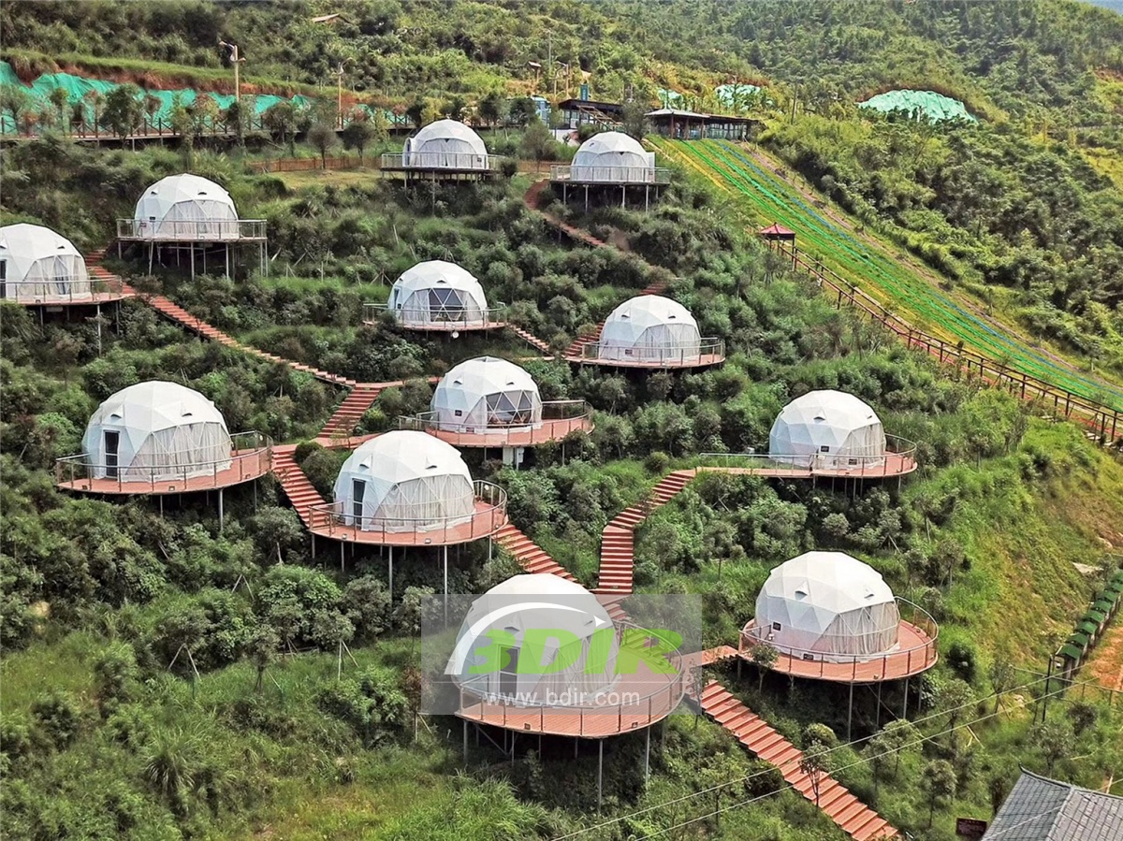
Wugong Mountain is located in the central and western part of Jiangxi Province, China, in the northern branch of the Luojing Mountains. Wugong Mountain is a national key scenic spot, a national AAAA tourist attraction, a national forest park, a national geological park, a national natural heritage, and a Chinese youth outdoor sports camp.
Ascend to the Jinding Mountain Scenic Spot of Wugong Mountain.With an altitude of more than 1600 meters, the 100,000-mu alpine meadow in the area will shine on the top of the mountains, which is unparalleled in the world. Along the way, you can enjoy the pastoral scenery and enjoy the hundred-mile terraced fields.
In 2017.05, BDiR Inc. designed and installed 12 spherical dome tent houses for Wugong Mountain Resort, so that vacationers can have Luxurious and comfortable accommodation. Jiangxi Wugong Mountain Resort is a leisure and entertainment amusement park which integrates grass skiing, water park, go-kart paradise, outdoor sports and expansion,it is including restaurants, tea bars,landscape folk photography exhibition hall, outdoor tent base, vegetables. The comprehensive boutique resort area of “food, shelter, travel, travel, purchase and entertainment”, which has the melon and fruit base and the spherical dome tent hotel, and covers an area of more than 140 acres.
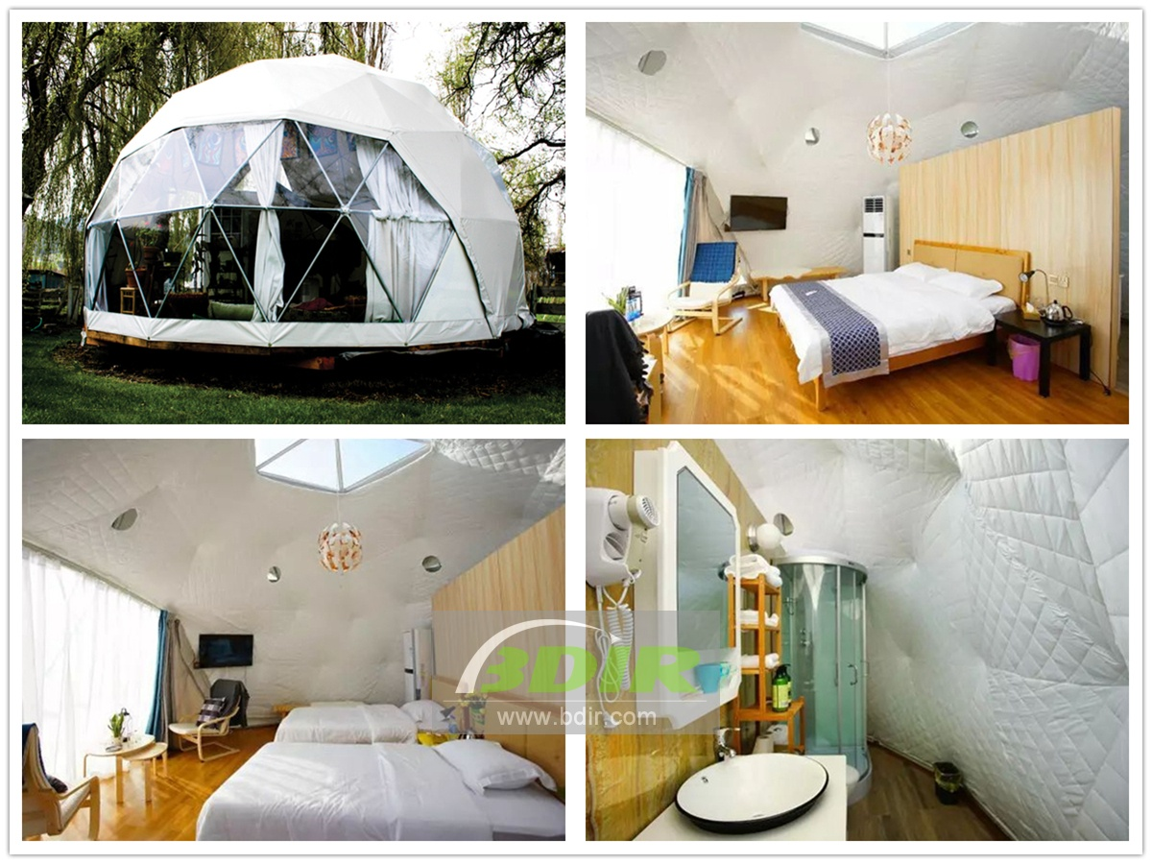
The domes tent hotel designed and installed by BDiR Inc.. The spherical domes tents are named by the constellation. Four different types of spherical tents houses are available (standard room, double bed room, family room, star room). The spherical dome tents are not big, the area of spherical tent room is only about 30m2. The outside of the tent cover with PVC fabric membrane , the interior is divided into the bathroom, bedroom and living room by the white wall. The roof of the geodesic dome tent facing the bed is a transparent sunroof, with a remote control switch, and you can see the stars while lying on the bed at night. The hemisphere dome tent is made of Q235 galvanized steel tubes to ensure the safety and stable. The eco hotel tent lodge is 6 meters in diameter and 3 meters in height. It is suitable for couples and families. The eco-friednly dome tents are all designed and manufactured using environmentally friendly materials, and they also take care of the original ecology of the surrounding environment.

Technical advantages:
Spherical dome tent with a transparent skylight on the roof and a remote control switch that can lie in the bed and look up at the sky. The Q235 galvanized steel pipe is used in the hemisphere dome tent to ensure the safety and stable. The eco domes tents houses are designed and manufactured using environmentally friendly materials, and they also take care of the original ecology of the surrounding environment.
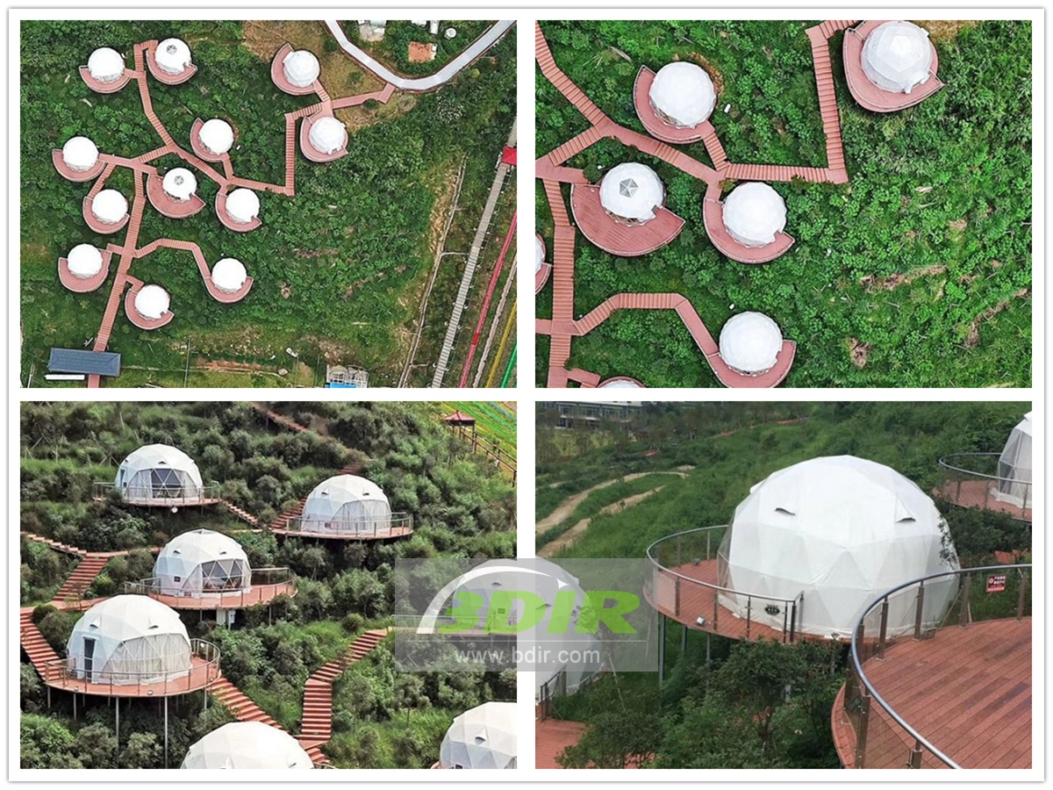

Reviews:
Resort Owen Said: Shenzhen's BDIR company with superb expertise and designed for our resort to build a spherical dome tent cabin,which added different experience to our resort! The dome tented hotel provides a more comfortable and luxurious camping experience for Outdoor enthusiast.

