Concert Dome Festival Structures Music Event Dome Design Supplier
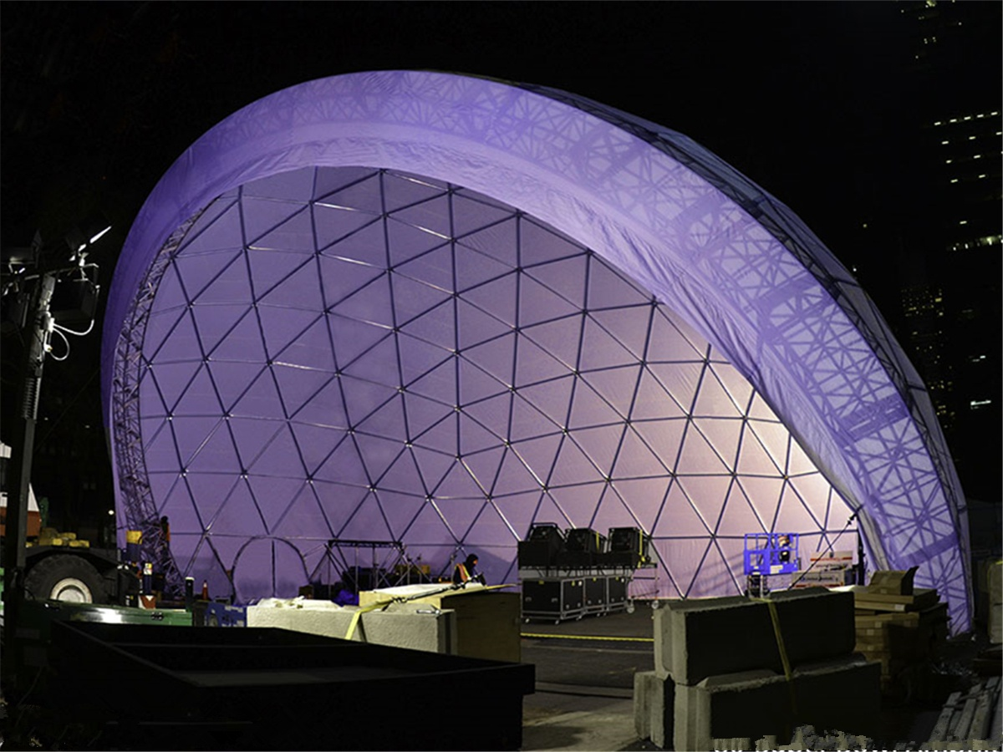
Why is the geodesic dome tent suitable for concerts?
The lightweight domes are assembled in a less time frame and are designed for concerts, celebrations or theatrical performances - good acoustic and sound control, microclimate management and a variety of design options. The steel dome structure is designed to withstand the high loads that hang from the internal structure of the dome, such as sound systems, lighting and decoration. The movable dome tent is usually covered with PVC fabric membrane for fire retardant, waterproof, and blizzard loads. The sturdiness of the dome structure and the thickness of PVC fabric membrane are chosen by geographical area to withstand the required loads such as wind, rain and snow. Several adjacent dome tents can be connected to create a composite designed to meet specific needs.

l Keep high load equipment
The well-made geodesic dome as a structure can withstand heavy loads that are better than any other type of building - such as wind, sand, rain and snow. The interesting fact is that the dome becomes more stable with these loads! Event promoters and organizers can hang the sound, lighting systems and decorations directly on the dome steel structure. As a result, they save a lot of rent on the stage structure and get better aesthetics.
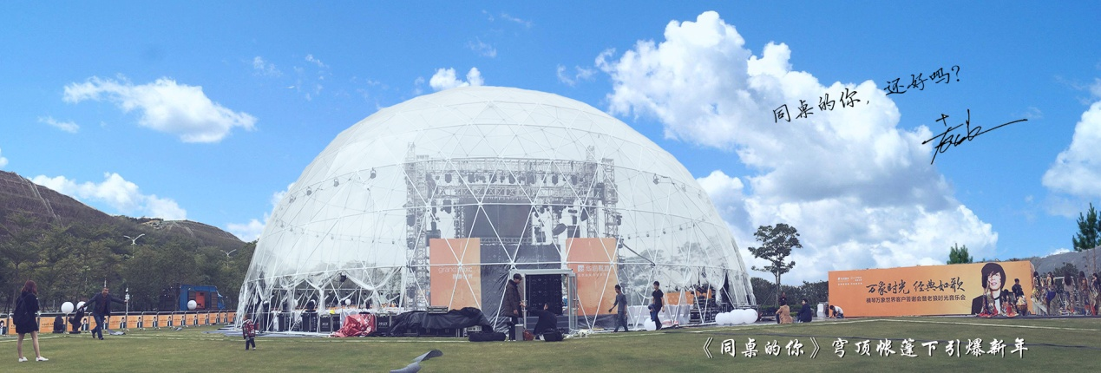
l Great sound effects
To ensure the perfection of the event tent structure, we designed a dome with the most advanced software in space. The carefully crafted dome has a perfect concave shape that ensures sound passes through the dome and is perfectly collected at different focal points. The sensible choice of coating material absorbs excess sound and becomes magnificent in the end .
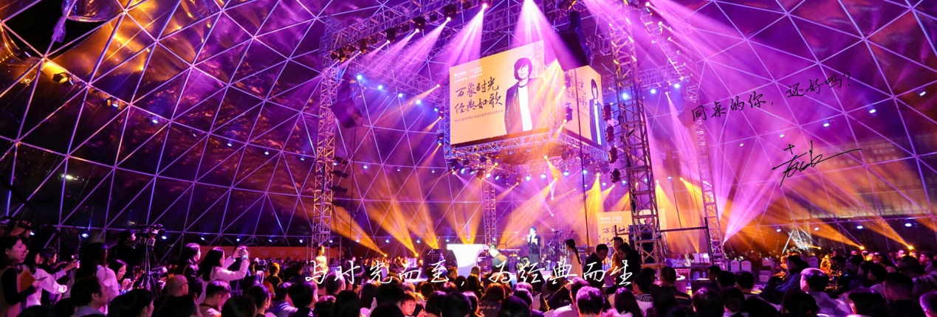
l Effective microclimate management
The dome tent requires 30% of the utility resources to maintain the desired microclimate because the dome is smaller in size than a square building. Therefore, in industries where microclimate maintenance is very important and costly, domes are very popular, such as greenhouses, greenhouses, and of course activity venues.
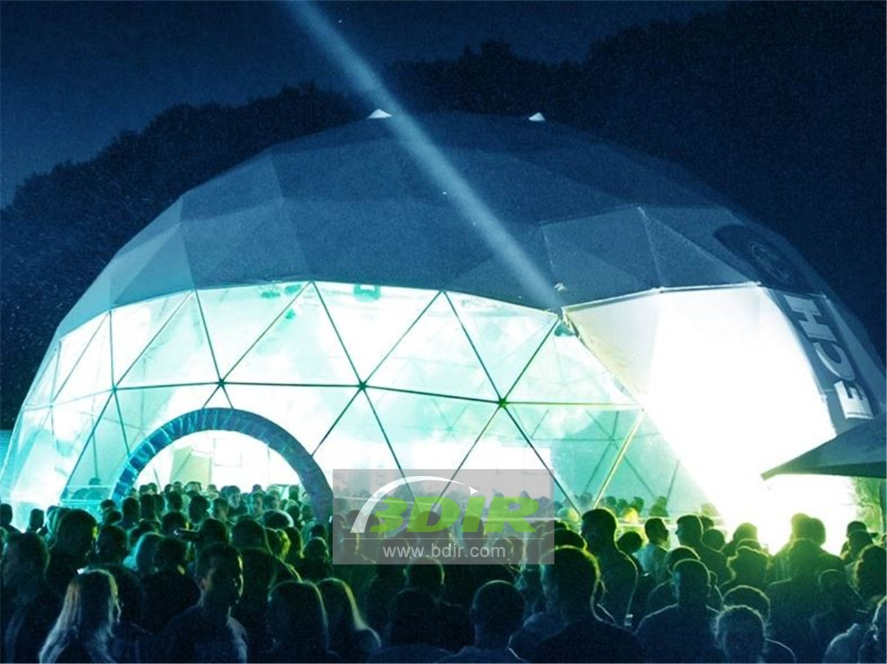
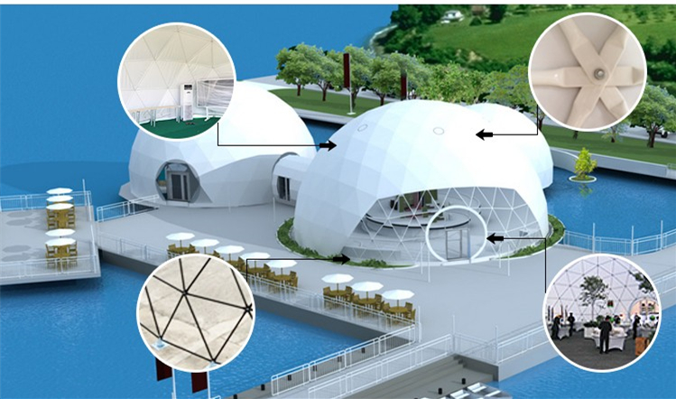
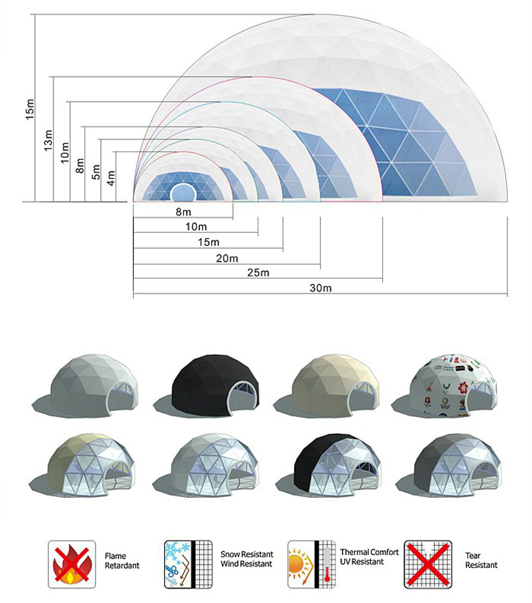
BDiR Inc. is a dome designer and manufacturer, which provides 5m - 100m best quality complete dome tents for living home, glamping tent house, camping pods, greenhouse, branding, product launches, commercial receptions, outdoor concerts and business annual celebrations, festival, performance, trade show booth, corporate events and conferences, product launches and promotions, Art installations, floating domes, igloo and rooftop lounges, movies, private parties, special occasions, etc.

