Basketball Court Tensile Structure Canopy - Outdoor Basketball Courts Shade

Membrane Material | PVC / PVDF / PTFE / ETFE
Material Brand | Ferrari, Heytex, Duraskin, SATTLER, Mehler, Sioen, etc.
Fabric Color | White or Customized
Shape | Customized (Arc, Barrel Vault, Hypar, Cone, Dome, Umbrella, etc.)
Structure | Q235 steel, Hot Dip Galvanized
Size | Customized
Warranty Time | 10-35 years
Transport Package | Standard Export Sea-Worthy Packing
Delivery Time | About 30 Days after confirm deposit
Certification | ISO9001, MSDS, CE, BV, TUV, SGS
Place of Origin | Shenzhen, China

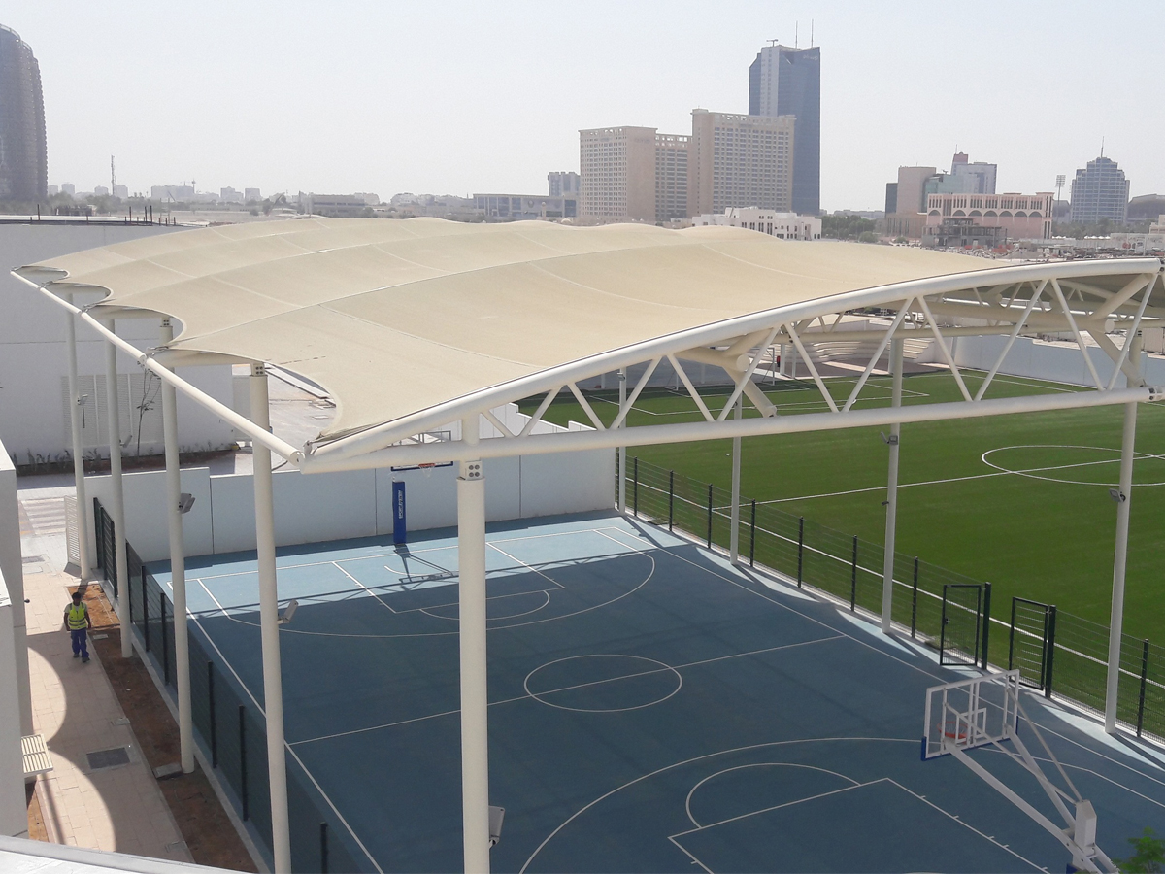
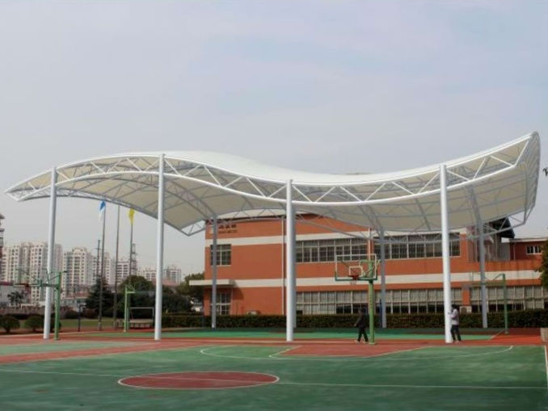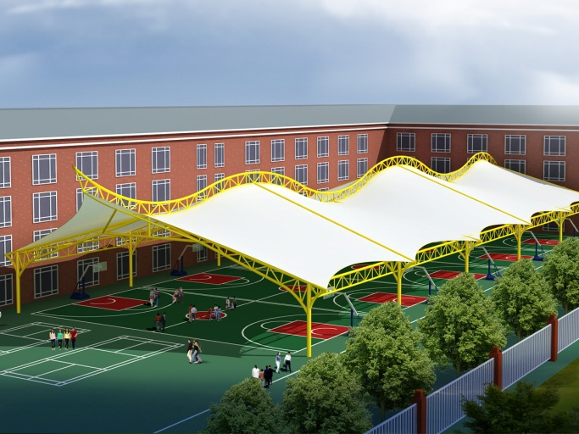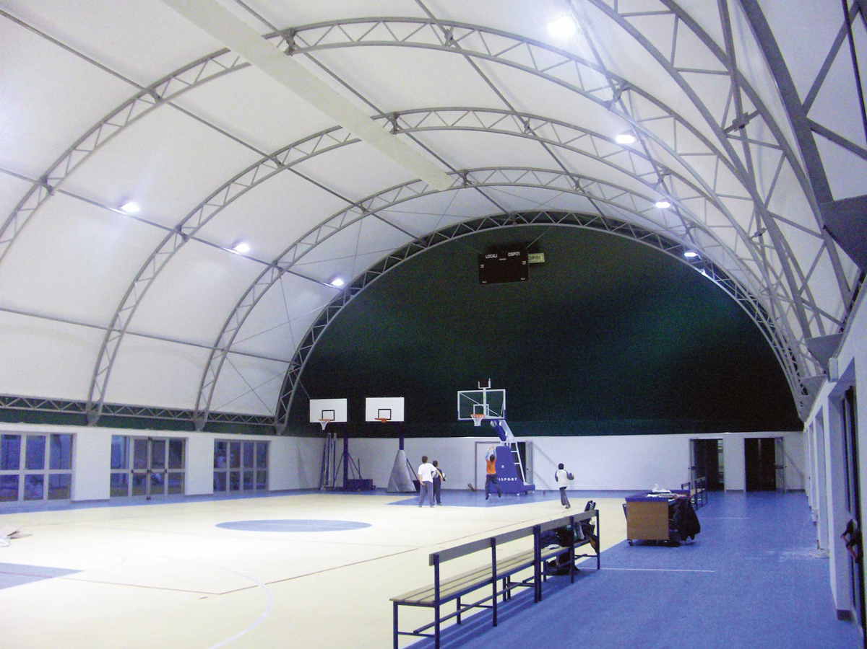

Looking to install or resurface your basketball court? Tension membrane structure is a perfect combination of architectural and structural architecture. It is high-strength flexible thin-membrane materials and support system combine to form a stable surface has certain stiffness and can withstand a certain load of space outside the structure. It’s owns features as shape freedom lightweight, fire-retardant, making easy to install, energy-efficient, safe, etc. , and thus it has been widely applied throughout the world.

