Tensile Structures for Gymnasium, Soccer Football Stadium, Sports Center

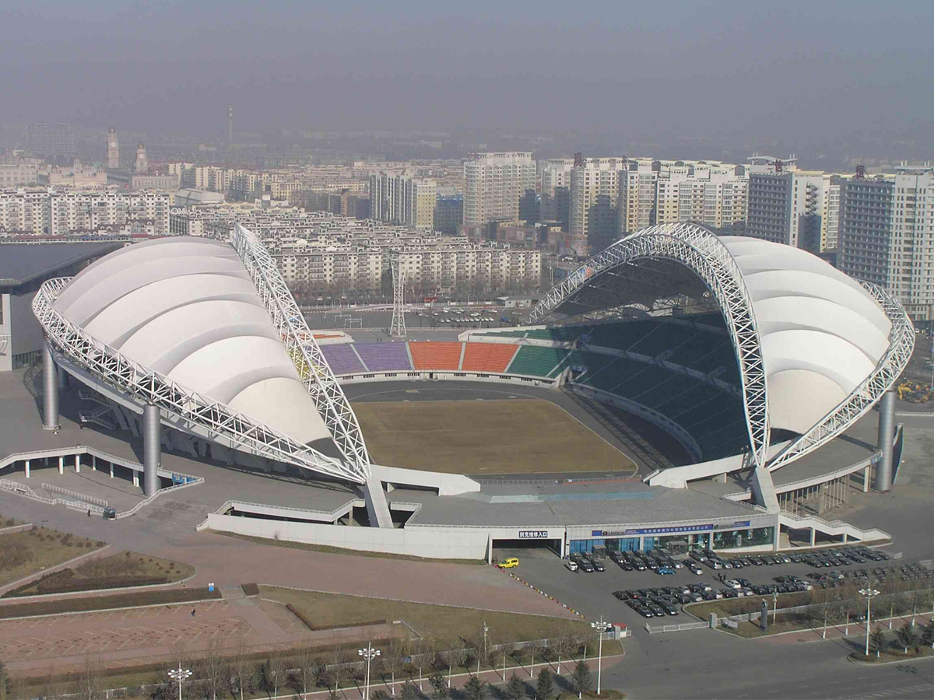

Membrane Material | PVC / PVDF / PTFE / ETFE
Material Brand | Ferrari, Heytex, Duraskin, SATTLER, Mehler, Sioen, etc.
Fabric Color | White or Customized
Shape | Customized (Arc, Barrel Vault, Hypar, Cone, Dome, Umbrella, etc.)
Structure | Q235 steel, Hot Dip Galvanized
Size | Customized
Warranty Time | 10-35 years
Transport Package | Standard Export Sea-Worthy Packing
Delivery Time | About 30 Days after confirm deposit
Certification | ISO9001, MSDS, CE, BV, TUV, SGS
Place of Origin | Shenzhen, China

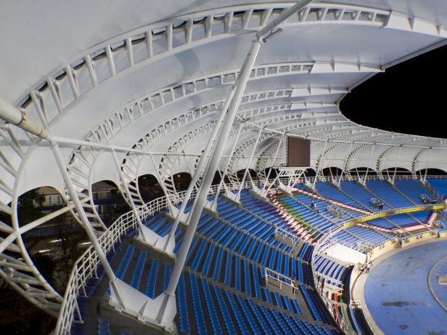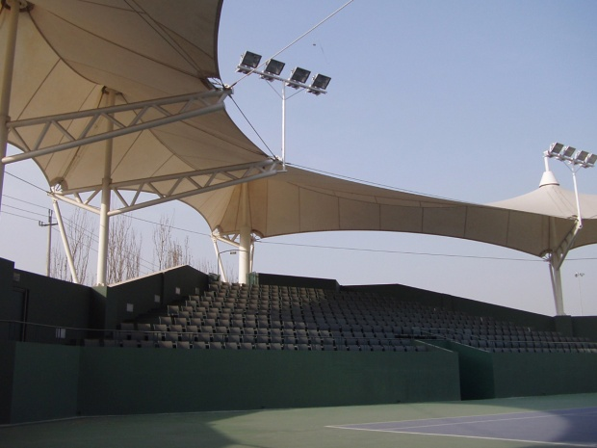

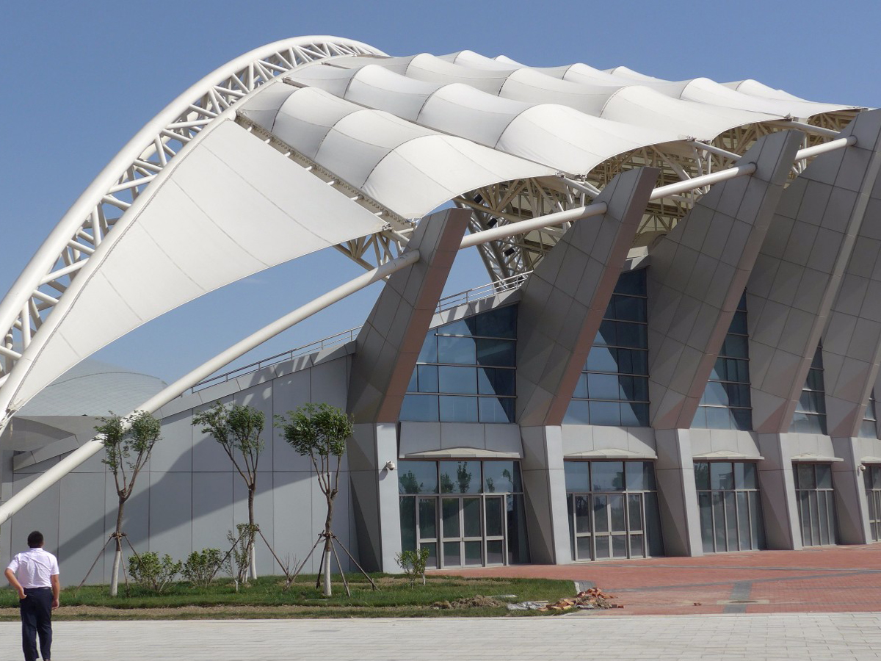

Tensile structures have large spans, few ridges, outstanding visual functions, rich in colors, practical use of sunshade and rain shelter, quick and simple construction, modern art design, It’s the best architectural form for gymnasium and stadiums. Tensile structures are used as many World Cup stadiums, NBA basketball halls, tennis halls and more sports architectures!

Gymnasium & Stadium Tensile Structures Advantages:

1. Light weight: Tensile structures are only one-thirtieth the weight of traditional constructions. This also make tensile structures fundamentally overcome the difficulties encountered when traditional structures are realized on large-span (unsupported) constructions, especially for large stadiums and other constructions that require huge unobstructed visual space.
2. Natural light: Membrane fabrics are translucent and guarantee excellent, uniform light. Natural light helps players feel more comfortable, and also avoid electricity cost during the day. Of course we ca also install LED light spotlights that allow your courts to be used at night.
3. Great Aesthetics: Stadium is generally an iconic construction in the urban area. At night, light illuminates the night sky through membrane of the top cover, create a very dreamy visual function.
4. Long lasting nature: The result of highly sophisticated engineering technology, tensile systems comply with stringent construction codes. Depending on the type of membrane and specific project requirements, these superior structures perform well in extreme environments and fluctuating weather conditions.

Gymnasium & Stadium Tensile structures Attentions:

1. Generally, Tensile structures gymnasium has a large span of construction space, so it is necessary to fully consider how to divide the fire compartment. Membranes have good flame retardancy and high safety.
2. Construction of the construction must be fireproofed, Membrane material should be closely attached to the underside of the steel cable. So that the steel frame is not subject to any high temperature function.
3. In order to withstand the rain and snow, shape of membrane surface should ensure that the drainage and snow discharge are convenient and smooth, avoid rain and snow accumulation. Membrane and joints must be sealed and waterproof, edge of membrane should also be specially designed to prevent rain from entering the room.

