Swiss Eco friendly Domes Resort with 15 Geodesic Dome Tent Pods
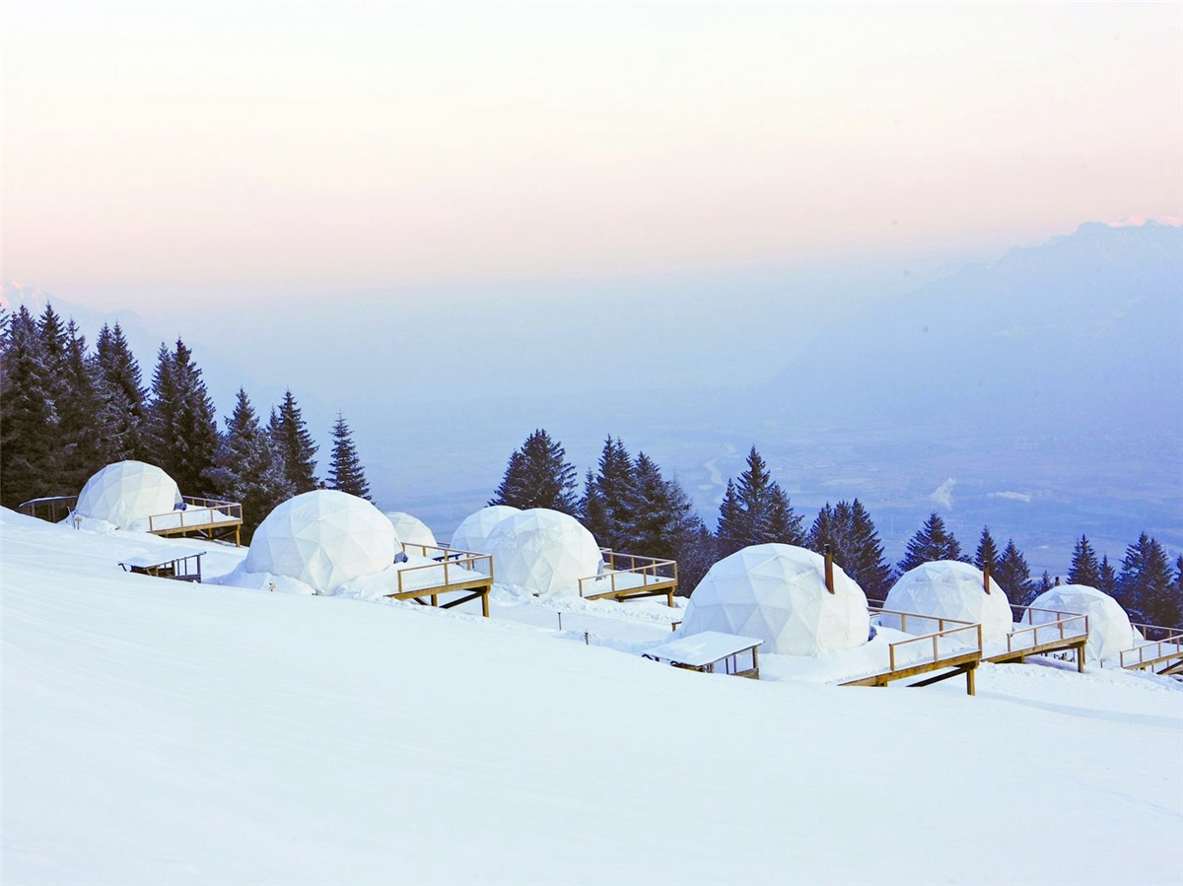
Product specifications:
• Diameter: 4.9 meters or 5.9 meters
• Base area: 20 square meters or 27.5 square meters
• Entrance: H 180cm x W 70cm
• Maximum height: 2.9 meters or 3.65 meters
• Quantity: 20 dome tents
Material:
• 950g/m2 Germany imported white PVC film material, 850 g/m2 Germany imported transparent PVC film material
• Windproof up to 80-100km/h, 100% fire retardant, waterproof and snowproof
• Galvanized steel pipe Q235, diameter 20*1.5mm
• Use stainless steel tube as frame material
• Configure insulation, wood burning stove, curtains
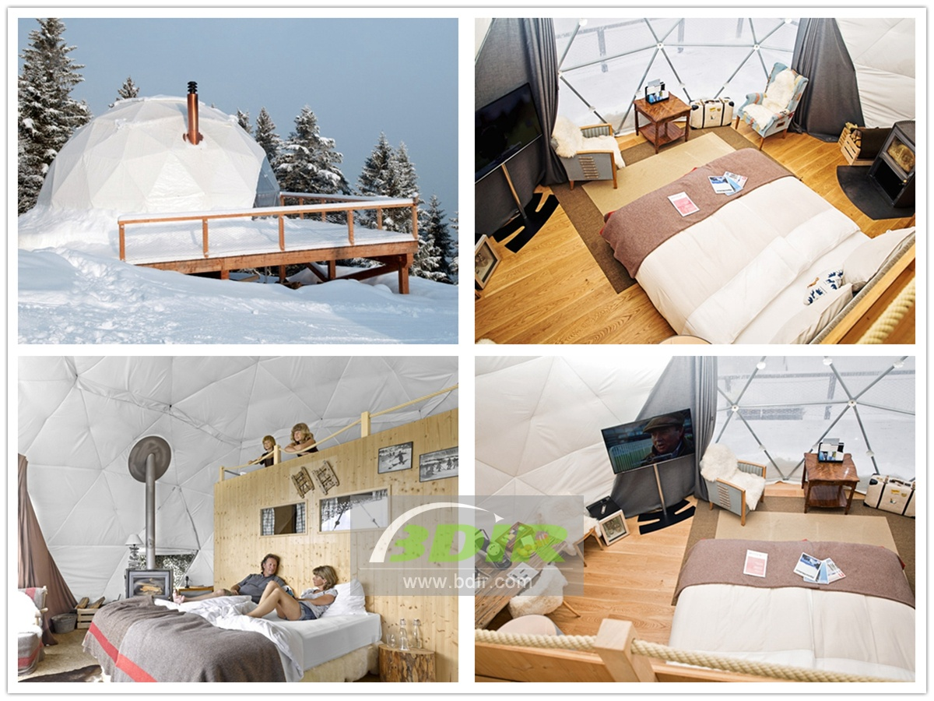

The Eco Friendly Resort consists of 15 geodesic dome houses. Each dome pod is fixed to a wooden deck and offers a furnished terrace with far-reaching views. Standard dome room with one large bed, fully equipped bathroom with toilet and shower, wood burning stove, kettle and mezzanine floor, can accommodate an extra single bed. The family dome tent room has the same facilities and the mezzanine can accommodate 2 extra beds for children. Each pod can comfortably accommodate for 2-4 people, and the green PVC fabric covers on the exterior seems to blend in with the surrounding environment; it is removed during the winter, leaving a white appearance on the dome, blending with the snow .
The geometry of the dome pod is called a geodesic: a spherical structure consisting of a network of triangles. The triangles form a self-supporting frame that provides structural strength while using as little material as possible. Geodetic terminology comes from Latin, meaning the separation of the Earth. Our tents are the same size. Diameter is 7 m , surface area is 40 m2 , ceiling height is 4.3 m, 220 kg for dome.

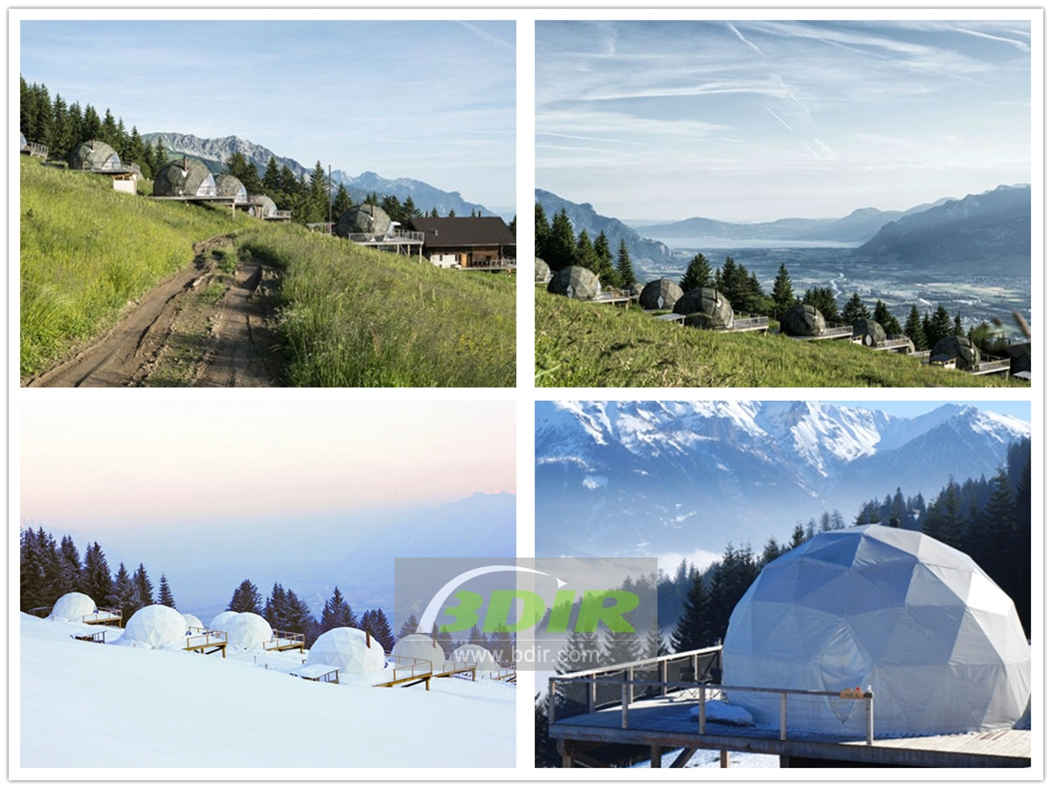

Energy saving,and a little impact on nature. There are two reasons for dome energy saving. First, the ambient airflow within the dome is continuous, with no stagnant corners, requiring less energy to circulate the air and maintain a uniform temperature. The energy required to heat and cool the dome is about 30% less than that of conventional buildings. The second is the ratio of high capacity to surface area, requiring less building material to enclose more space. The lower the ratio of the perimeter of the building to its enclosed living area, the less energy is needed for construction, heating and cooling.

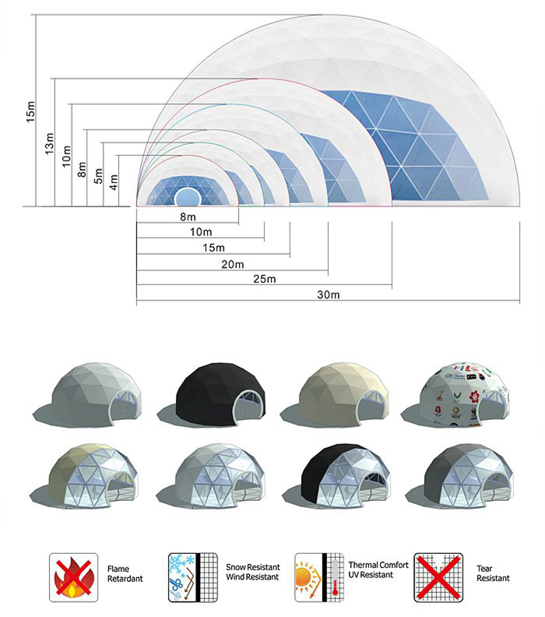
BDiR Inc. is a dome designer and manufacturer, which provides 5m - 100m best quality complete dome tents for living home, glamping tent house, camping pods, greenhouse, branding, product launches, commercial receptions, outdoor concerts and business annual celebrations, festival, performance, trade show booth, corporate events and conferences, product launches and promotions, Art installations, floating domes, igloo and rooftop lounges, movies, private parties, special occasions, etc.

