Luxury Safari Tents, Tent Cabins, Luxury Camping Tents
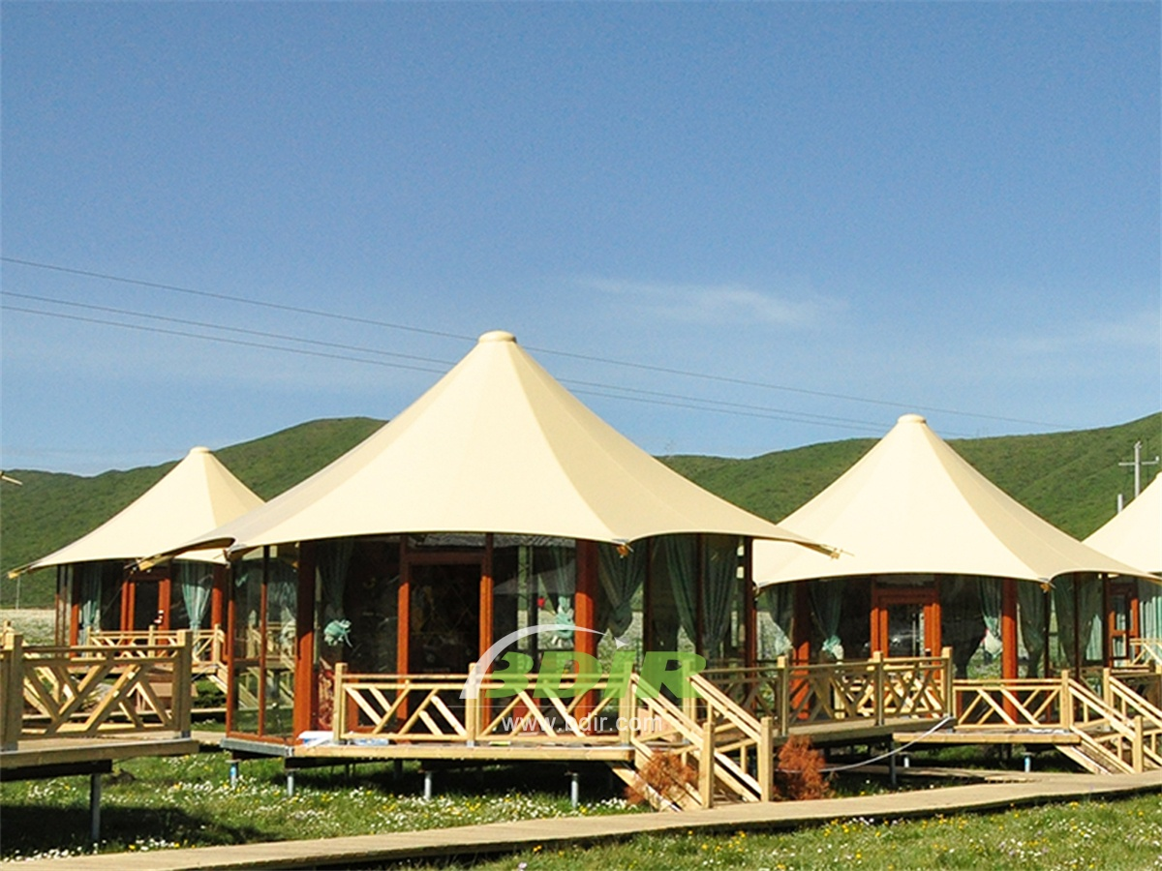
The tented camp is situated on a ridge overlooking the views of the River and the jungle. It offers spectacular views of exotic birds, anteaters and wild monkeys. Every day there are amazing sunsets and you will see why the tent house is a good choice. The luxury camping tent cabins brings you close to nature while providing the comforts of home. The camp features 4 luxury safari tents, each with a king-size bed, full-service bathroom, and plenty of space to stretch and relax.
BDiR Inc. Design, manufacture, installation, maintenance Luxury safari tent resort, glamping tents, eco-lodges and resort tents at very reasonable prices. We ship canvas tents worldwide for all purposes. No matter where your tent or camp will be located in - be it on water, rocks, desert, sand, a grassy plain, tropical beach, ice field or in dense rainforest - we will ensure it is built to last.

