Luxury Island Tented Resort, Fabric Membrane Roof Structures Lodges - Maldives 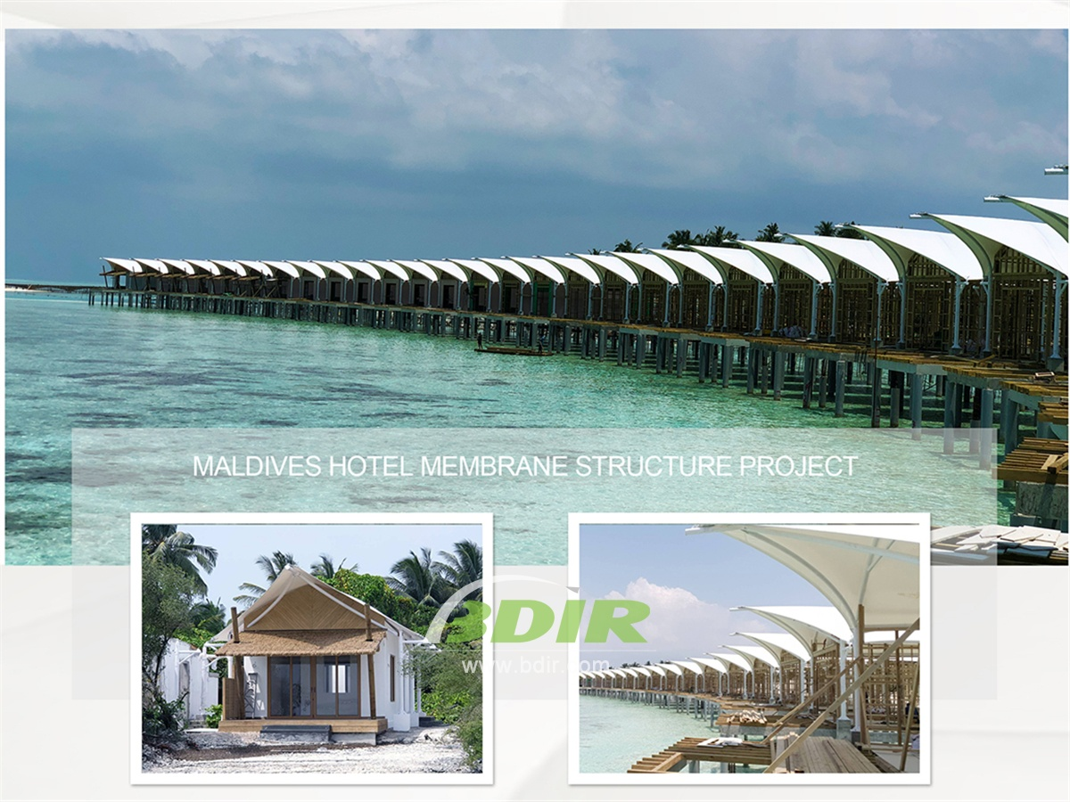
This tented hotel is a great choice for a Maldivian holiday. This tent resort has new and improved facilities and comfortable accommodation for all those who want to experience a wonderful tropical holiday. The island tent resort is good ideal for experiencing the exotic Maldives with its pristine beaches and azure sea.
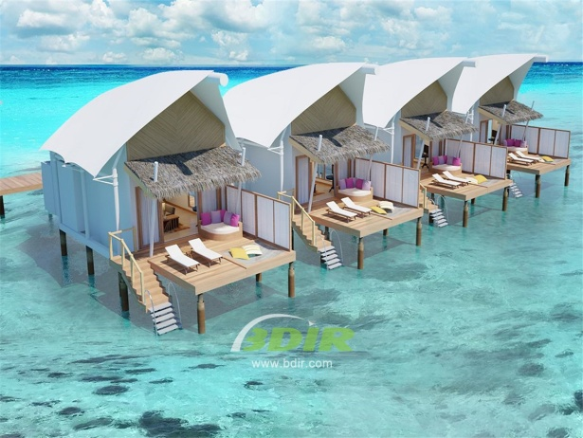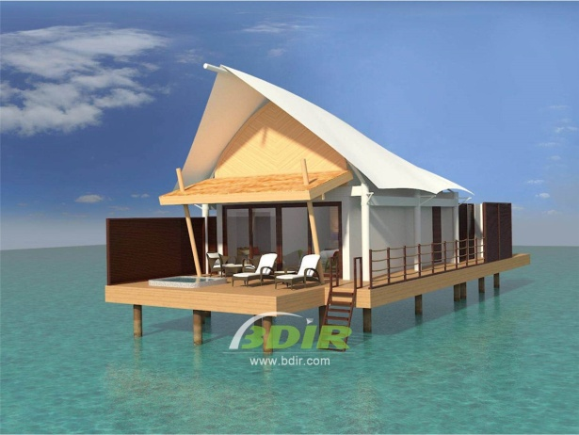
Accommodation at this spectacular beach tent resort which includes 70 water bungalows and 10 beach bungalows. Water bungalow (56 square meters) - The stilts on the lagoon are connected to the coast and connected to the sidewalk. The bungalows have a bedroom (double or twin), with a living area with a transparent floor to observe the life of the underwater dwellers, a bathroom with a shower, an outdoor terrace with sunbeds and a sewer. Beach Bungalow (45 m2) - Beach room includes 1 bedroom (double or 2 single beds), living area, open bathroom, patio with mini garden and hammock.

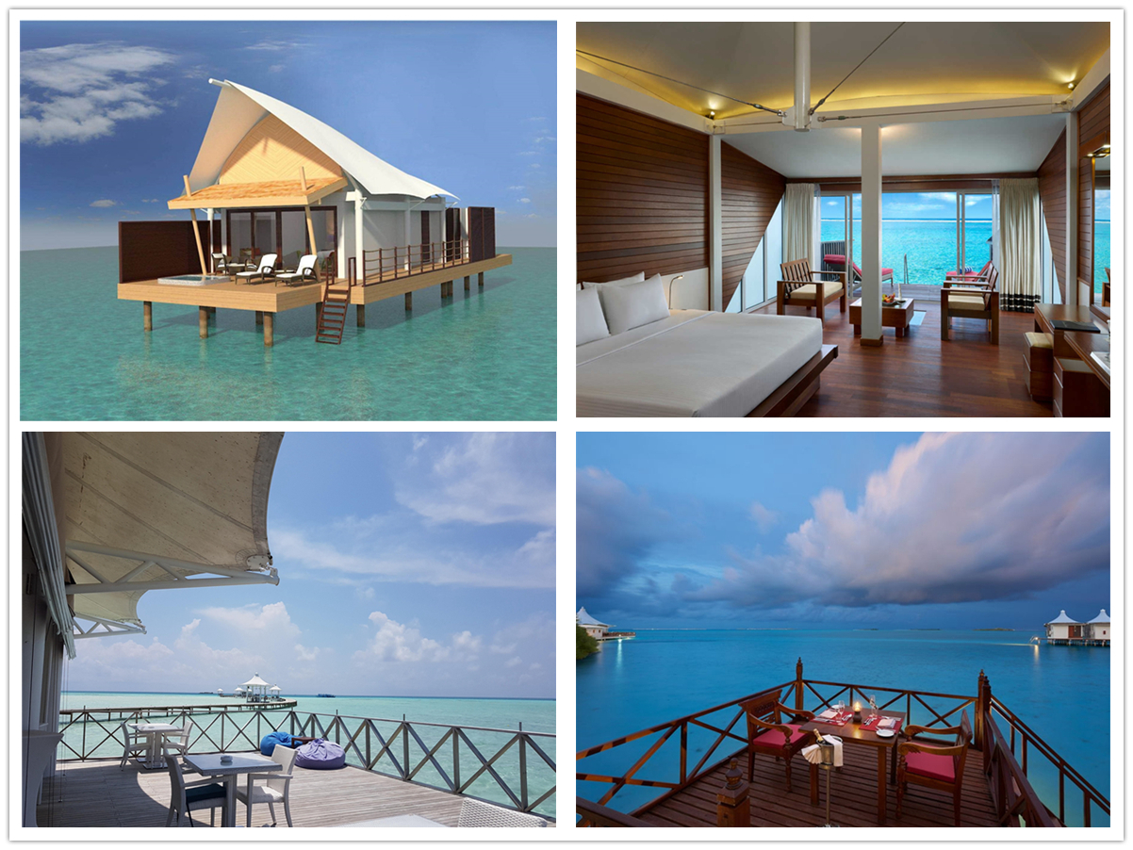
BDiR Inc. Design, manufacture, installation, maintenance Luxury safari tent resort, glamping tents, eco-lodges and resort tents at very reasonable prices. We ship canvas tents worldwide for all purposes. No matter where your tent or camp will be located in - be it on water, rocks, desert, sand, a grassy plain, tropical beach, ice field or in dense rainforest - we will ensure it is built to last.

