Luxury Family Eco Tent Structures For Conserve Turtle World Resort
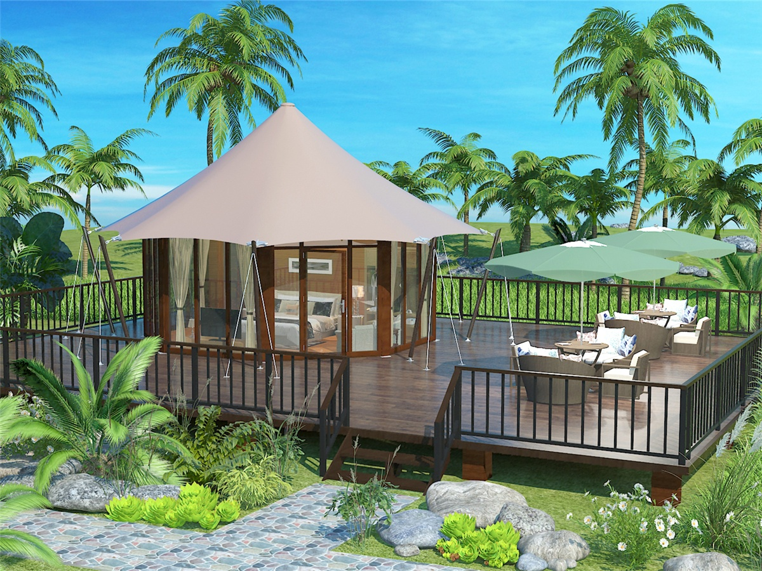
All eco tents offer great standard accommodation, air conditioner and full en suite shower with dressing table, in-room safe, mini fridge, tea/coffee making facilities and LCD TV. Free internet access is also available. These luxury eco-friendly tents are weatherproof and have been tested in the cyclone hit area to ensure durability and safety.
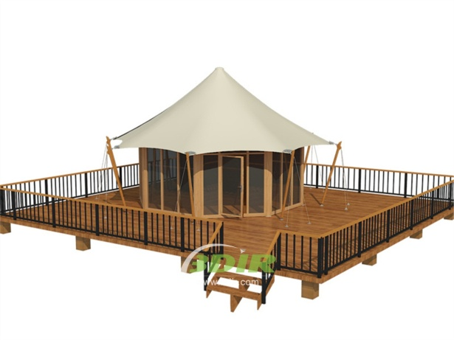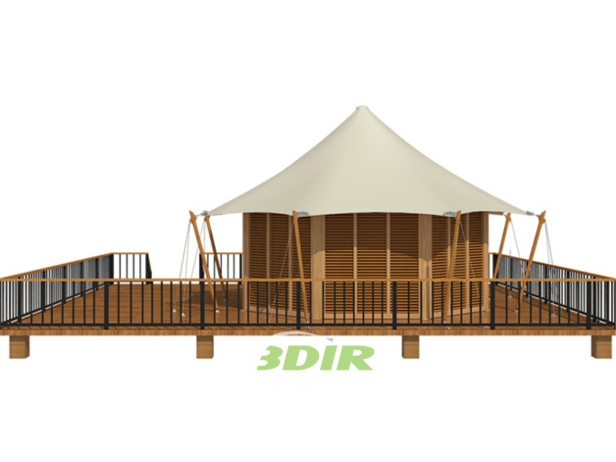
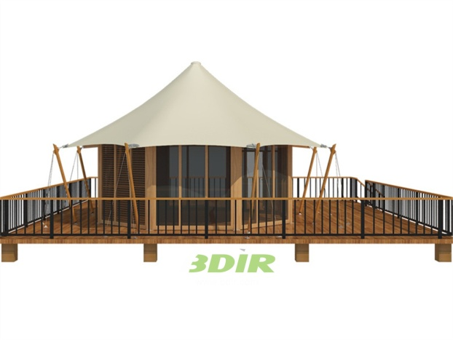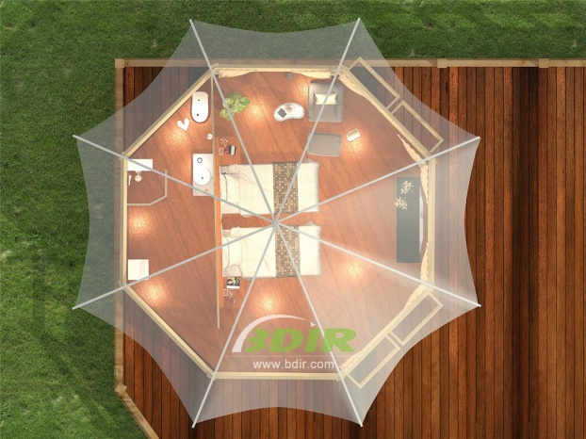
BDiR Inc. Design, manufacture, installation, maintenance Luxury safari tent resort, glamping tents, eco-lodges and resort tents at very reasonable prices. We ship canvas tents worldwide for all purposes. No matter where your tent or camp will be located in - be it on water, rocks, desert, sand, a grassy plain, tropical beach, ice field or in dense rainforest - we will ensure it is built to last.
