Greenhouse Domes, Geodesic Greenhouses, Geodesic Greenhouse Domes
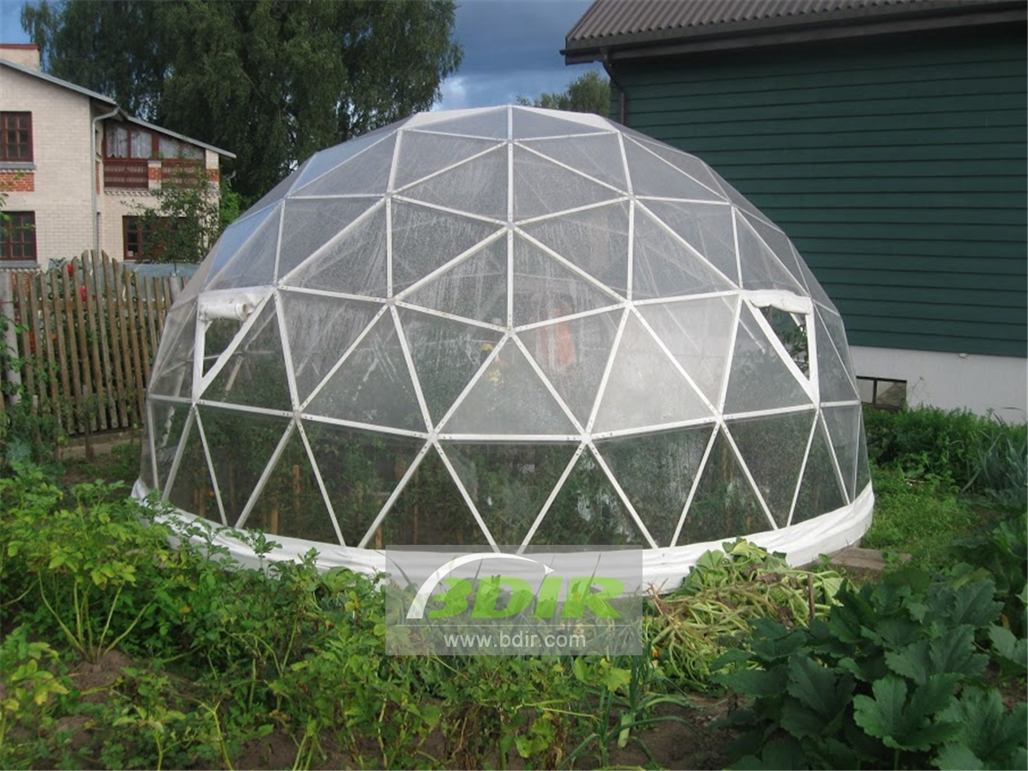
Winter gardens, oranges and zoo designers often choose dome buildings. Good airflow distribution and natural light distribution in the dome ensure good conditions for the plants. We use greenhouse domes built with climate control systems to grow tropical plants even in the northern climatic zone. It also ensures controlled diffusion of different solar radiation into the dome and regulates temperature, humidity and airflow. It offers the possibility of building large spaces without columns and beams, which is very advantageous for dome buildings.
A great choice for those looking for a unique gardening experience. The dome greenhouses are convenient because they can turn into trees or oranges. With open windows, special doors and a ventilated room. We can build a simple tent-covered greenhouse for traditional gardening or luxury orange-glazed greenhouses so that plants can be surrounded and harmoniously relaxed.
• In terms of space lighting, the dome greenhouse is the best choice; the light spreads naturally and evenly.
• Compared to a rectangle, the sphere amplifies light and absorbs light. Therefore, in the dome greenhouse, you will get more daylight than the average greenhouse.
• The spherical greenhouse can be adapted to any landscape.
• The dome greenhouse has a uniquely stable and powerful framework.
• Perfect for all weather conditions, it can withstand the strongest winds and the strongest snow.
• Quick installation
• High quality, reliability and versatility.
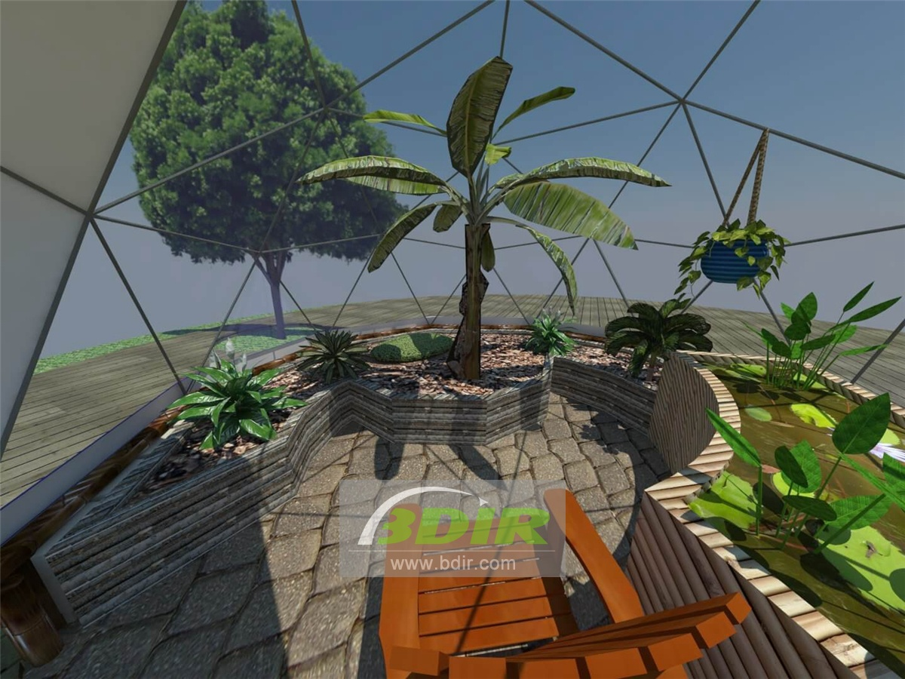
Whether you are interested in basic gardening or commercial planting, we design, produce and build greenhouse domes to meet your needs, which help you grow plants and help them thrive. When it is exposed to the sun, our greenhouse domes are significantly warmer than the outside environment, protecting the contents in cold weather. The size of the dome ranges from 5m to 100m and is an economical way to build any garden, germination facility or commercial planting business of any size.

The main body of the spherical tent is made of special high-strength steel pipe, which is made of 6061 carbon steel, galvanized or painted on the surface, PVC tarpaulin on the roof, or tempered glass. It has good waterproof, fireproof, anti-UV and anti-aging properties, making it the largest. It has a service life of up to 30 years and is equipped with a variety of optional configurations such as glass doors, glass walls, glass doors, ground anchors, load-bearing plates, and wooden floors, so that its functions are fully expanded.
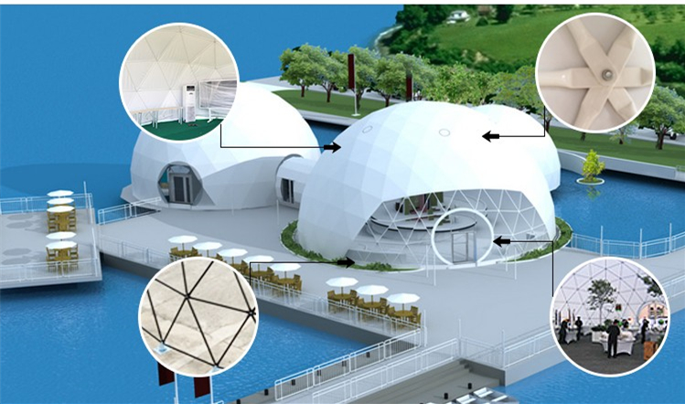
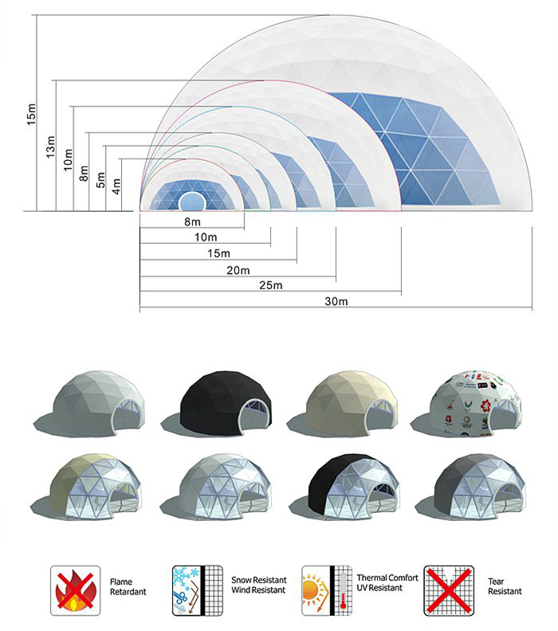
BDiR Inc. is a dome designer and manufacturer, which provides 5m - 100m best quality complete dome tents for living home, glamping tent house, camping pods, greenhouse, branding, product launches, commercial receptions, outdoor concerts and business annual celebrations, festival, performance, trade show booth, corporate events and conferences, product launches and promotions, Art installations, floating domes, igloo and rooftop lounges, movies, private parties, special occasions, etc.

