Golf Driving Range Roof - Tensile Fabric Shade, Canopy for Golf Course

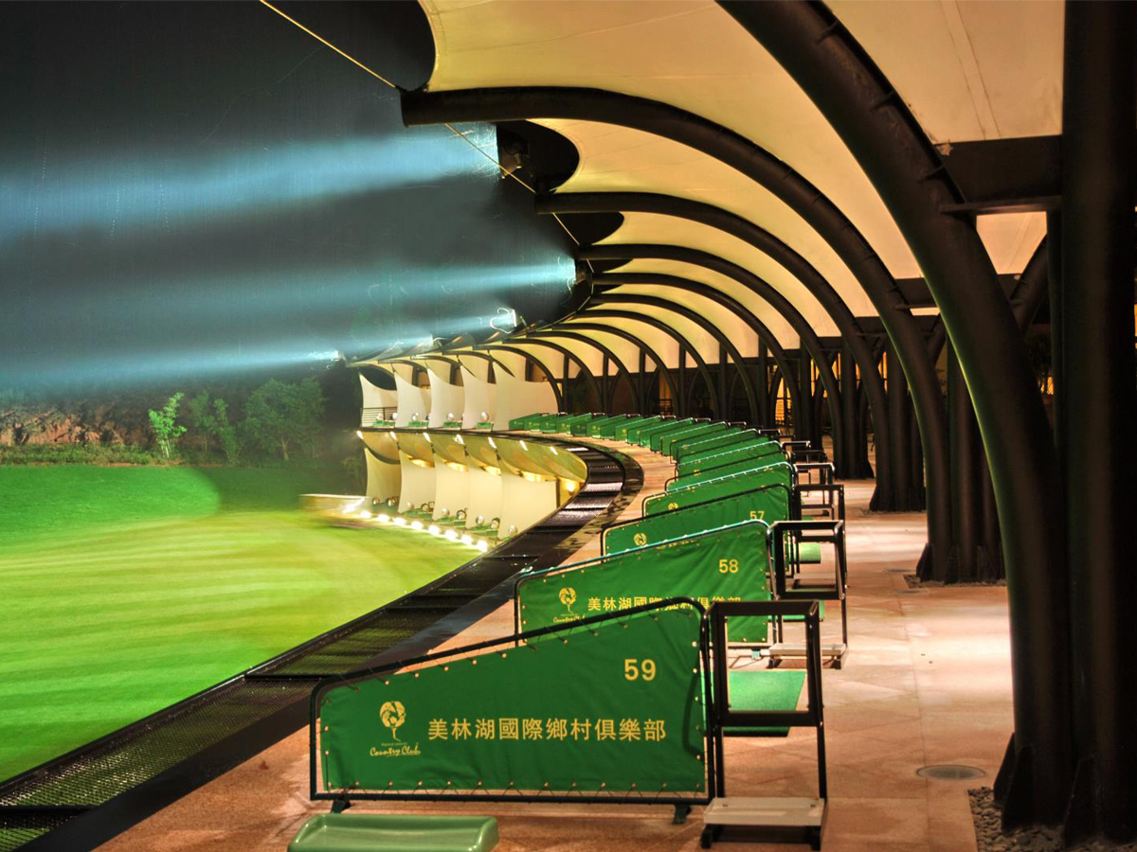
Membrane Material | PVC / PVDF / PTFE / ETFE
Material Brand | Ferrari, Heytex, Duraskin, SATTLER, Mehler, Sioen, etc.
Fabric Color | White or Customized
Shape | Customized (Arc, Barrel Vault, Hypar, Cone, Dome, Umbrella, etc.)
Structure | Q235 steel, Hot Dip Galvanized
Size | Customized
Warranty Time | 10-35 years
Transport Package | Standard Export Sea-Worthy Packing
Delivery Time | About 30 Days after confirm deposit
Certification | ISO9001, MSDS, CE, BV, TUV, SGS
Place of Origin | Shenzhen, China

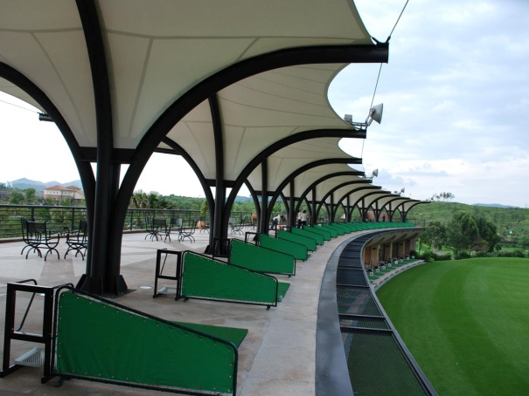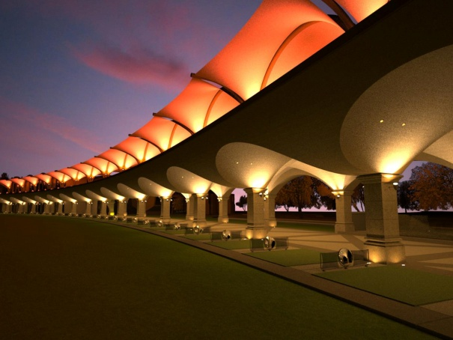
Golf Driving Range Tensile Structure is built on the golf course, provide shade for linksman. Shape can be diversified and manufactured with the needs of the owner. With It’s beautiful and unique design, stable quality, it is widely popular used by Golf club.

Golf driving range canopy could make the golf course more beautiful. The steel structure body is hot-dip galvanized and rust-proof black imported paint spray, gloss texture highlights, More than 30 years of service life.

PVDF / PTFE/ ETFE fabric material imported from Germany, high-end technology membrane processing technology makes each membrane tension force achieve the best function. Membrane itself has a pulling force of more than 6500N, color of membrane will be more bright and whiter by the bleaching of ultraviolet rays!

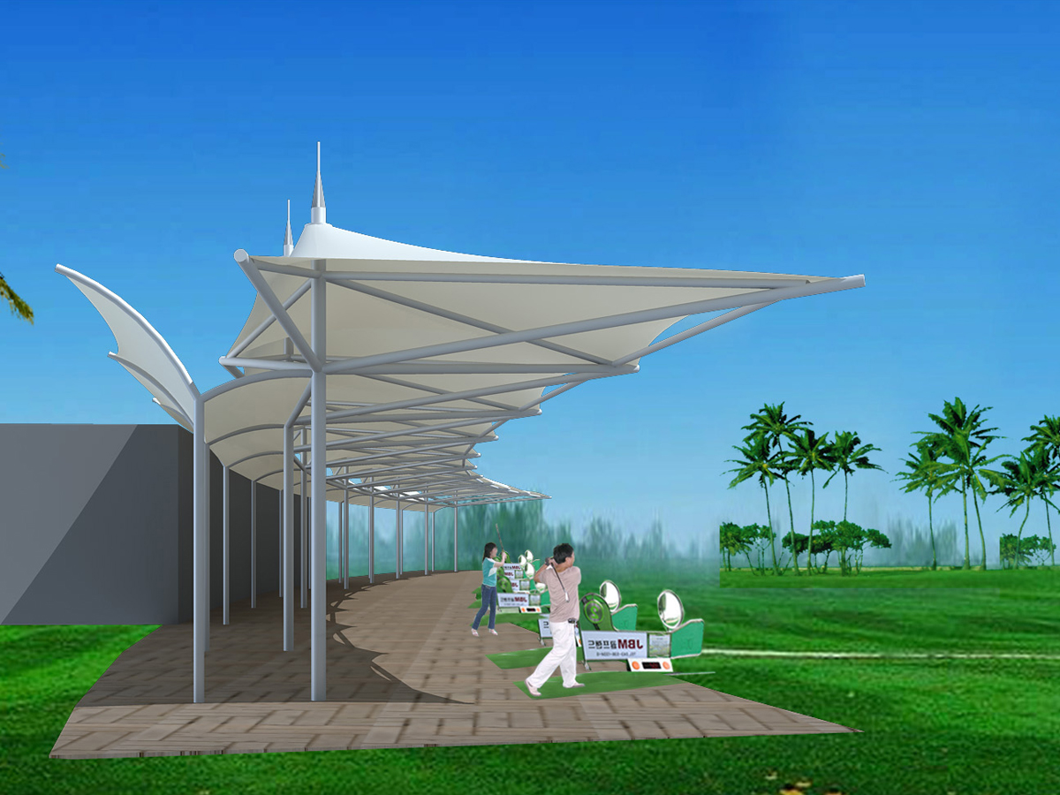

Golf Driving Range Tensile Structures Advantages:

1. Unique & Elegant Design : Form Shades can be customized freely by us.
2. Practical & Durable : All structures are hot dipped galvanized to BS EN 150 1461: 2009 and available in a range of decorative finishes.
3. Great Coverage: Tensile fabric structures can create an expansive covered area. Is the best partner for sports

