Glamping Tent Lodges | Luxury Desert Camping Site
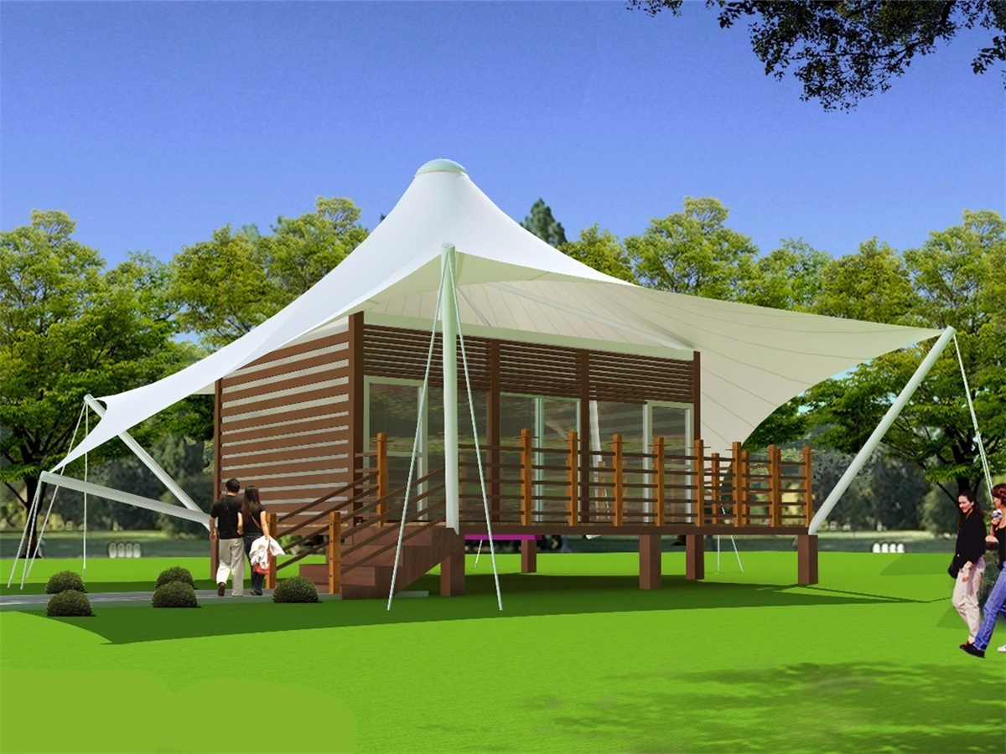
The Desert Tent Hotel has only fifteen tent rooms with glass walls, and you can enjoy the changing colors of the desert with the sunrise and sunset from the private rooms. The roof of each room is made up of three layers of material. The outermost floor It is a rain cover in the traditional sense, which provides shelter and most of the rainproof effect, and similar in shape to small sand dunes. The lower two layers form a closed cavity with sound insulation and heat insulation. The room is simple to use. The square body design, the south wall is equipped with the whole glass window, which can get the most wide view of the landscape. The sliding glass panel can be half-opened, which allows the guests to directly contact the external environment. The wall is slightly deflected,which makes the landscape further Open, you can see the sand dunes through the window.

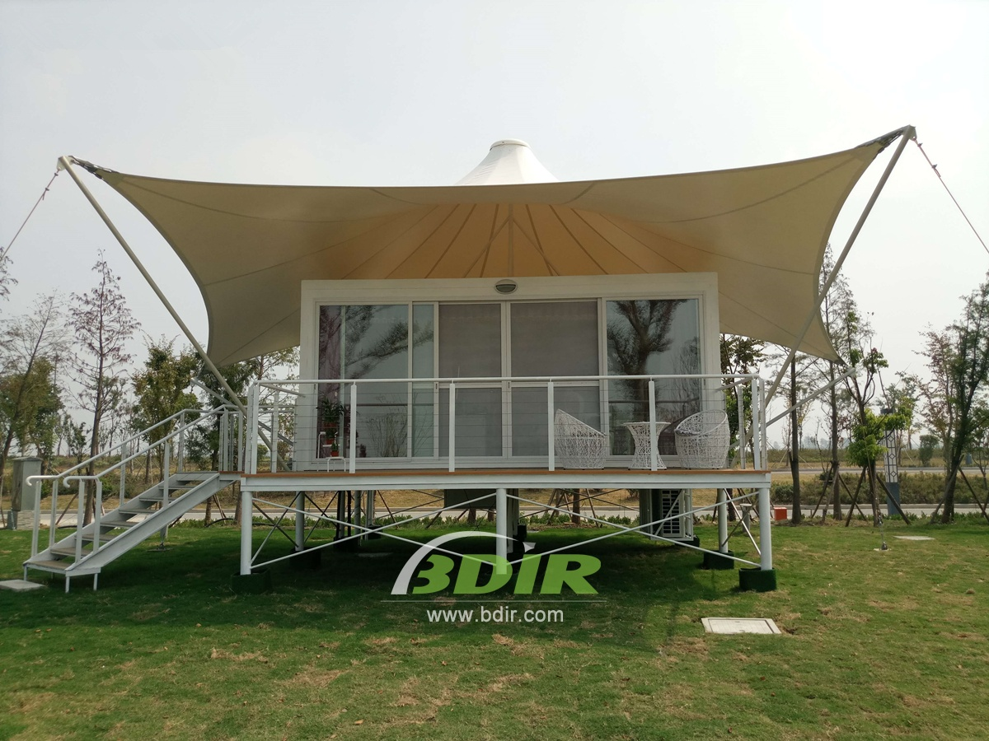
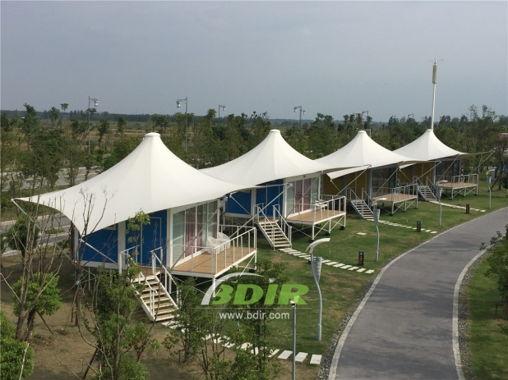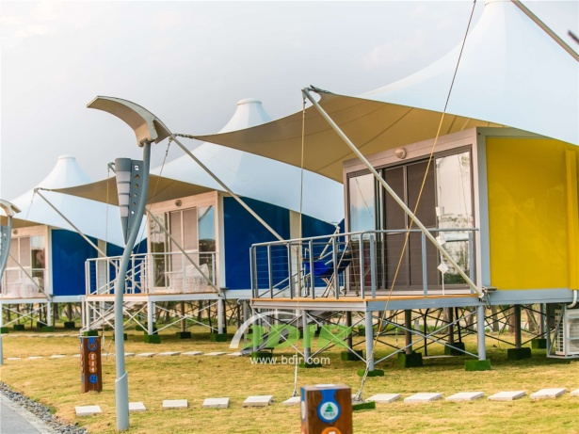
BDiR Inc. Design, manufacture, installation, maintenance Luxury safari tent resort, glamping tents, eco-lodges and resort tents at very reasonable prices. We ship canvas tents worldwide for all purposes. No matter where your tent or camp will be located in - be it on water, rocks, desert, sand, a grassy plain, tropical beach, ice field or in dense rainforest - we will ensure it is built to last.

