Glamping Domes Tent | Luxury Camping Dome Homes - Portugal
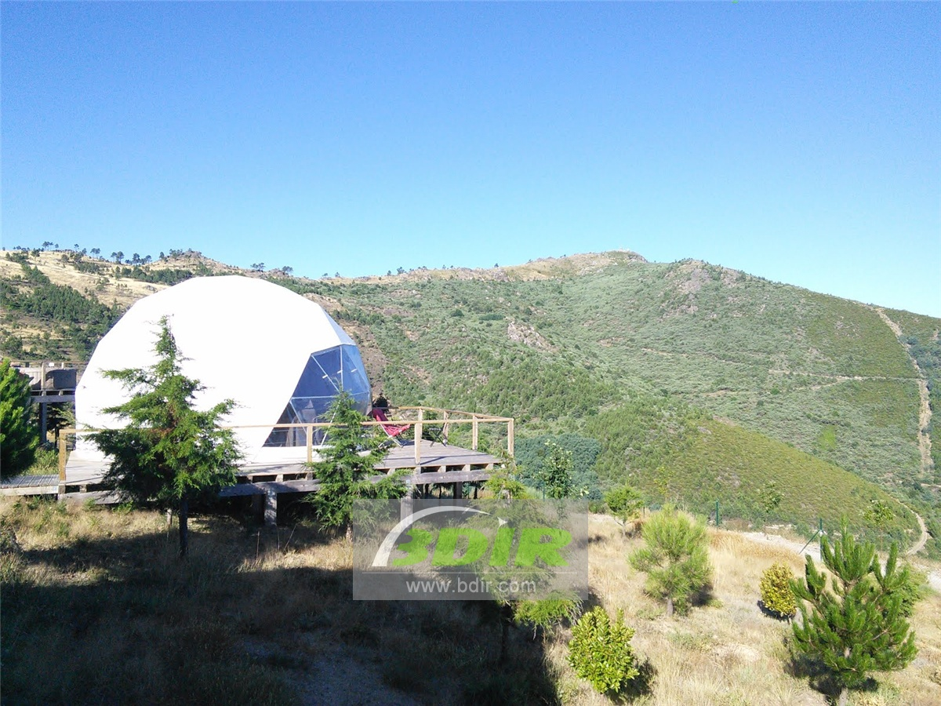
Product specifications:
• Diameter: 4.9 meters or 5.9 meters
• Base area: 20 square meters or 27.5 square meters
• Entrance: H 180cm x W 70cm
• Maximum height: 2.9 meters or 3.65 meters
• Quantity: 8 dome tents
Material:
• 950g/m2 Germany imported white PVC film material, 850 g/m2 Germany imported transparent PVC film material
• Windproof up to 80-100km/h, 100% fire retardant, waterproof and snowproof
• Galvanized steel pipe Q235, diameter 20*1.5mm
• Use stainless steel tube as frame material
• Configure insulation, wood burning stove, curtains
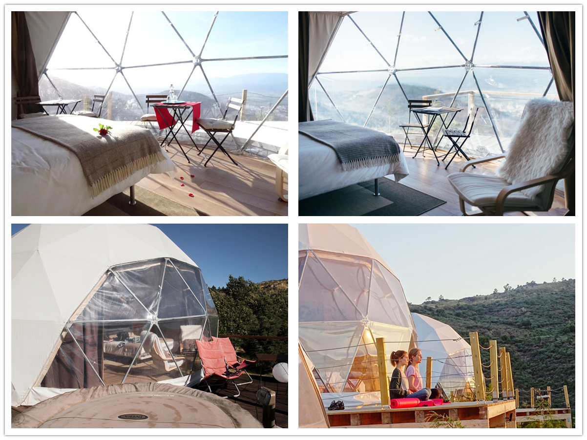
Natural eco tourism is the result of the evolution of social models. Glamping dome home stems from a need to connect uniquely with nature's unique touches and charms and comfortable accommodations to experience a unique and diverse experience.
Located at the sea level at Serra da Gardunha above 925 metres, The Glamping dome hotel is designed to meet the needs of demanding customers, who looks for a truly diverse destination with a diverse, unique experience and culture, and they appreciate the comfort of a refined venue. Guests can respect and directly touch the biodiversity of the area to fully experience nature.
The Glamping's purpose is to respond to the needs of customers who is looking for diversity and experience across the culture, enriching the authenticity of the unique destination of the culture, and also looking forward to a luxurious and comfortable accommodation space. Campers will be able to fully think about and experience nature in all its aspects, , they can respect each other and come into direct contact with the the region's biodiversity, and learn about the region's railways, heritage, food and customs.
The spherical dome tent camp uses modular assembly structure to manufacture structural modules in the factory. During the construction process, the surrounding natural environment is rarely excavated and destroyed, and it can be better integrated into the ecological environment. At the same time, flora and fauna can coexist unrestricted under each structure.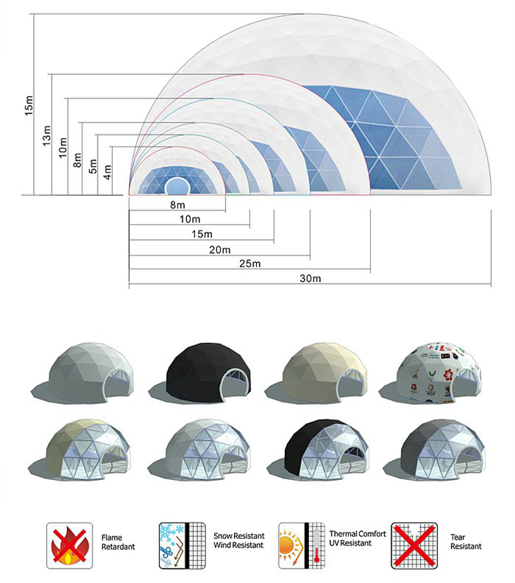
BDiR Inc. is a dome designer and manufacturer, which provides 5m - 100m best quality complete dome tents for living home, glamping tent house, camping pods, greenhouse, branding, product launches, commercial receptions, outdoor concerts and business annual celebrations, festival, performance, trade show booth, corporate events and conferences, product launches and promotions, Art installations, floating domes, igloo and rooftop lounges, movies, private parties, special occasions, etc.

