Experience a Accommodation in a Glamping Dome Cabins, where Luxury Meets Nature
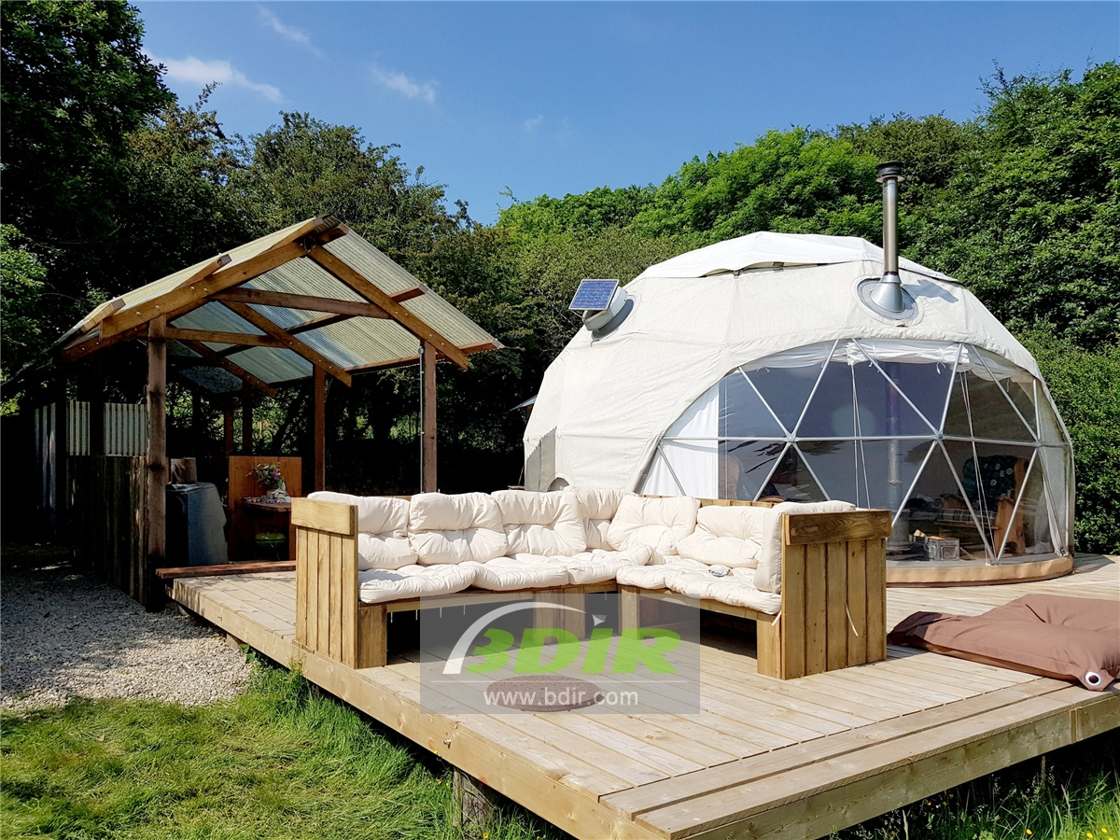
Product specifications:
• Diameter: 3*7 meters
• Base area: 40 square meters
• Entrance: height 180cm x width 70cm
• Maximum height: 3.5 meters
• Quantity: 6 dome tents
Material:
• 950g/m2 Germany imported white PVC film material, 850 g/m2 Germany imported transparent PVC film material
• Windproof up to 80-100km/h, 100% fire retardant, waterproof and snowproof
• Galvanized steel pipe Q235, diameter 20*1.5mm
• Use stainless steel tube as frame material
• Configure insulation, wood burning stove, curtains

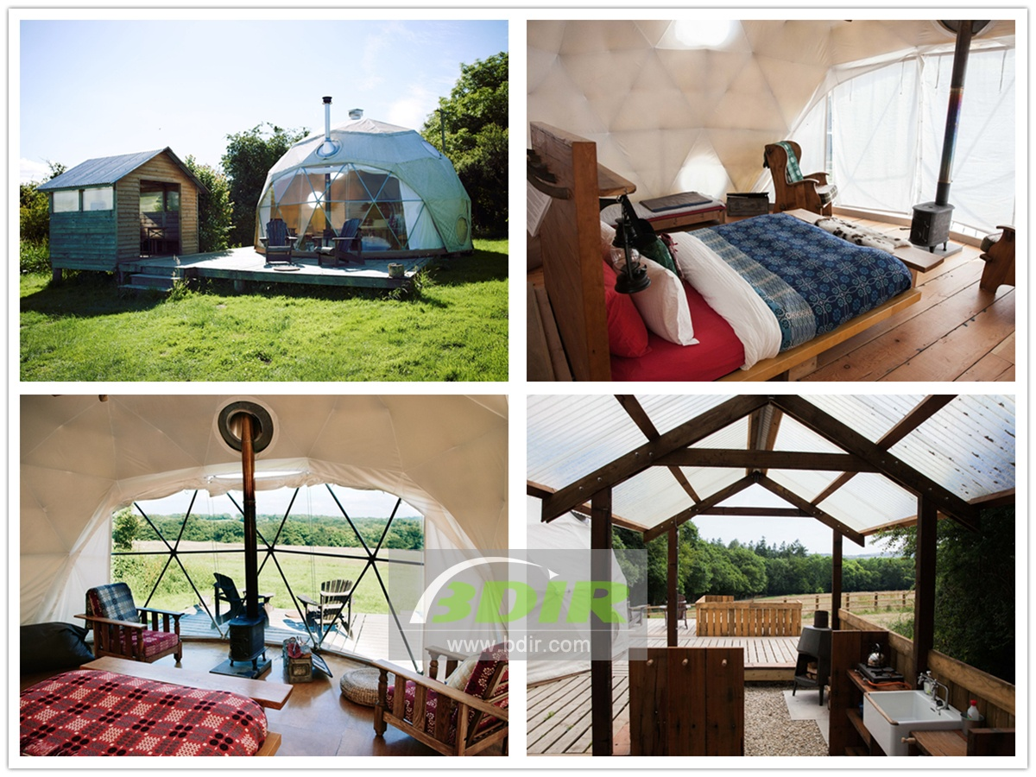
The farm camp has 10 geodesic domed cottages. The luxury geodesic dome cabins is known for its forest, with solid wood floors, wood burning stoves, bespoke furniture and huge bay windows.
Each eco friendly dome tent has unique characteristics, formed by its location and its individualized treatment. But they all have the same level of comfort. This is a perfect romantic getaway with a king-size bed with duvet and pillows, it transforms into a camping dream for every family.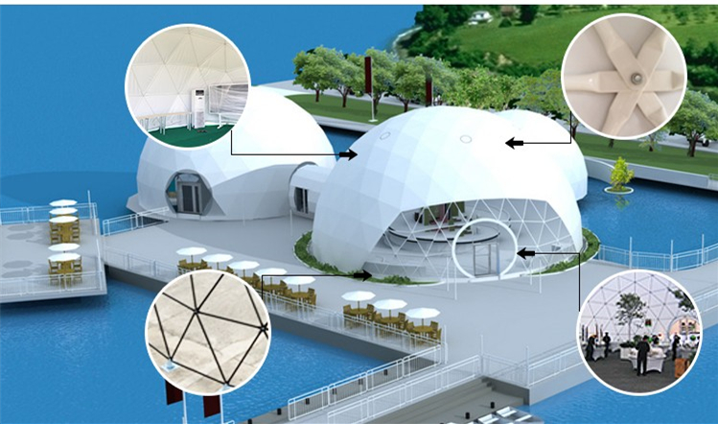
Each eco dome tent can accommodate up to 4 people. Each sustainable dome tent house is carefully planned to ensure an independent feel, whether in a field or woodland environment. The Eco Domes Resort has a comfortable king-size bed and an armchair, perfect for sipping a tea/coffer in front of the wood burning stove.
The outdoor deck of dome room has plenty of space to relax, with a fully equipped all-day camp kitchen and dining area.
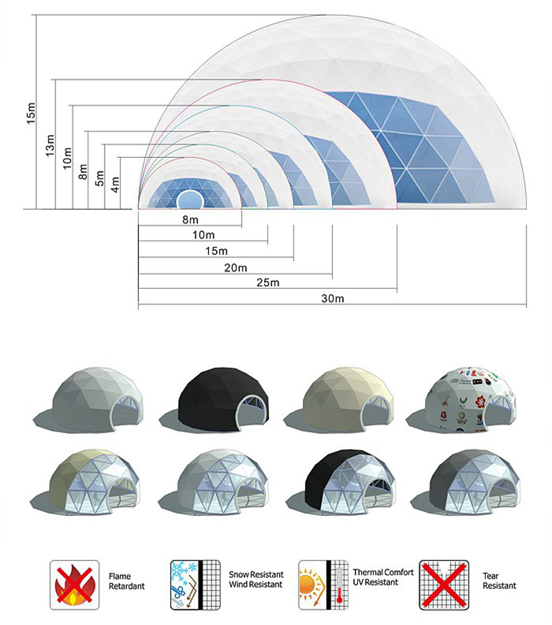
BDiR Inc. is a dome designer and manufacturer, which provides 5m - 100m best quality complete dome tents for living home, glamping tent house, camping pods, greenhouse, branding, product launches, commercial receptions, outdoor concerts and business annual celebrations, festival, performance, trade show booth, corporate events and conferences, product launches and promotions, Art installations, floating domes, igloo and rooftop lounges, movies, private parties, special occasions, etc.
