Camping Tents, Tent Lodge, Tented House – Capella Ubud, Bali, Indonesia
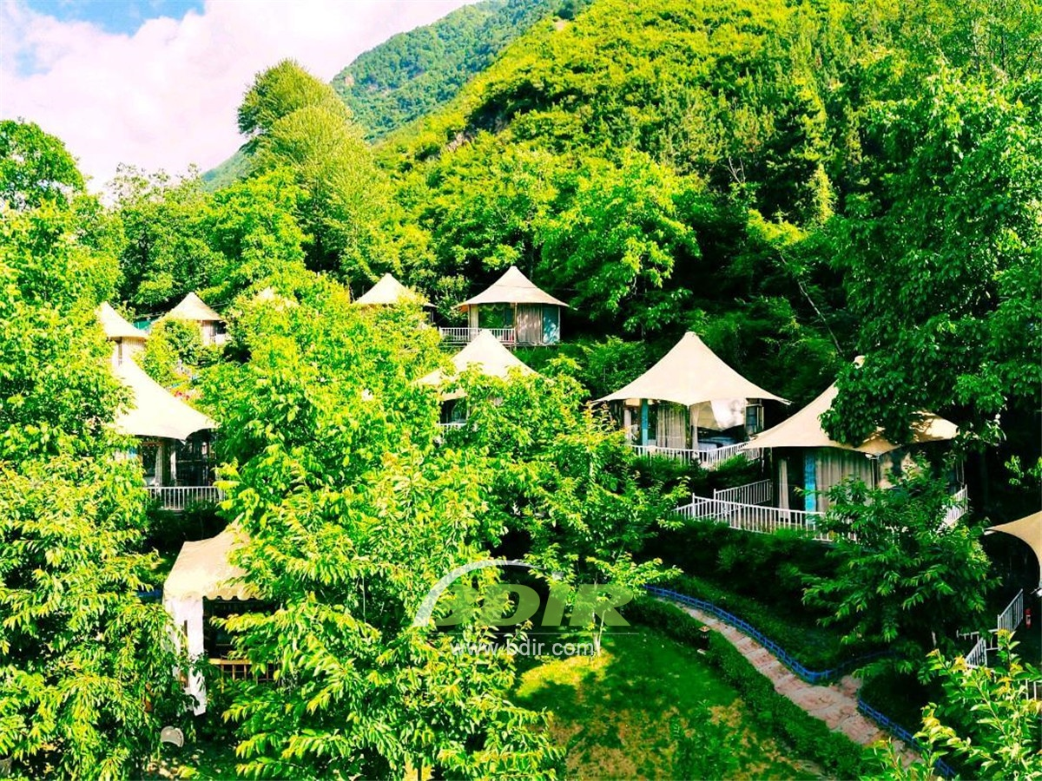
The unique tented camp is situated in the heart of a lush green forest, in harmony with the surrounding natural environment.
This exquisite tented camping site is more than just a hotel. It is built in the bushes,which is hidden in the distance, and captures the imagination of those who seeks a unique experience in the unspoiled natural environment of Bali. The tented camp has twenty-two 173 square meters of one-bedroom tents (tent house) and a 217 square meters of tent cottage (The tented Lodge), each with a private saltwater pool.
5 Terrace Tents: Each Terrace Tent house has Viewing deck and guests can overlook the terraced field and rainforest on the large outdoor deck. The tent deck has the saltwater pool, sun loungers. The interior of tent room is complemented by luxurious modern comforts such as freestanding bathtubs and art and antiques from the owner's private collection.
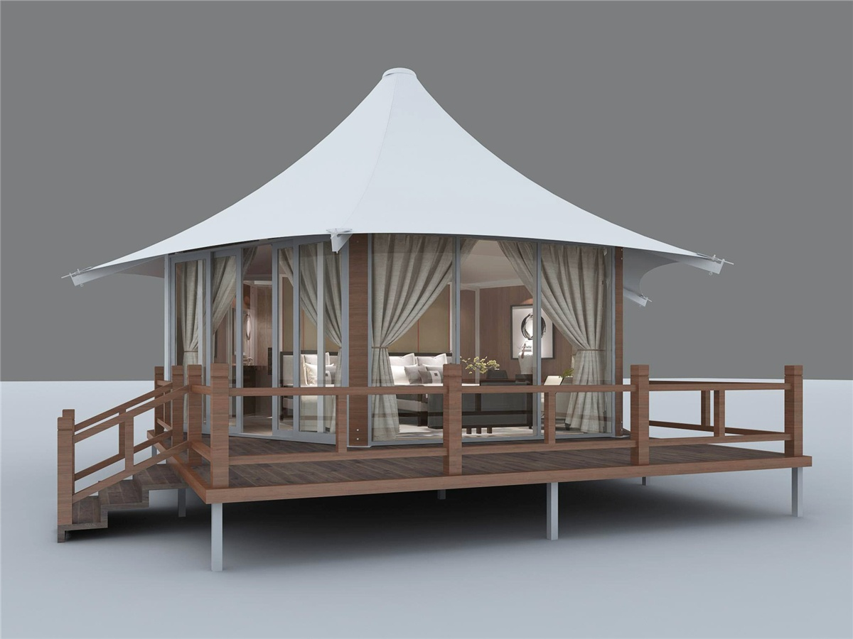
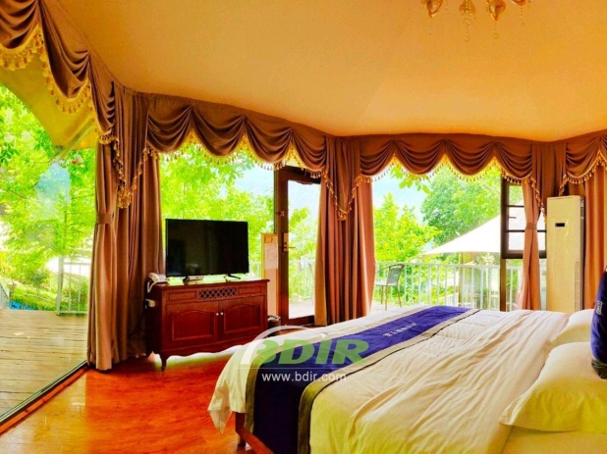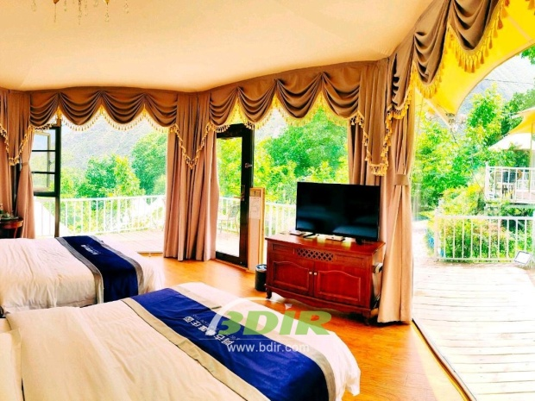
6 rainforest Tents: The rainforest Tent houses are scattered in the rainforest and offer lush surroundings. Some tented cabins are built on sloping terrain. It makes Bali's beautiful natural scenery and the luxurious comfortable accommodation in the tent complement each other.
6 River Tents: River Tents house is a comfortable place to sleep close to nature and water. Each tent room has a unique style inspired by the atmosphere of an early explorer. Each tent room has modern facilities and attentive service, which includes organic bathroom products and a beautiful copper bath.
5 Valley tents: You can lie on the sofa bed or relax on the poolside loungers near the infinity pool. Each Valley tented villa offer views of the beautiful valleys and rainforests. The interior of tent rooms features an explorer-inspired styles and modern comforts to create a private luxury sanctuary.
1 tented Lodge: Featuring an exotic Oriental Chinese color and design, The Lodge is a blend of terraced views. The Lodge offers views of the impressive green Valley, an open-plan living room and a master bedroom with a king-size bed. There is a twin bedroom with 2 double beds. Two bathrooms (one with a Japanese bathtub and the other with a hand-polished copper bathtub) and a large wooden deck with two large sofa beds. A 19 square meter private saltwater pool complements this accommodation, perfect for adventurous small families or wealthy travelers looking for stylish luxury accommodation and tranquillity.
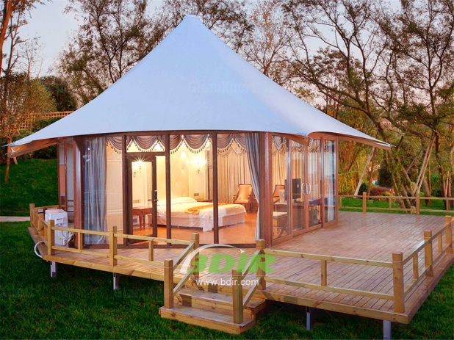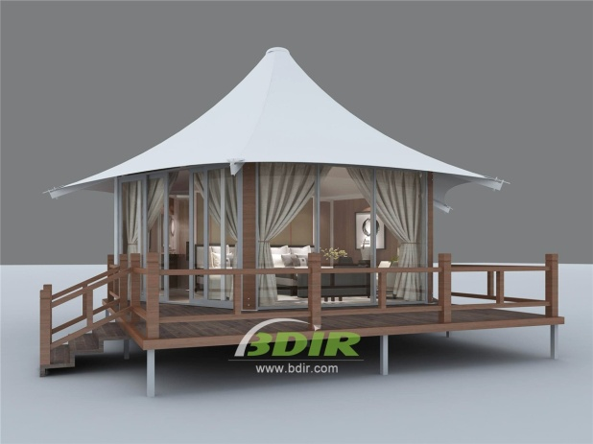
BDiR Inc. Design, manufacture, installation, maintenance Luxury safari tent resort, glamping tents, eco-lodges and resort tents at very reasonable prices. We ship canvas tents worldwide for all purposes. No matter where your tent or camp will be located in - be it on water, rocks, desert, sand, a grassy plain, tropical beach, ice field or in dense rainforest - we will ensure it is built to last.

