Outdoor Hotel Tent, Wild Luxury Resort Tented Cabins - Designer & Manufacturer
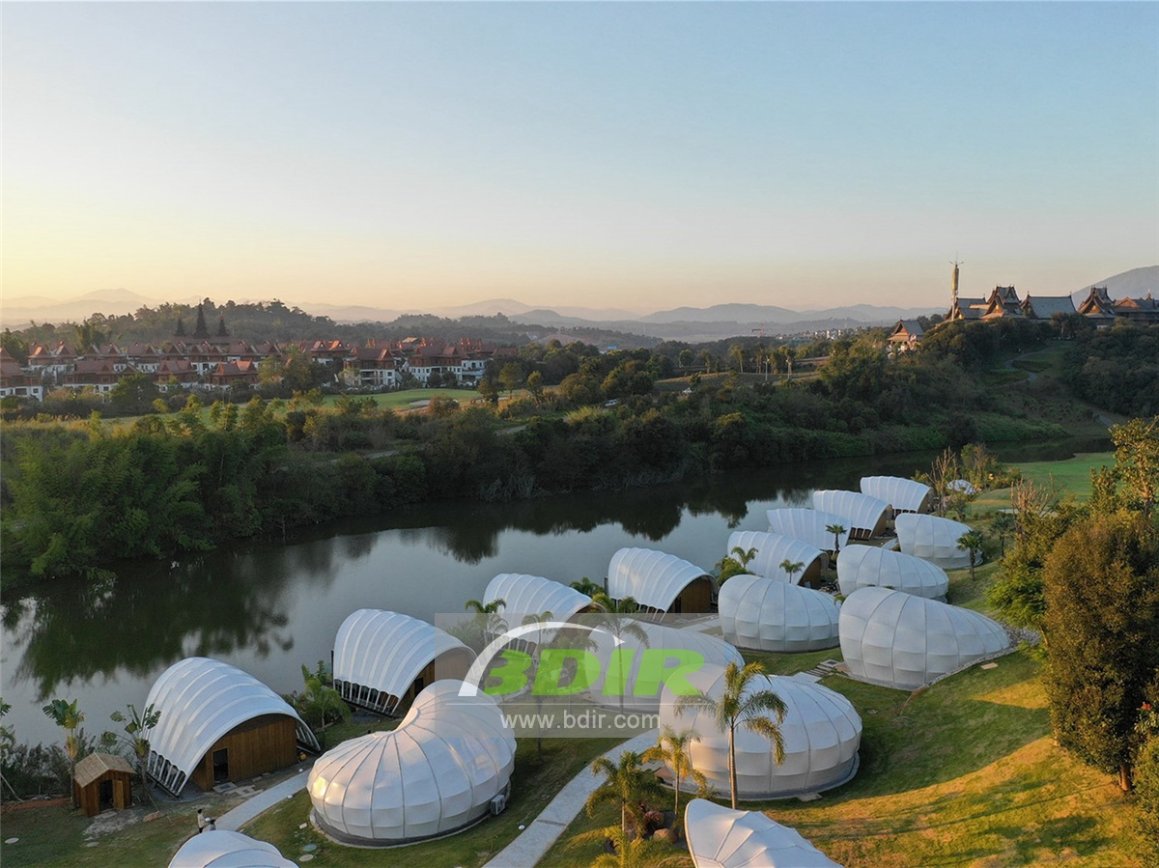
Menghai County is located in the southwest of Yunnan Province and in the west of Xishuangbanna Dai Autonomous Prefecture. It is located between 99°56′-100°41′ east longitude and 21°28′-22°28′ north latitude. It is connected to Jinghong City in the east, Simao City in the northeast, Pixian County in the northwest, and Myanmar in the west and south. Menghai County is the hometown of “Pu'er Tea”, which is famous both at home and abroad, and the earliest place for Chinese tea production. It has a wild “Tea Tree King” 1700 years ago and a group of ancient tea trees. The four seasons are suitable for rice growth and are rich in high-quality rice. It has been called “Southern Granary” since ancient times and is a national grain production base and sugar base.

At the beginning of 2018, BDiR Inc. began to participate in the bidding for the construction of the Kejianzeqi Tent Art Hotel and eventually became its builder. KeJianZeQi Tent Art Hotel is located in the Zhabala Golf Resort Zone, Menghai County, Xishuangbanna Dai Autonomous Prefecture, Yunnan Province. The hotel is currently adjacent to Yuechun Spa and Golf Course. BDiR's architects have transformed into a modern tent hotel building through the agile creatures. The total area of 13,000 square meters, the first phase of the luxury tent hotel is 18 tent houses, two types of "firefly" and "Snail". The second phase of the tent resort has 12 tented cabins "bee & butterfly". The hotel restaurant has a bionic image shape with a building area of 200m2 and has a holiday service function such as front desk, light meal and bar. After the night banquet, the restaurant became a bar, under the tent, it is brilliance, and colorful eyes fascinated people.
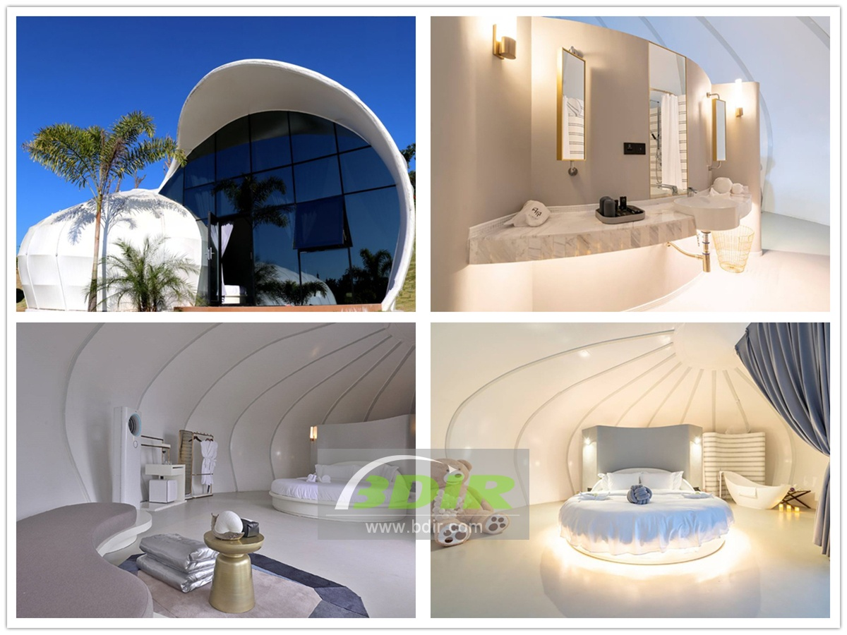
The size of a single tent house ranges from 60-70 square meters. The tent room with large floor-to-ceiling glass window structure, and the tent architectures are perfectly integrated with nature. The tent house are located next to the lake, and the night falls, and the lights are on. Under the tent, there is a light inside. Above the tent, it flashes fluorescent. The "firefly" tent house with a building area of 60 square meters, The space enclosed by the glass curtain wall and the anti-corrosion wood introduces sufficient natural light and also ensures the privacy of the bathroom. The "Snail" shape of the room is like a conch in the palm of your hand. The building area of 70 square meters for garden view room, this scale can accommodate a family.
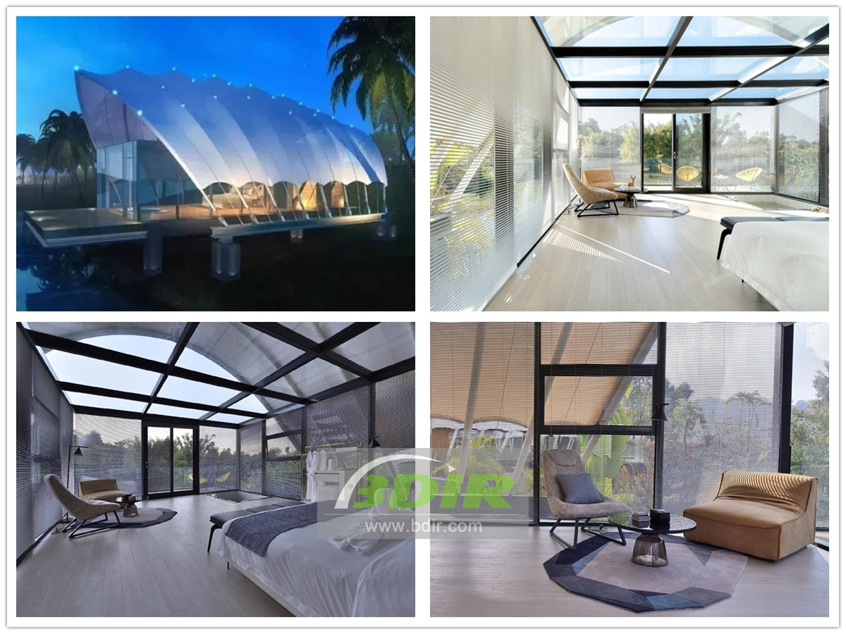

Technical advantages:
The hotel tent uses a membrane structure for the hotel's architectural form. The imported PVDF membrane material and high-strength structural parts (steel frame, steel column or steel cable) generate a certain pre-tensioning force in a certain way to form a special-shaped space shape, so that the bionic image forms a unique conch room.

Reviews:
BDIR's strong technical strength and excellent working attitude which made the building of "Firefly" and "Snail " tent house lifelike! In the design and construction process, not only the communication was smooth, but also they provided us with more professional engineering advice. Make the entire hotel project more perfect!

