Luxury Outdoor Tents Hotel With PVDF Textile Structures Roof Lodges
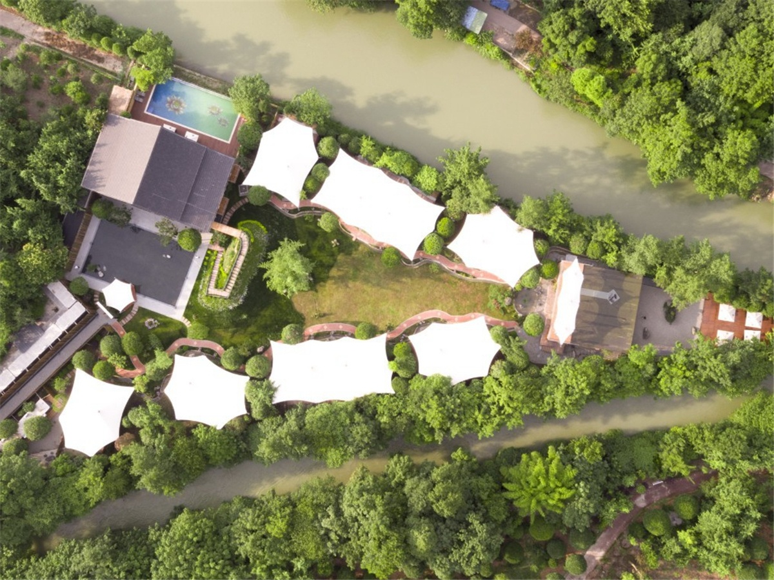
Miaoxi Tent Resort Hotel - the first wild luxury tent hotel in the southwest of china, which is the wild and luxury perfectly blend. Hidden in the green hills of the mountains, and it is surrounded by water, winding path, and one side of the world. The rooms are oversized and scattered along the river bank. You can see the river and the stars. The tent resort was designed by Owen’s Mr huang and built each tent house and tensile membrane awning by BDiR Inc.
The Miaoxi Tent Resort is built along the way,which is hidden between the trees and the river. As a tributary of Dujiangyan was cut and merged by Wulong Island, a triangular "small island" was formed here. The "small island" is located in Shou'an, Wenjiang, near Dujiangyan and Qingcheng Mountain.
19 sets oversized tent rooms which offers you the best sense of enjoyment. The tent rooms are divided into: Superior River View Room, Japanese Suite rooms, Deluxe Tent rooms, and Deluxe Tent Suite rooms. Each of the luxury tent rooms has a different theme color, and with 180 ° floor-to-ceiling glass window, which gives you an unprecedented viewing experience, the outdoor "wild" and the indoor "luxury" contrast.
“Wild” is the natural and natural charm. Even the best artificial landscape will be eclipsed.Living in nature, walking into the nature and interacting with the forest. You can not only enjoy the unpretentious leisure, but also the exploration of nature.
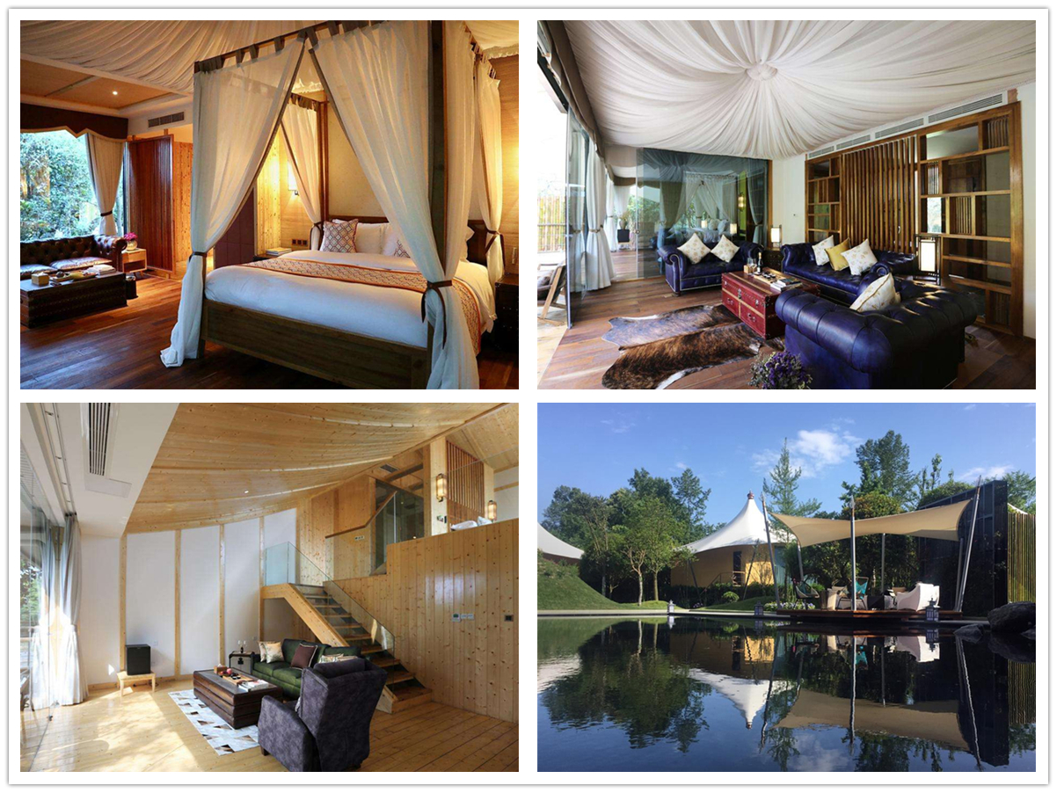
Technical advantages:
How to build a safe and reliable tent house in riverside?
The hotel tents are made of modular steel-wood frame, which can be safely and stably used in different terrains. The outdoor can withstand of level 8-10 winds, which can carry rain and snow, and adapt to the temperature range of -30℃ to 70℃. And the tent hotel uses modular assembly structure to manufacture structural modules in the factory. During the construction process, the surrounding natural environment is rarely excavated and destroyed, and it can be better integrated into the ecological environment.

Reviews:
Mr Huang said: The hotel tent built by BDiR Inc.which is very stable and safe! Communication is very enjoyable during the design and construction process! Many thanks to BDiR Inc. and employees are hard for their work!

