Design Luxury Tent Camping Resorts, Glamping Tented Cabins Supplier
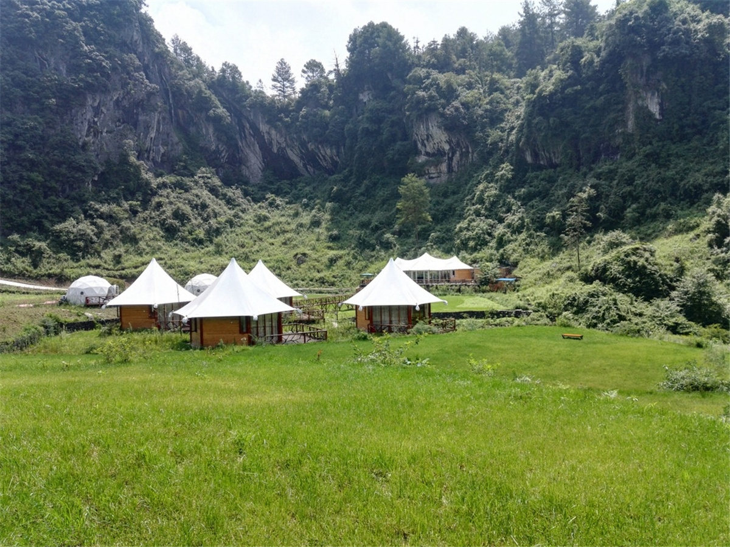
Chongqing Rose Valley Tent Hotel was officially opened in July 2015. The eco friendly hotel is designed and built by BDiR Inc.. The sustainable tent hotel is located in the Rose Valley of the 100-acre scenic spot of the Lijiang River Dam. It is currently the first tent-style hotel in Chongqing. BDiR Inc. designed & built 17 distinctive tent houses according to the scenic terrain. The tent types included tree cabins, phantom house, country villa, Australia lodges and Nordic rooms. The trees in the valley are towering. The colorful roses bloom, and the vines, hedges and stone walls romanticize the entire valley. The white tent hotel is dotted with it. You can here to smell the flowers and enjoying getting up ,sleeping with fragrance. A cup of tea and two light wines are intoxicating. Maybe you forget bustle of the world and integrate with nature. Let the heart be quiet and let the soul be sublimated.

Each tent room is built to the standards of a four-star hotel, which has a large bed room and a separate bathroom. A tree-hanging tent cabins in the jungle - the small moon, which is a spherical tent that is towed by trees and hung in mid-air, and you can see the panoramic view of the Rose Valley inside the tent. The boardwalk outside the Rose Valley Resort reception centre is directly connected to the country tent hotel.
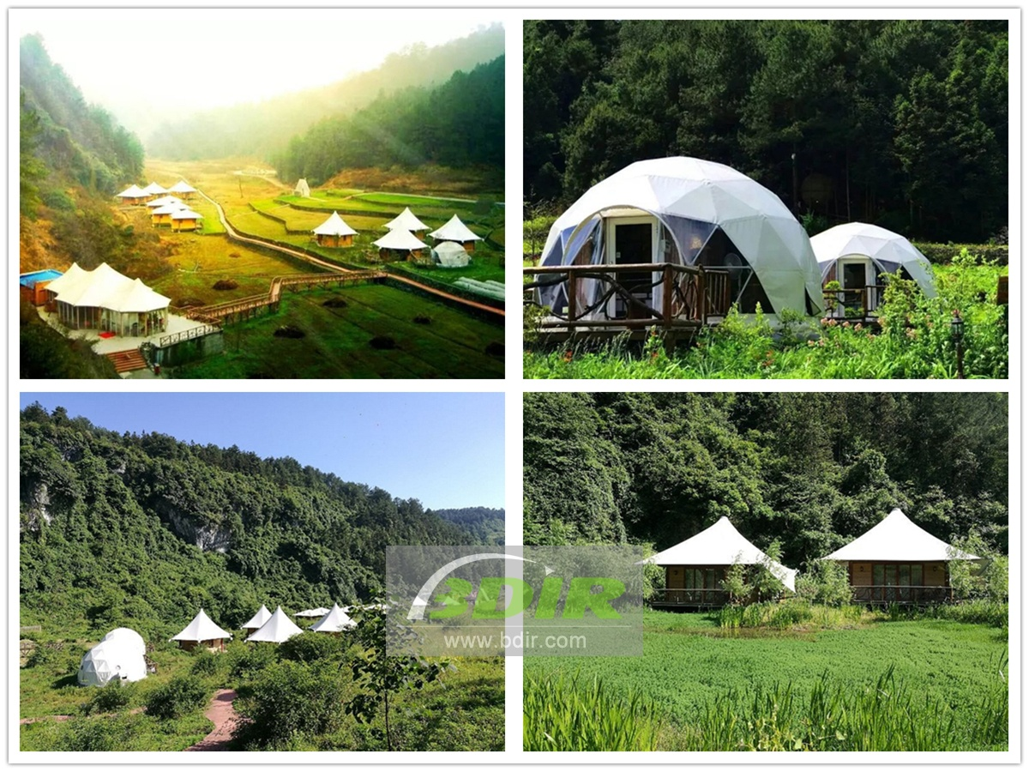

Technical advantages:
The hotel's rooms feature a tensile PVC membrane structural roof that embodies a variety of shapes. The membrane structure is a special modern building structure, which is a space structure with a certain rigidity formed by combining a high-strength flexible film material with a tensioning system. Based on its terrain and environment, we have designed five different styles of tent huts for visitors to choose from.

Reviews:
BDiR Inc. designed and built a variety of membrane structure cabins for me, which gave our customers more choices and experiences! They use imported materials during the construction process while maintaining the ecological beauty that we rely on to survive without being destroyed! BDiR Inc. is an expert in the design and construction of an ecological tent cottage!

