Best Permanent Camping Cabins Tent Hotel, Luxury Conch Tented Lodges
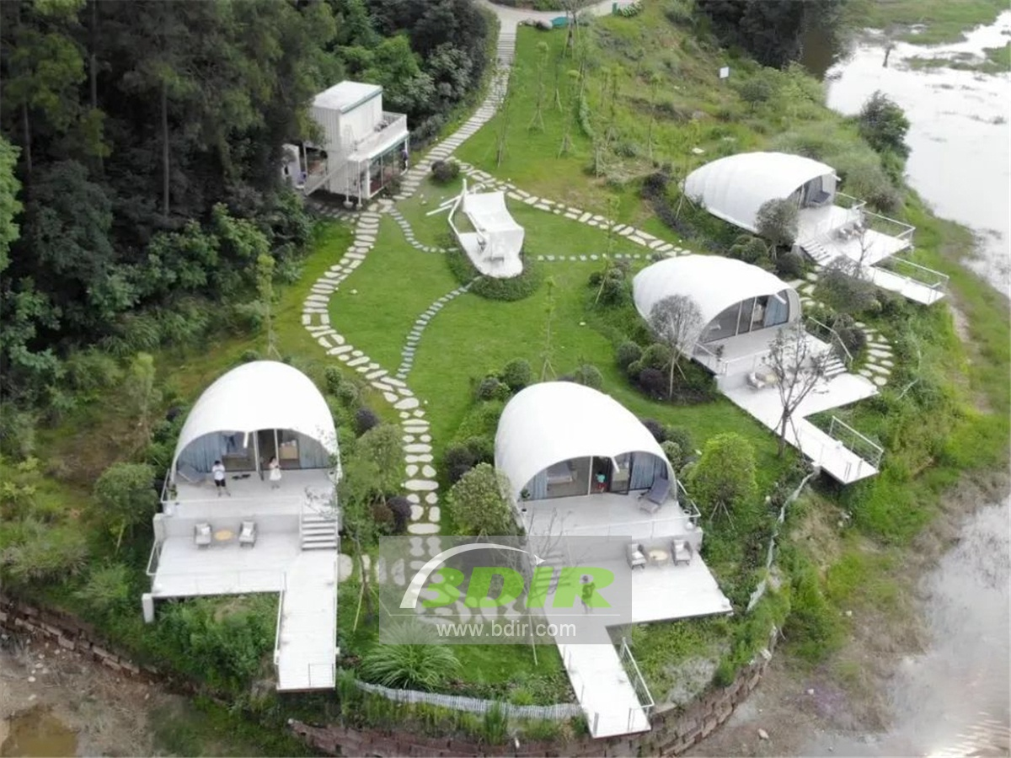
In March 2018, three self-driving tourism enthusiasts found BDiR Inc. And they wanted to build a specially tent hotel camp. Our shell style hotel tent just meets their requirements (environmentally friendly, energy-efficient, non-destructive, comfortable and close to nature). The MinYaoLi hotel tent was built and officially welcomed the guests in May. The three founders of the MinYaoLi Hotel like to travel by car, because they are more interested in nature than the traditional hotels. They decided to introduce a special hotel: environmental protection and energy saving, not destroying the land, comfortable and close to nature. MinYaoLi Luxury Tent Hotel is located in the 4A-class Shixiang Lake, 2000 acres of Lake view, 95% of the Primeval Masson pine forest and other natural environments, which are blended with nature.

4 Shell Style Tent Cabins: Each tent house with Half of tent which is pure white comfortable room, half are open-air Observation deck. The tent cabins with large floor-to-ceiling glass windows are well lit. We can enjoy the pleasant sunshine on the lounge. This shell-shaped tent house roofing is made of PVDF and is fire-resistant and safe. Each room has a vertical air conditioner. The white gauze on the bed which makes the whole room gentle, and every space is reasonably used, and with a layered feel, but not crowded.

The hotel tent room has a privacy of 100%, each of tent which is independent. The tent hotel is surrounded by mountains and has a beautiful environment. Every tent cabins has medium size, excellent area planning, superb hardware, minimalist Nordic style, separate bathtub and terrace, smart home system (lights, curtains, air conditioning, music).
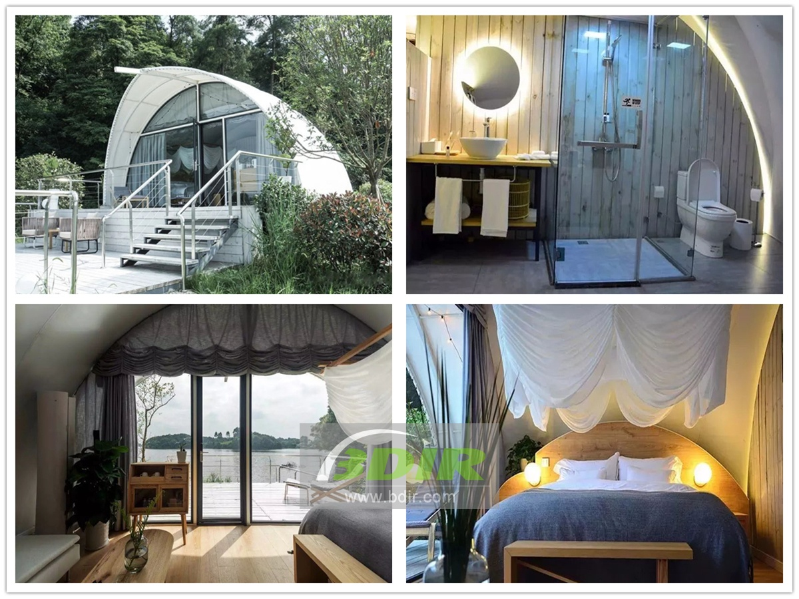

Technical advantages:
The shell style hotel tent design can create a feeling of integration with nature. Because the tent has a transparent PVDF roof, the visitors can lie on the bed covered with quilts and see the stars all over the sky. Most of the tents have deck balconies, which fully consider the natural ecological environment and the perfect protection of flowers and grasses.

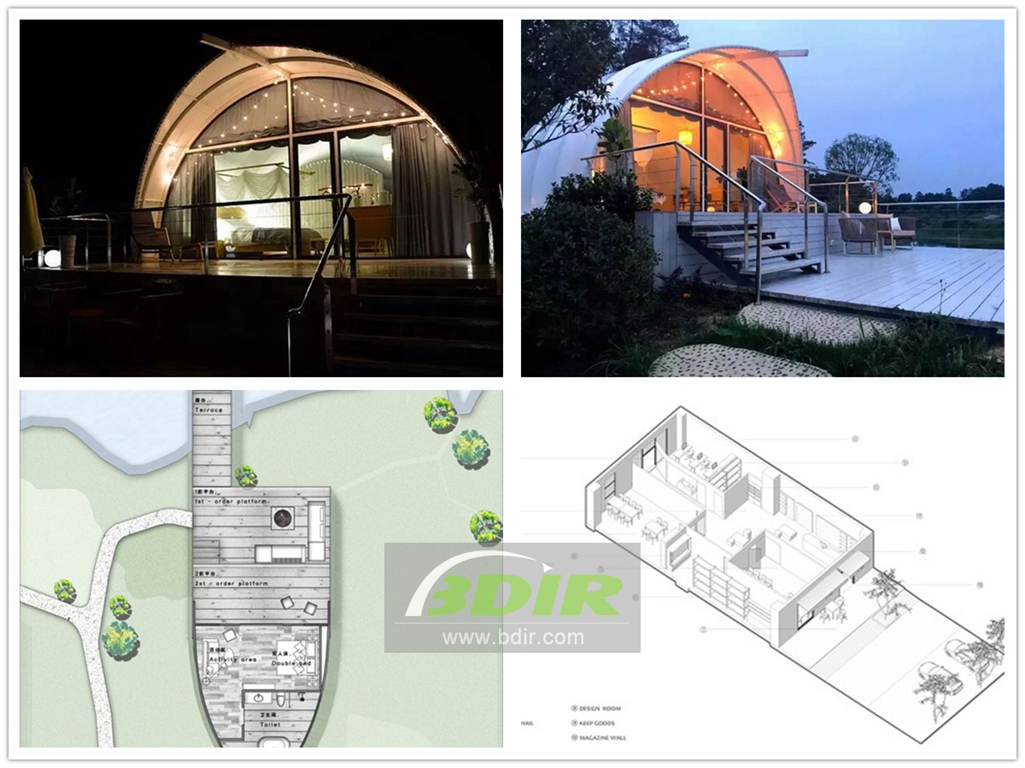

Reviews:
One of the three founders, said: BDiR Inc. Has fully realized our expectations. The shell tent hotel is very environmentally friendly and energy-saving. It does not destroy the land during the construction process. The interior decoration is comfortable. When you walk out of the tent, you can feel the closeness of nature. Thanks to BDiR Inc. for your efforts!

