Tented Lodge, Cocoon Lodges, Tented Yala Accommodation
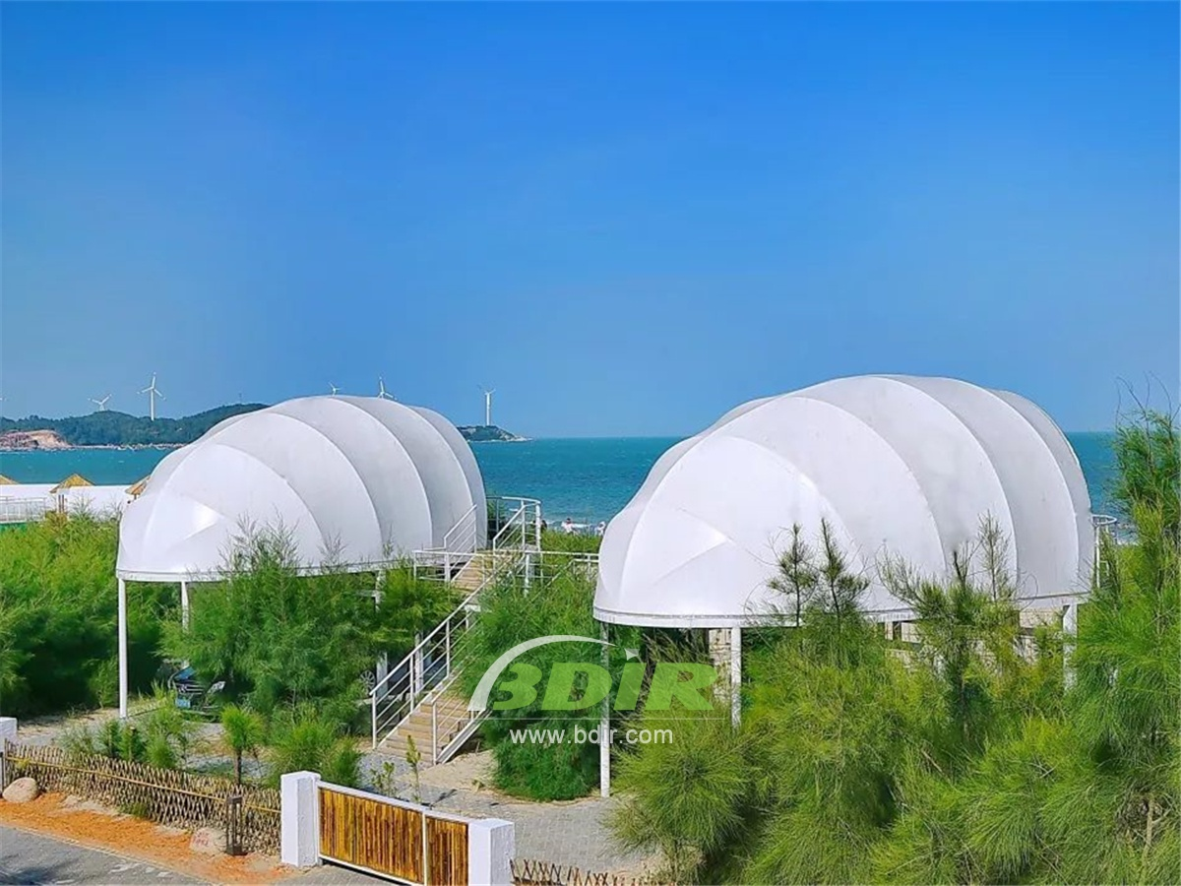
This spectacular luxury tent camp is located in an excellent location, and the jungle echoes the rugged open beach overlooking the Ocean. Our main building is made of bamboo and blends with unique rock formations. Our uniquely shaped tent cabins, called Cocoons tented villas, truly represents the luxury five-star resort under the canvas membrane, offering state-of-the-art amenities, including air conditioning.
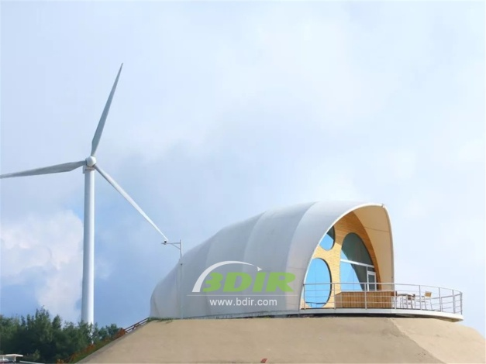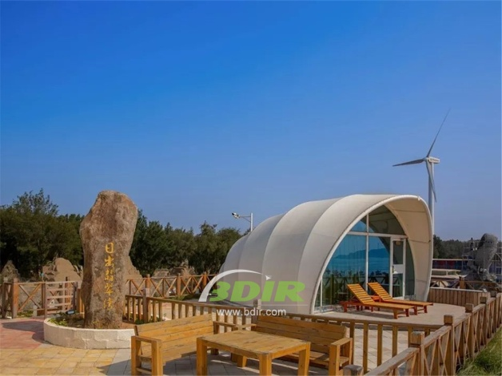
The 55-square-metre Cocoons tent lodge have soaring vaulted ceilings and views of the jungle from the double-glazed façade. The interior design combines fashion colonial-style and modern design innovation, from a separate handmade copper bathtub to a luxurious four-poster bed. Teak floors and canvas walls complement the dark leather touch and redesigned metal fittings to create an eclectic design aesthetic. Cocoons & Urchins offers air conditioning, hot and cold running water, teak floors, Wi-Fi, mini bar, streaming audio.
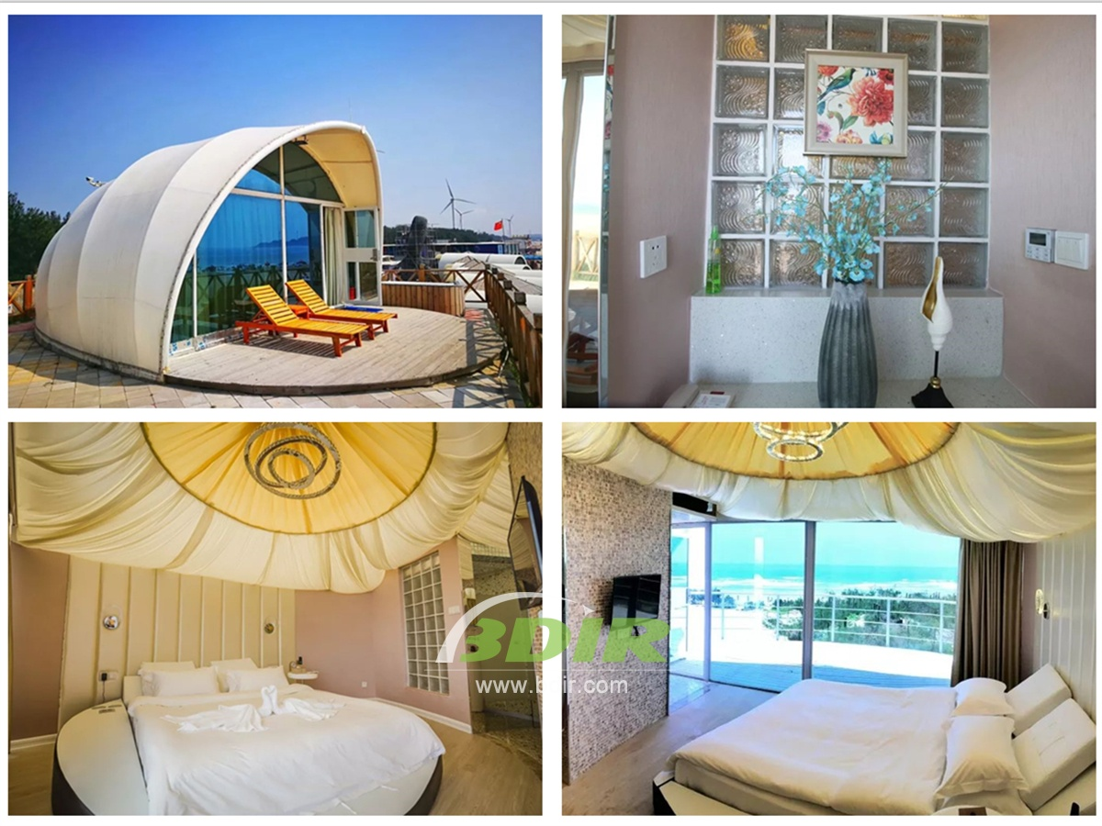
BDiR Inc. Design, manufacture, installation, maintenance Luxury safari tent resort, glamping tents, eco-lodges and resort tents at very reasonable prices. We ship canvas tents worldwide for all purposes. No matter where your tent or camp will be located in - be it on water, rocks, desert, sand, a grassy plain, tropical beach, ice field or in dense rainforest - we will ensure it is built to last.

