Sri Lanka Ceylon Tea Trails Garden Luxury ECO Friendly Tent Resort
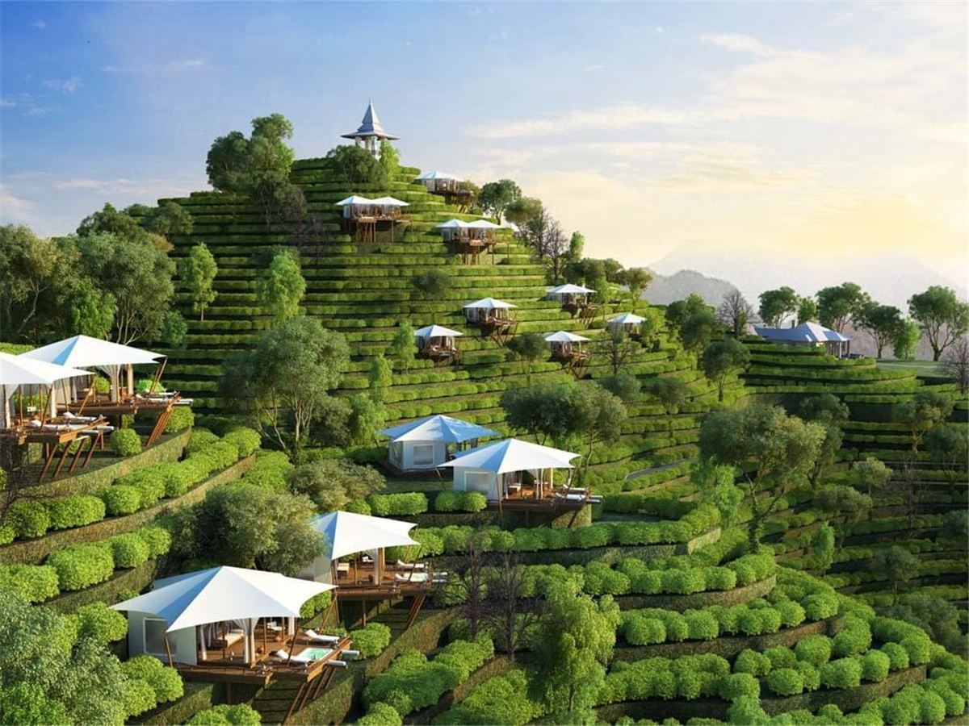
Here is the hometown of the prestigious Ceylon black tea. There are not only sweet and fragrant black tea, but also fresh and oxygen-rich air. The mountain town of Nuwara Eliya and Ella has become a destination for many foreigners to spend their holidays. The dense jungle,which meanders streams and majestic mountains to make for a comfortable and pleasant environment that can make people who live in the city for a long time. Return to nature, blend in with nature, and love nature.
Ceylon Tea Trails tent resort is a new concept in a luxury camp experience that combines world-class design to protect threatened tea gardens, as well as provides a leisure resort for people who has been living in the city for a long time.
The tent house hidden in the landscape, a green NUWARA ELIYA tea garden, a wild white-white tent house. . . In the tent resort, you can experience more than that. In the tent room, the umbrella-shaped ceiling on the tent building makes people feel a wind blowing on the top.When wandering in the tent,you feel like playing in the rural fields as a child, it is all the fresh air of nature.
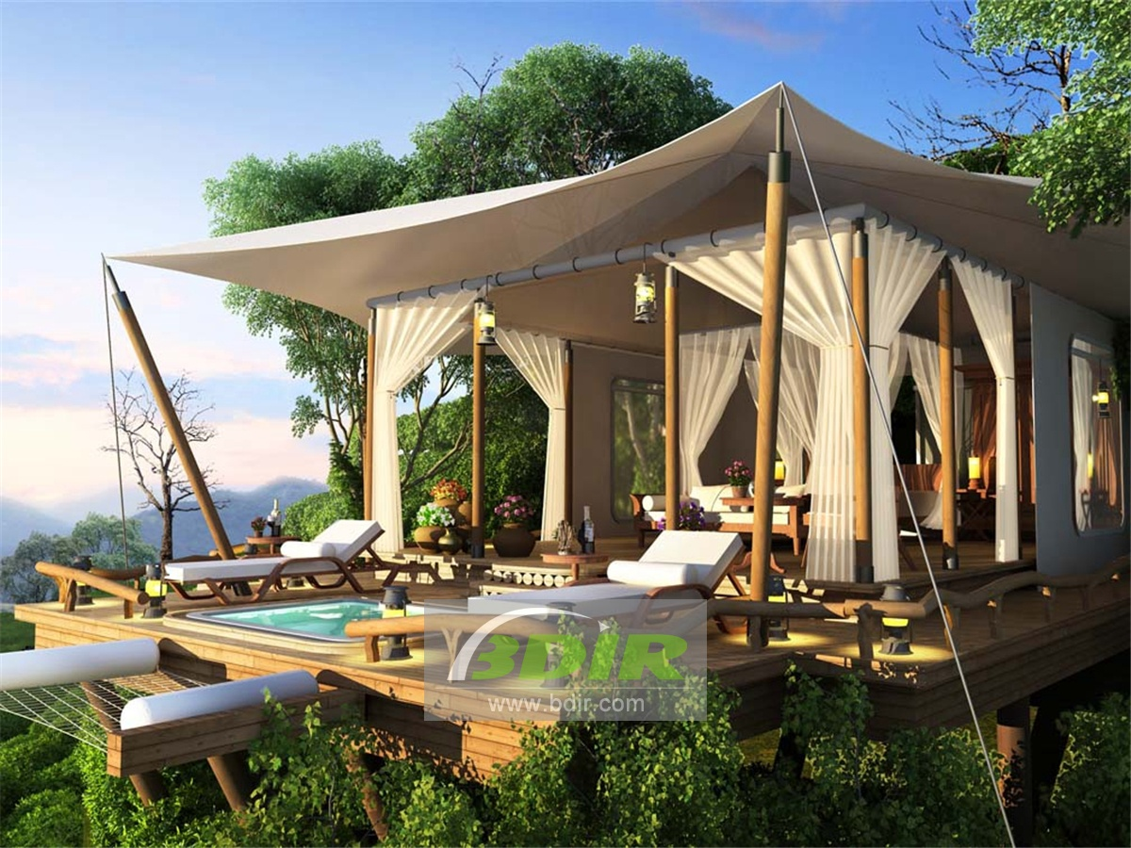
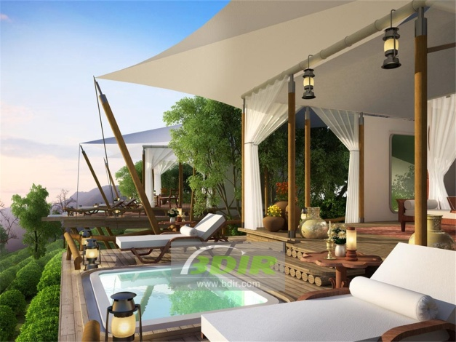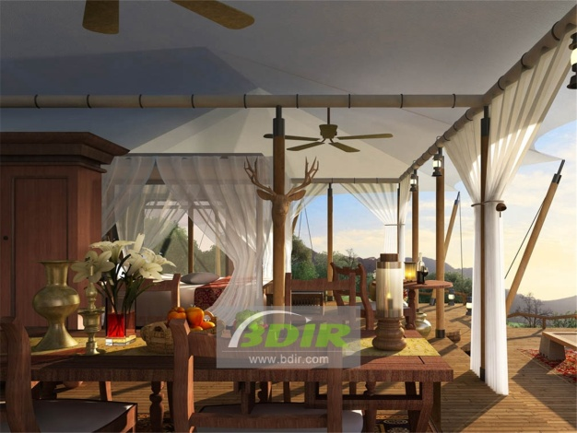
BDiR Inc. Design, manufacture, installation, maintenance Luxury safari tent resort, glamping tents, eco-lodges and resort tents at very reasonable prices. We ship canvas tents worldwide for all purposes. No matter where your tent or camp will be located in - be it on water, rocks, desert, sand, a grassy plain, tropical beach, ice field or in dense rainforest - we will ensure it is built to last.

