Eco-friendly Forest Tented Camp with Sustainable Structure Tent Cabins
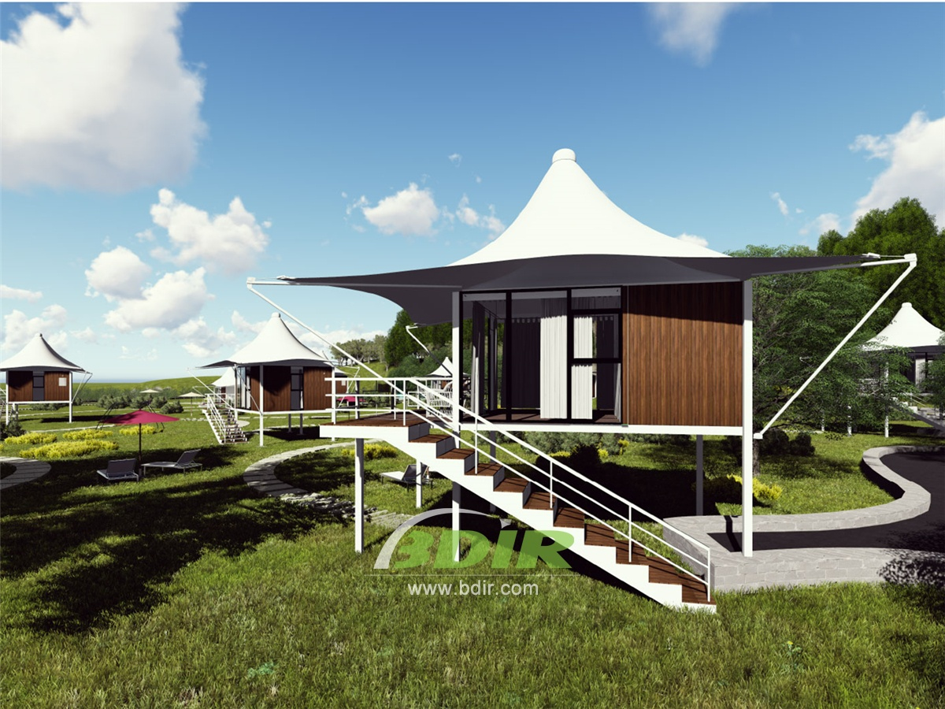
The Tent Resort is a new concept in the experience of a forest luxury camp. Combining world-class design, hospitality and protection, it creates a new model for public/private partnerships that not only protects threatened wasteland, but also creates New and traditionally sustainable opportunities for people who call these land homes.
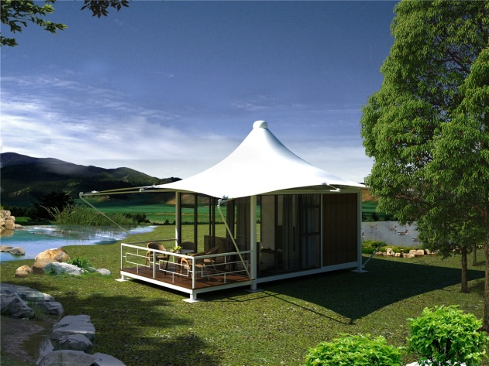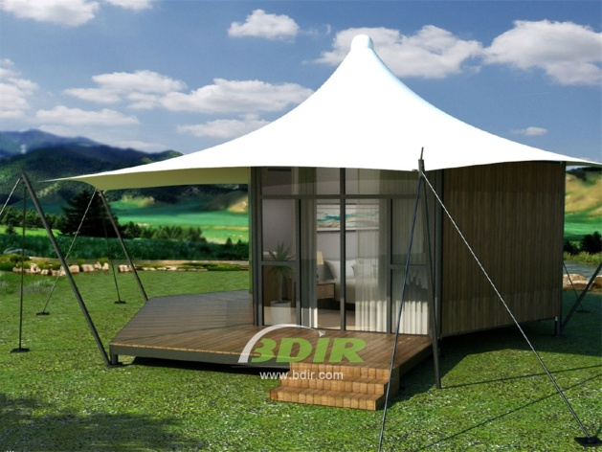
Each of the luxury tents is the first and most eye-catching thing, they are vintage fans and old world boxes, irresistible vintage decoration of lamps and books, all of which are carefully arranged through a tent room, and with more than 1,000's spacious floor plan with square feet. The entire dotted with hand-carved ornaments, candles, trinkets and kitsch clocks, although stylish and memorable, those are all fun. Dark wood floors, sofas, king size beds and own the outdoor decks of the roll-top bath are impressive with extra amenities; it's hard to forget the luxury accommodation of the Forest Tent Hotel Resort, which is actually located in the heart of the rainforest wilderness, such as its style and standards. Deep Forest Tent Resort has endless opportunities for wildlife viewing and outdoor travel.
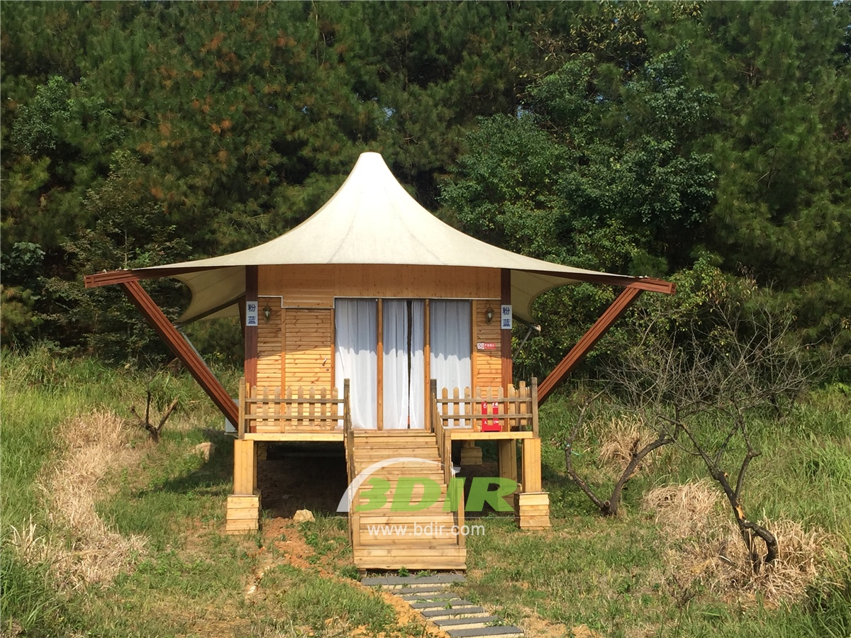
BDiR Inc. Design, manufacture, installation, maintenance Luxury safari tent resort, glamping tents, eco-lodges and resort tents at very reasonable prices. We ship canvas tents worldwide for all purposes. No matter where your tent or camp will be located in - be it on water, rocks, desert, sand, a grassy plain, tropical beach, ice field or in dense rainforest - we will ensure it is built to last.

