Luxury safari tents, Glamping Tents, Hotel Tents, Tent House
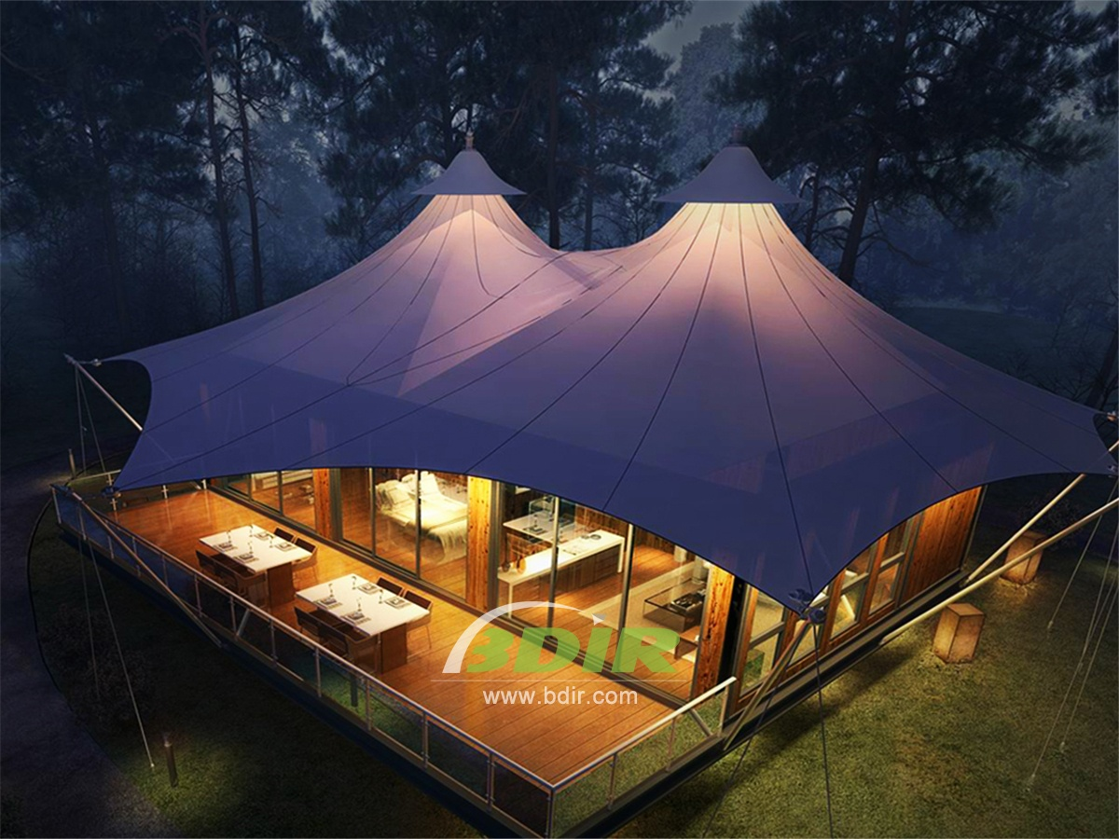
The glamour camping tented resort is the cultural center of the island and the most sought after destination in the tourism industry. Immersed in the corner of paradise, the green rice fields create a unique landscape made up of winding terraces. The luxury Glamping tent hotel offers an unusual and refined environment and Italian style, which combines with Eastern and Western details to create a refined, luxurious and enchanting Accommodation experience.
Staying at the tented Hotel means trying to blend in with the Original ecology natural environment. The Glamping tent hotel offers a unique hospitality to a small number of guests to ensure that the tent house in the rice fields makes it a very fascinating, privacial and serenity place. It has 5 luxurious eco-designed tent structures surrounded by lush greenery. It allows you to experience the exoticism of an unspoiled place, not only enjoying the privilege of engaging with nature, but also providing excellent comfort in an environment of exquisite luxury.
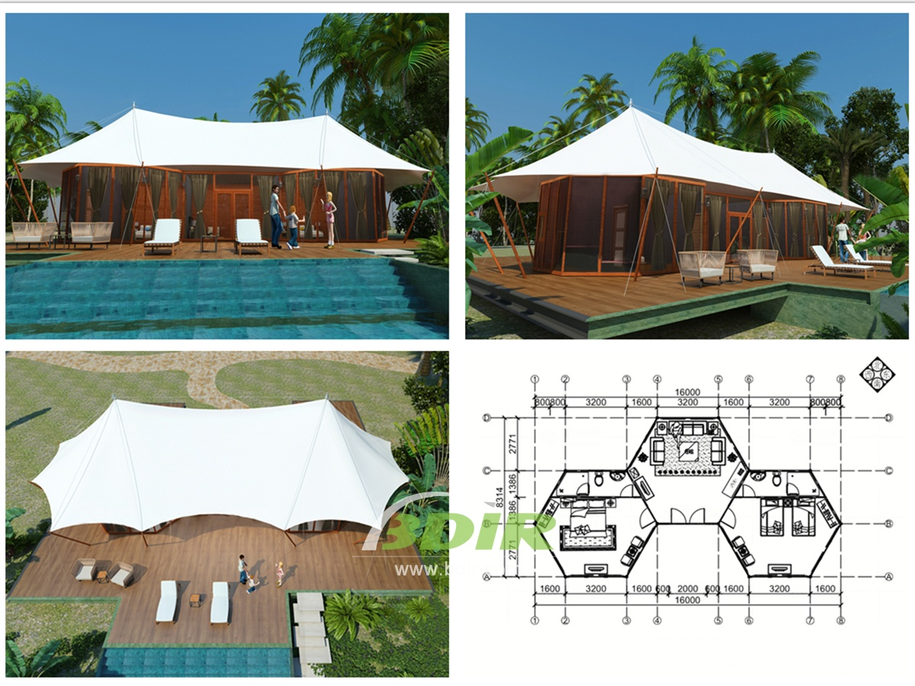
Five gorgeous luxury tents house in a "safari" style of 40 square meters, each tent villa with a private pool overlooking the forest, surrounded by tropical gardens and spectacular indoor bathrooms.
BDiR Inc. Design, manufacture, installation, maintenance Luxury safari tent resort, glamping tents, eco-lodges and resort tents at very reasonable prices. We ship canvas tents worldwide for all purposes. No matter where your tent or camp will be located in - be it on water, rocks, desert, sand, a grassy plain, tropical beach, ice field or in dense rainforest - we will ensure it is built to last.

