Luxury Sustainable Hospitality Rainforest Resort with Tent Pool Villas – Thailand
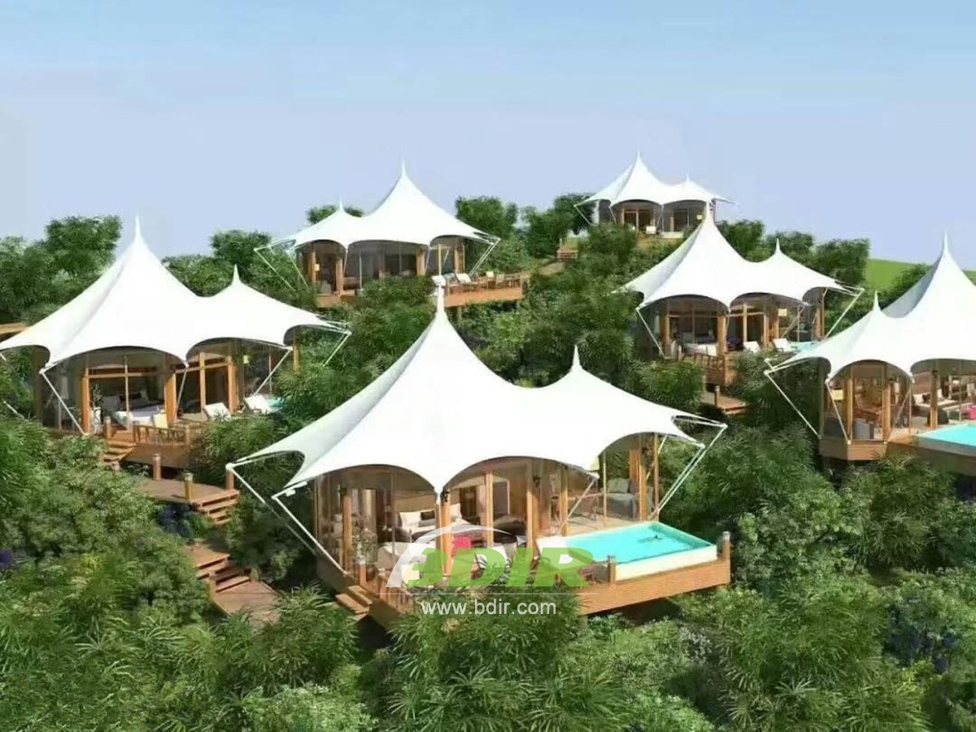
The tent pool villa is inspired by the nomadic life of the Khon-Jorn clan and features a master bedroom with a view. The Khon-Jorn clan is an adventure group consisting of hunters, herders, performers, businessmen and explorers. They spend time in trading goods with other tribes who they encounter on the way. Because of their nomadic style, they prefer to build semi-permanent tent homes so they can move forward easily, so we offers them with our seven one-bedroom tent villas with outdoor swimming pool.
In the tent house, you will find inspiration from the interior of the wildlife and choose materials to highlight their lifestyle. Offering views of the rainforest and resort, the tented villa features a spacious bathroom with monsoon shower, outdoor shower and separate bathtub. The villa is 140 Sqm in size and includes a swimming pool and outdoor recreation area.

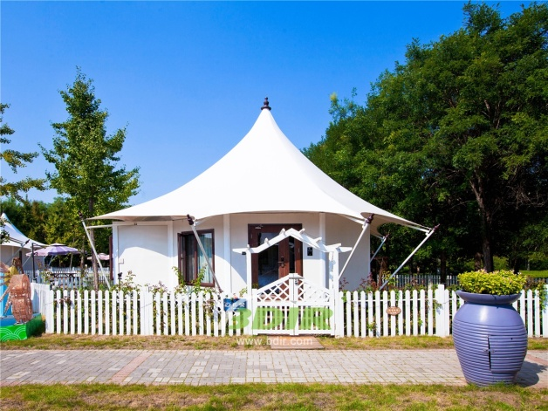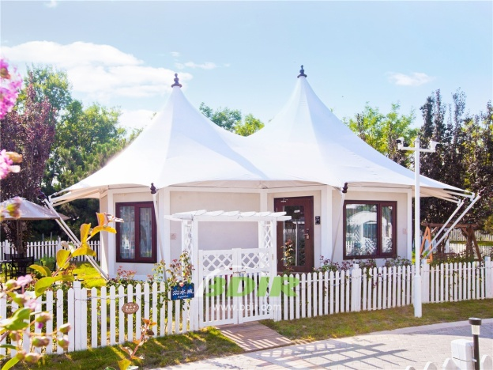
Keemala Villas offers the comforts of home to make your stay as relaxing as possible. The extra-large beds have luxurious soft cotton sheets to ensure a comfortable night's sleep, and all tent cabins are temperature controlled.
- partial sea view and forest landscape
- A cool outdoor living area, perfect for relaxing
- Cool swimming pool
- Great for couples and those who enjoy camp
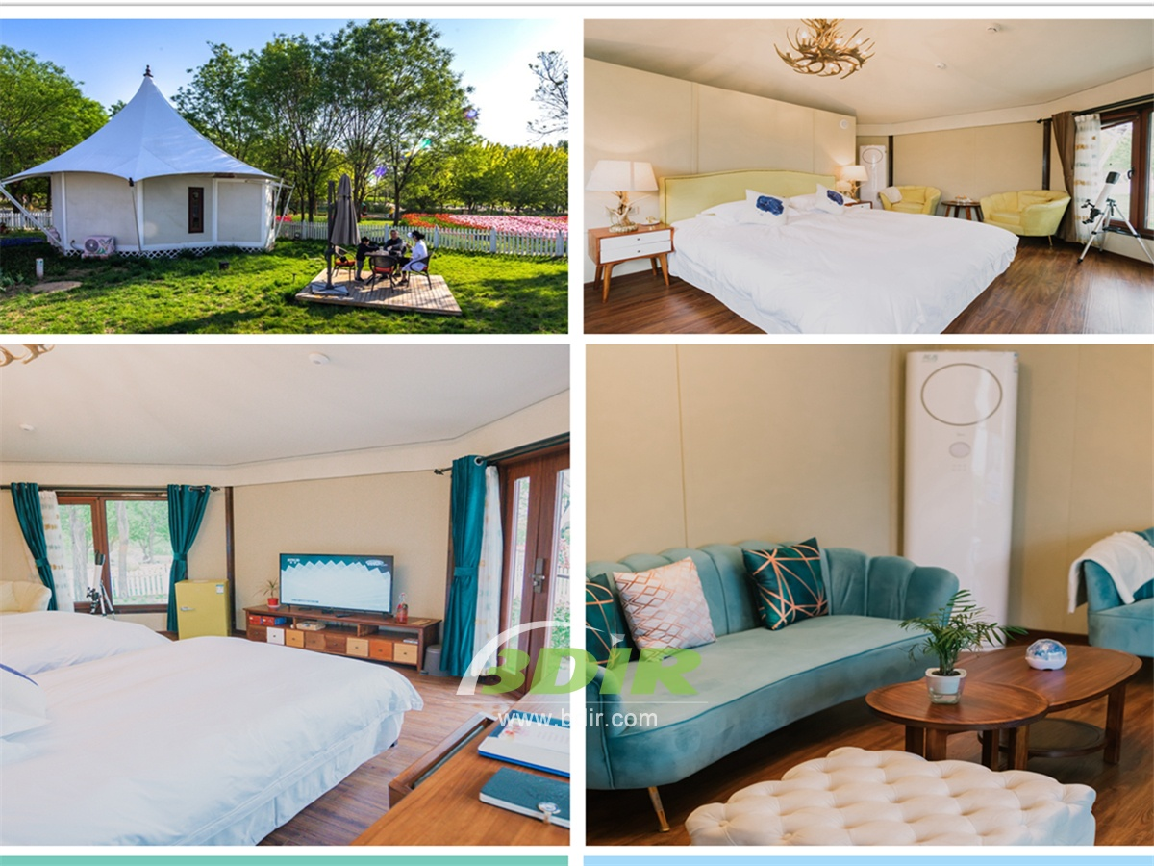
We offer wide range of Luxury canvas safari tents, glamping tents, eco-lodges and resort tents at very reasonable prices. We ship canvas tents worldwide for all purposes. No matter where your tent or camp will be located in - be it on water, rocks, desert, sand, a grassy plain, tropical beach, ice field or in dense rainforest - we will ensure it is built to last.

