Immersive Dome, 360 Projection Dome, 3d Projection, Geodesic Domes Tent
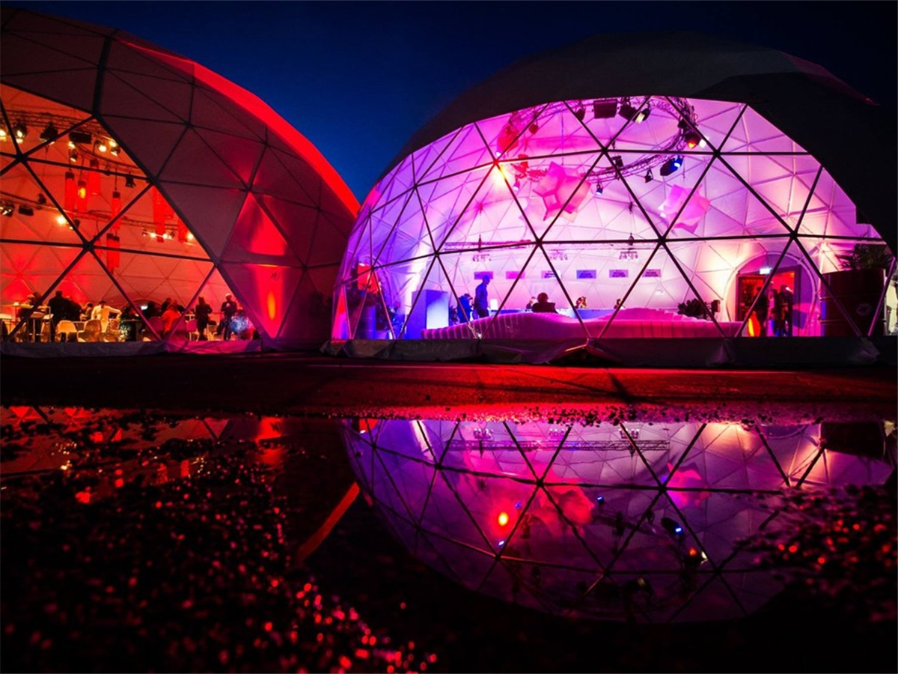
BDiR Inc. offers a all-in-one solution for ultimate virtual reality experience on your event that lets utilize the power of video to grab people’s attention and pique their curiosity. High-quality immersive video projections covering the entire membrane surface inside the dome are something that will take your guests to a different reality. The traditional cinema cannot reach the wishes of the guests who wants to have more fun during watching film. Shelter 360 projection dome tent can help you create the special venue for 4D immersive film. Without using any 4D glasses, the guests can enjoy the 4-degree screen under dome structure.
With this kind of projection on the inside of a geodesic tent, the viewer is literally thrown into another dimension. By using a special technology that combines the image from several projectors into one full display, the viewer is immersed in a space surrounding them from all sides. With added multi-channel surround sound, the spherical projection feels like much more than a multimedia show.
Key Features of Immersive Entertainment Dome
1. Available in a variety of sizes
From 6 meters (22 feet) diameter with capacity of 45 standing people, for boutique events, up to 80 meters (262 feet) diameter with capacity of 5,000 standing people, for all kinds of large-scale events. Larger and customized sizes can also be made to special order.
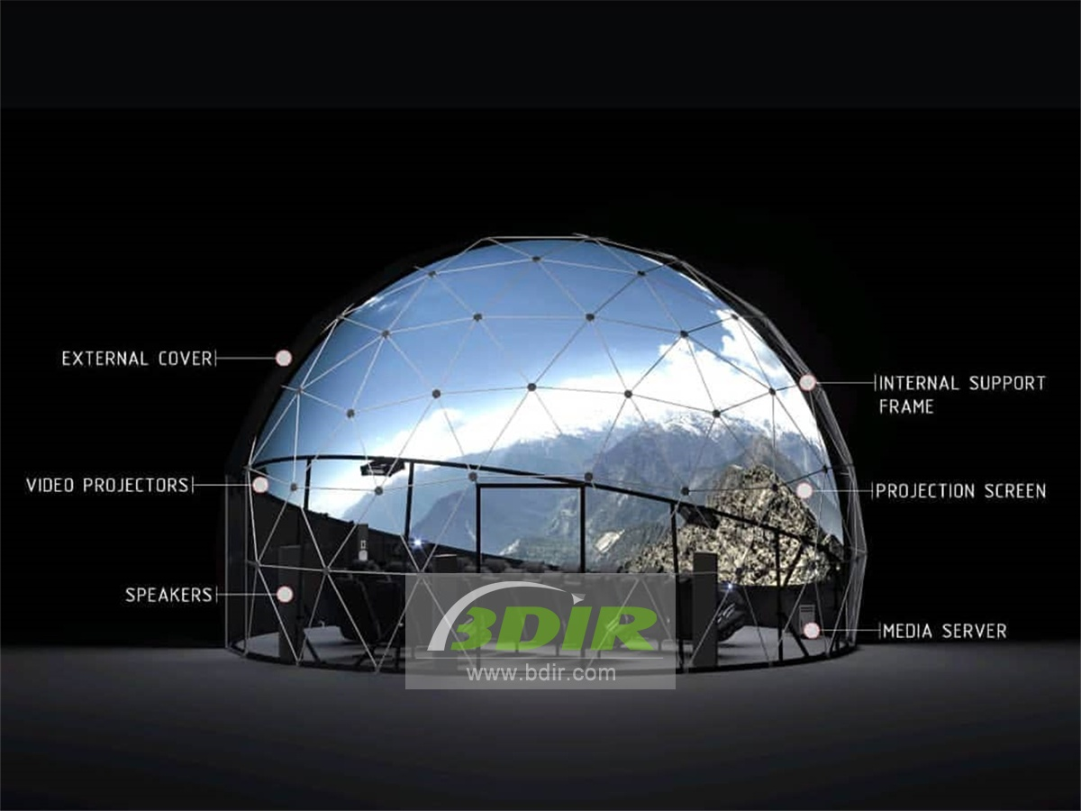
2. Portable & Durable
An immersive dome offers the lightest and strongest structure for a given size, making them highly portable and easily transportable. The dome frame and dome cover can be packed down into cases for easy transport. Though the dome tent is a lightweight structure, it’s durable to withstand in almost any weather.
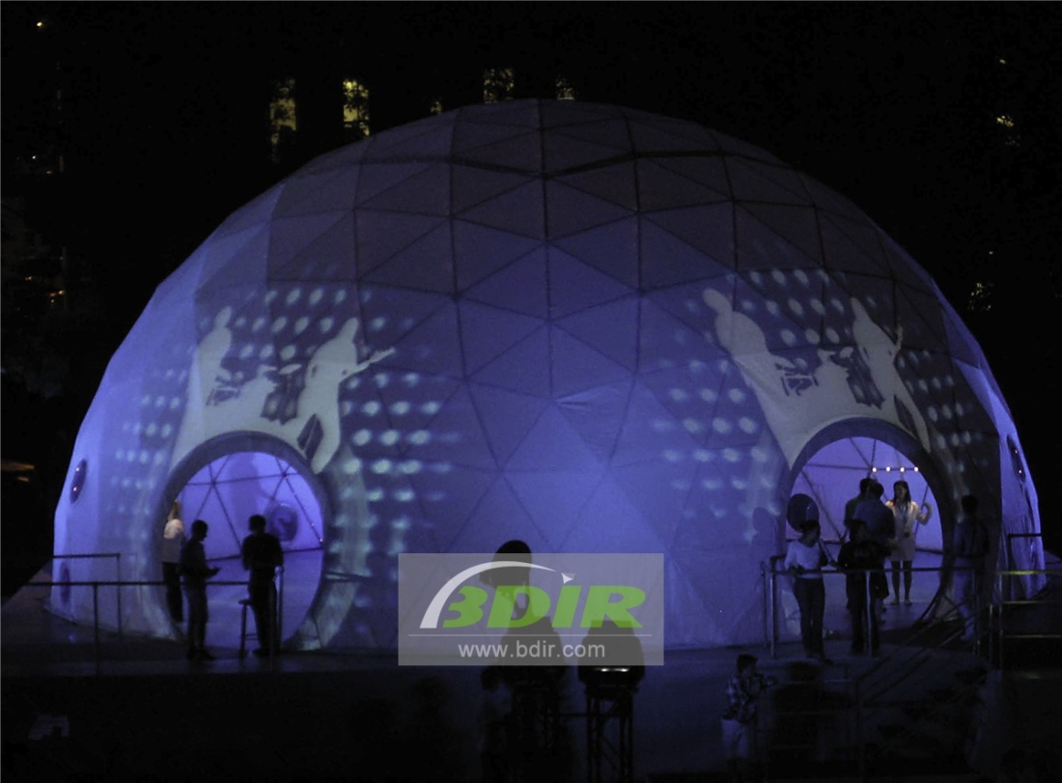
3. Customizable Fabric Coverings
The cover of immersive geodesic dome tent is a guarantee for exposure and impact for all types of branding. It can be customized with full color printing or projected with branded patterns.
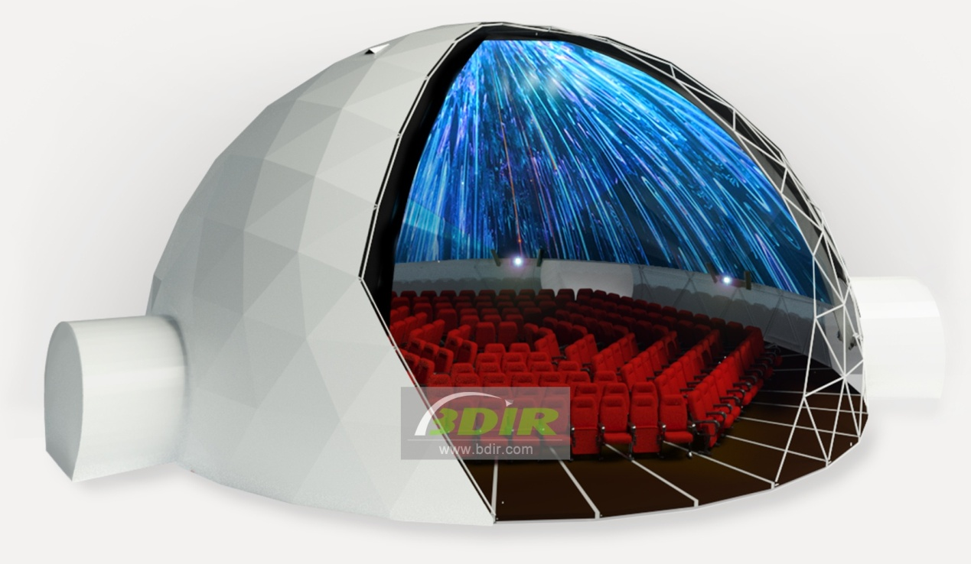
4. Projection Options
We offer two possible options for 360-degree projection, it either projects directly onto the dome cover or attachs a projection lining system. It would be the perfect backdrop for 360° surround projections using the projection lining system.
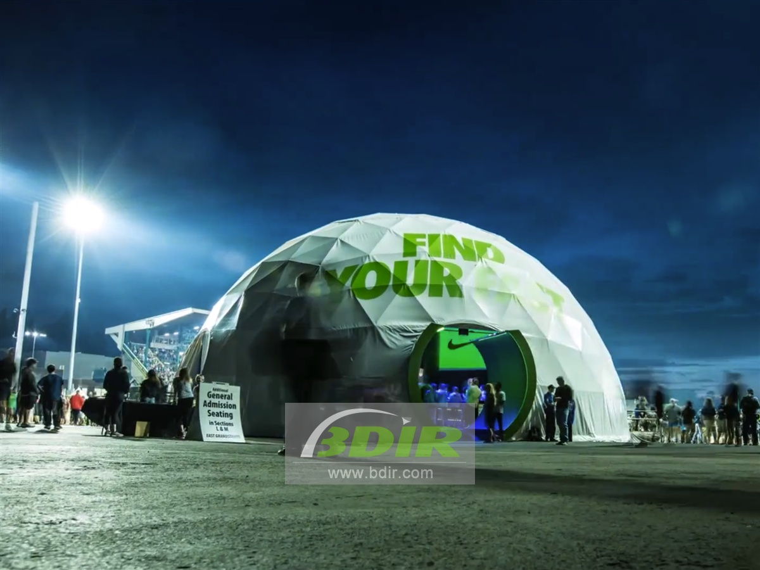
5. Complete Solution
We world widely provide projection domes together with the whole projection system or VR facilities and which creates 360 - 720 degree videos to make it easier for one-stop customizing and purchasing.
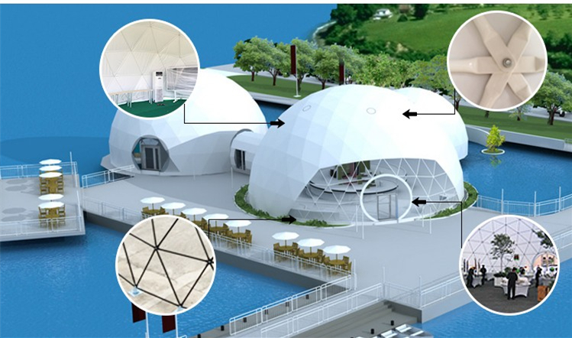
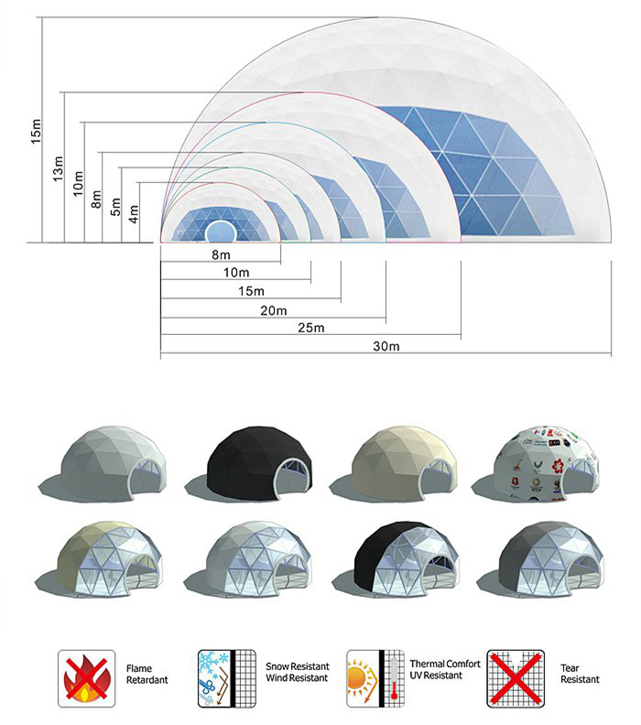
BDiR Inc. is a dome designer and manufacturer, which provides 5m - 100m best quality complete dome tents for living home, glamping tent house, camping pods, greenhouse, branding, product launches, commercial receptions, outdoor concerts and business annual celebrations, festival, performance, trade show booth, corporate events and conferences, product launches and promotions, Art installations, floating domes, igloo and rooftop lounges, movies, private parties, special occasions, etc.

