Yoga Domes | Geodesic Dome Shelter | Sport Dome Tent
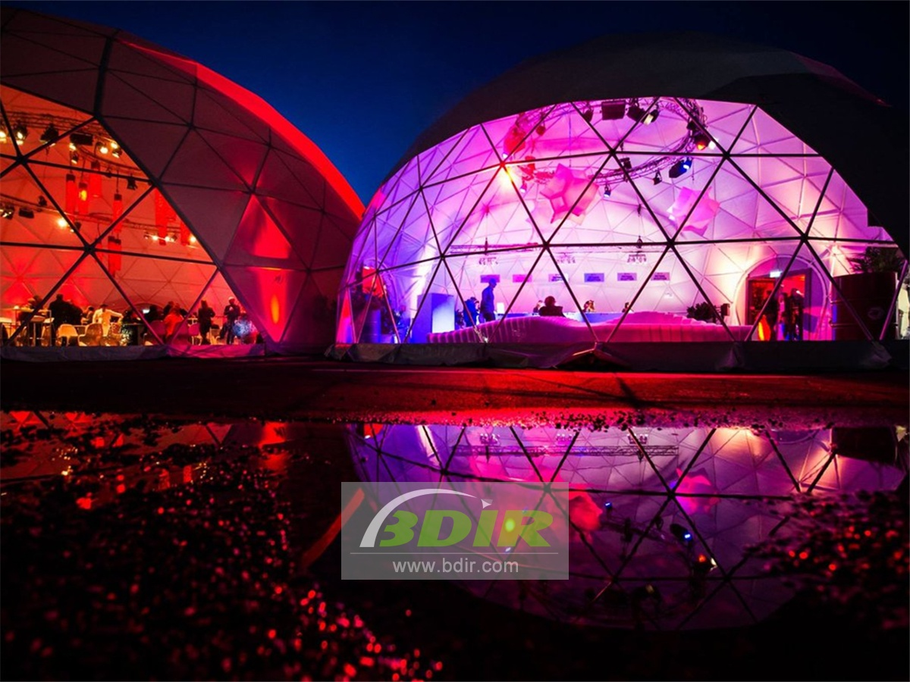
Celebratory Style Event Geodesic Domes:
Take your celebration to the next level with the Wedding Dome or Party Dome. The open geometry of Event Domes creates a sublime cathedral for the wedding and provides a unique environment for the party. The geodesic dome tent creates a simple and elegant way to celebrate your party. The geo domes can be used for all parts of your special day, from wedding ceremonies to receptions to banquets. Similar to a church, the dome provides guests with a comfortable and sacred space to observe the wedding while enjoying the privacy and beauty of the surrounding walls and windows. The unique and strength of the dome make it easy to fit into a variety of styles. The event dome tent optional is customied with mosque window design will complement any traditional or non-traditional environment, while the frame of the dome serves as a sturdy place to hang flowers, lights, banners and many other wedding decorations.

The banquet event under the geodetic dome is a unique decision in event management. As a desire to host unusual solutions for outdoor activities, spherical dome structures are becoming more and more popular at unforgettable moments.
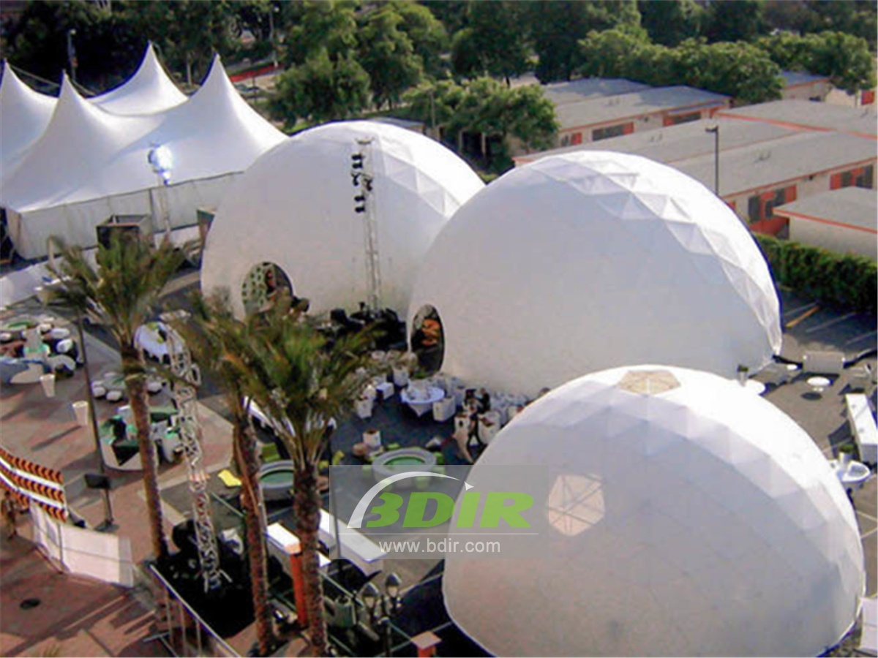
The use of galvanized and white printed steel tubes makes the entire dome structure more lustrous and durable, with better rust and corrosion resistance and a long life of 30 years. The 850 g/m2 PVC fabric membrane is with the function of UV, water and tear resistance. As a professional event dome manufacturer, our PVC fabric membrane meets European (DIN4102 B1 M2) and US (NFPA701) flame retardant standards.

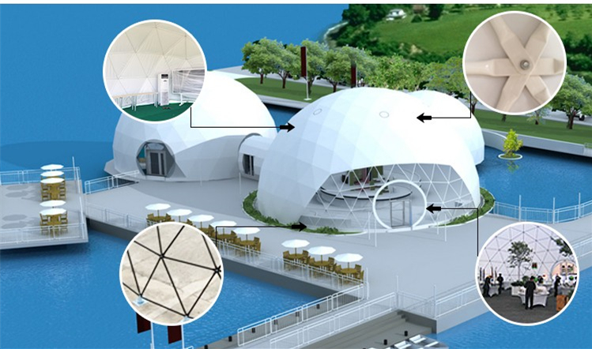
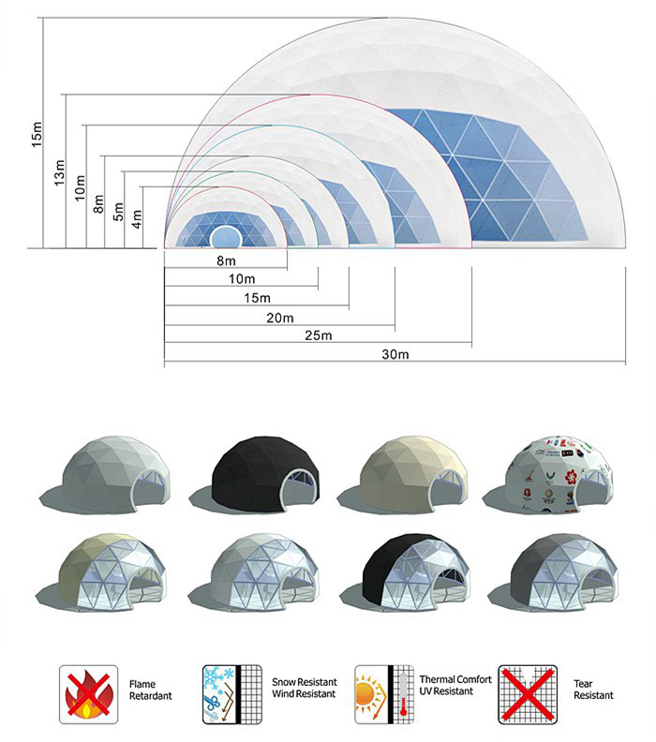
BDiR Inc. is a dome designer and manufacturer, which provides 5m - 100m best quality complete dome tents for living home, glamping tent house, camping pods, greenhouse, branding, product launches, commercial receptions, outdoor concerts and business annual celebrations, festival, performance, trade show booth, corporate events and conferences, product launches and promotions, Art installations, floating domes, igloo and rooftop lounges, movies, private parties, special occasions, etc.

