Geodesic Domes Pods Tent | Glamping Pods | PVC Dome Kits
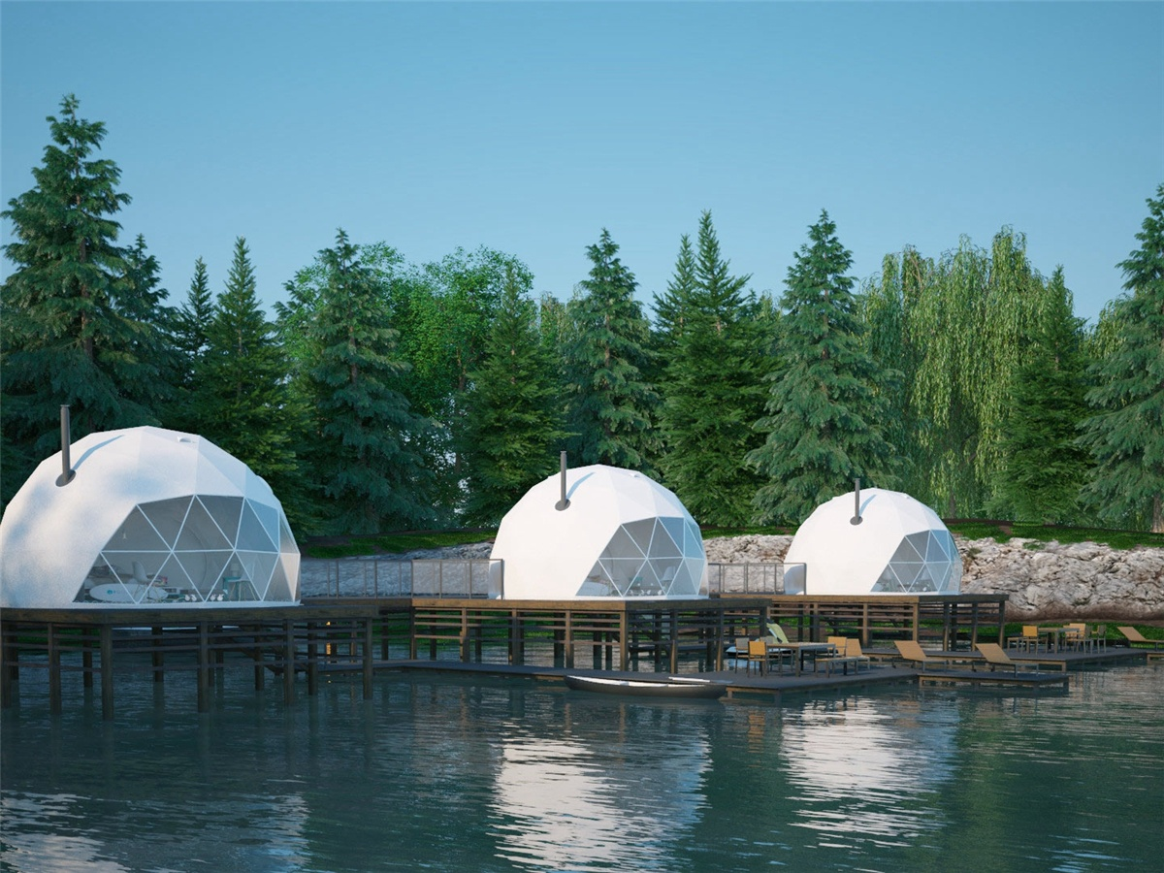
Product specifications:
• Diameter: 4.9 meters or 5.9 meters
• Base area: 20 square meters or 27.5 square meters
• Entrance: H 180cm x W 70cm
• Maximum height: 2.9 meters or 3.65 meters
• Quantity: 8 dome tents
Material:
• 950g/m2 Germany imported white PVC film material, 850 g/m2 Germany imported transparent PVC film material
• Windproof up to 80-100km/h, 100% fire retardant, waterproof and snowproof
• Galvanized steel pipe Q235, diameter 20*1.5mm
• Use stainless steel tube as frame material
• Configure insulation, wood burning stove, curtains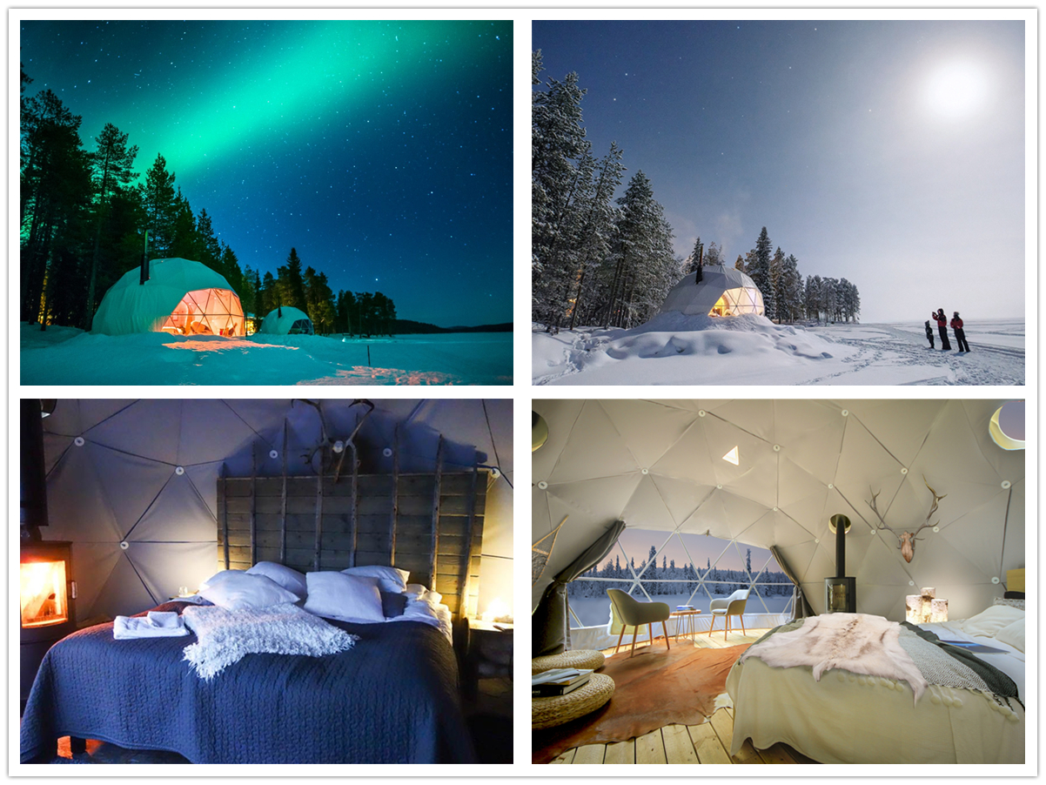
Spending an extraordinary night camp under the Northern Lights, living in the Camping with Dome Pods is a unique way to experience nature. The luxury, cozy and warm dome house is the perfect place to enjoy the magical winter scenery of the Lake illuminated by the Northern Lights. The Aurora Dome room is a round igloo tent with a Siberian & Reindeer theme and a transparent PVC fabric wall. The dome lodge is completely insulated and the fireplace with open fireplace creates a luxurious and warm atmosphere. The transparent PVC membrane wall of the dome faces north to ensure the views of the best starry horizon and the elusive Northern Lights on the frozen lake. With simple toilets, showers and saunas are just a few steps away. The dome has two beds but it can also accommodate two extra beds.
The unique dome structure of the spherical tent, the scientific design and construction are integrated with nature. The window can be customized in the dome or in different positions to make the air convection in the tent, which saves energy and reduces the cost of use. At the same time, other ventilation devices can be installed to achieve more functions.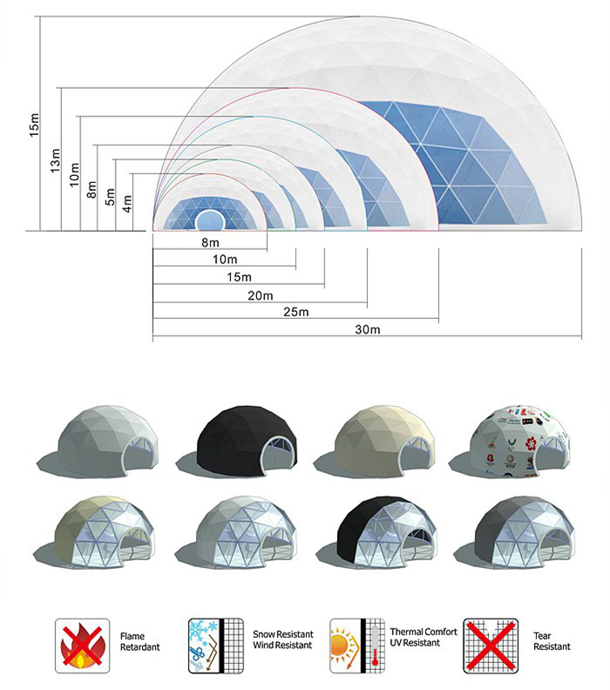
BDiR Inc. is a dome designer and manufacturer, which provides 5m - 100m best quality complete dome tents for living home, glamping tent house, camping pods, greenhouse, branding, product launches, commercial receptions, outdoor concerts and business annual celebrations, festival, performance, trade show booth, corporate events and conferences, product launches and promotions, Art installations, floating domes, igloo and rooftop lounges, movies, private parties, special occasions, etc.

