Geodesic Dome Hotel | Heodome Hotel | ECO Dome Hotel | Sun City Camp Domes
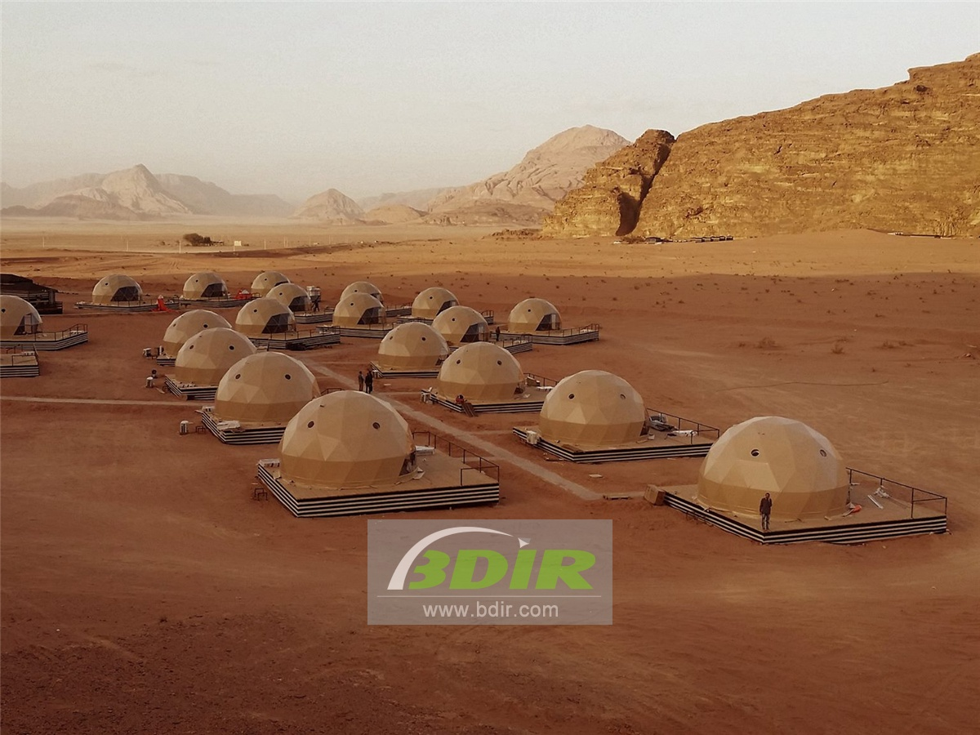
Product specifications:
• Diameter: 4.9 meters or 5.9 meters
• Base area: 20 square meters or 27.5 square meters
• Entrance: H 180cm x W 70cm
• Maximum height: 2.9 meters or 3.65 meters
• Quantity: 36 dome tents
Material:
• 950g/m2 Germany imported white PVC film material, 850 g/m2 Germany imported transparent PVC film material
• Windproof up to 80-100km/h, 100% fire retardant, waterproof and snowproof
• Galvanized steel pipe Q235, diameter 20*1.5mm
• Use stainless steel tube as frame material
• Configure insulation, wood burning stove, curtains
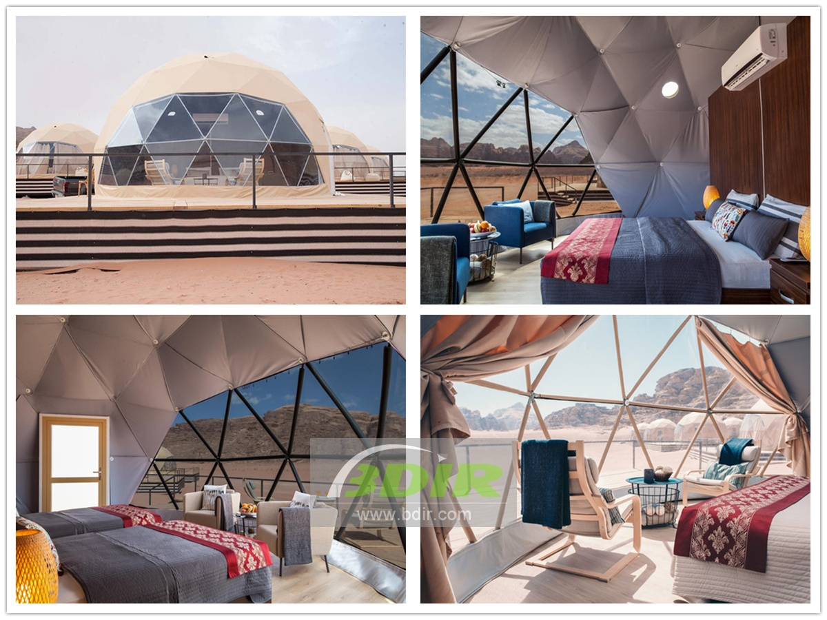
In the majestic desert centre of Wadi Rum, the incredible Sun City dome Camp offers a tranquil and soothing living experience. Living in the desert and enjoying the simple Bedouin life in the valley. With the unbeatable true charm and beauty. This experience is characterized by a high standard of service, amenities and accommodation options, as well as a variety of relaxing and adventurous entertainment. The camp is located in Wadi Rum, about 60 km from the city of Aqaba and 313 km from Amman.
Choose from any of our panoramic mountain view tents, whether it's a traditional Bedouin tent (30 tents), a royal tent (eight suites), a family suite (two suites) or our unique signature Mars Dome tent lodges ( 20 rooms). With a large reception geodesic dome tent and dining area with Wi-Fi access, the campsite offers a buffet-style, freshly prepared meal and a variety of dishes to choose from.
Sun City's signature Martian Dome tent combines modern style of living and comfort while still retaining a true desert experience, offering guests a luxurious and authentic experience. The Sun City Camp is the first place in the area to offer this dome tent, which allows you to stare at the magnificent moon and stars from your comfortable bed. Each dome tent room is equipped with individual air conditioning and bathroom.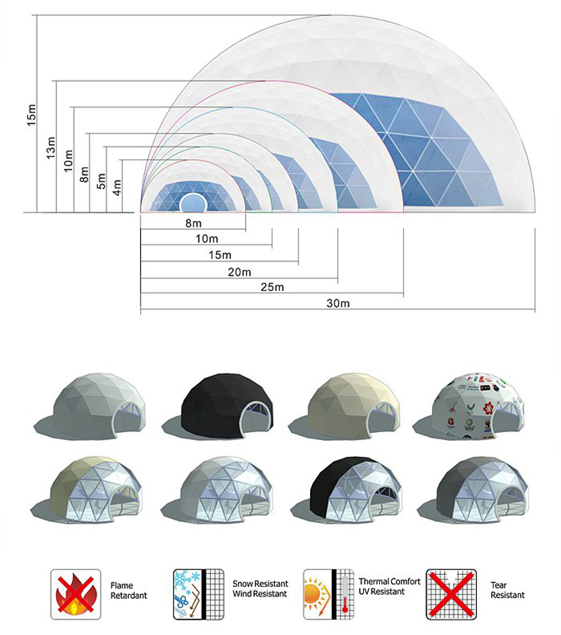
BDiR Inc. is a dome designer and manufacturer, which provides 5m - 100m best quality complete dome tents for living home, glamping tent house, camping pods, greenhouse, branding, product launches, commercial receptions, outdoor concerts and business annual celebrations, festival, performance, trade show booth, corporate events and conferences, product launches and promotions, Art installations, floating domes, igloo and rooftop lounges, movies, private parties, special occasions, etc.

