Experience a Accommodation in a Glamping Dome Cabins, where Luxury Meets Nature
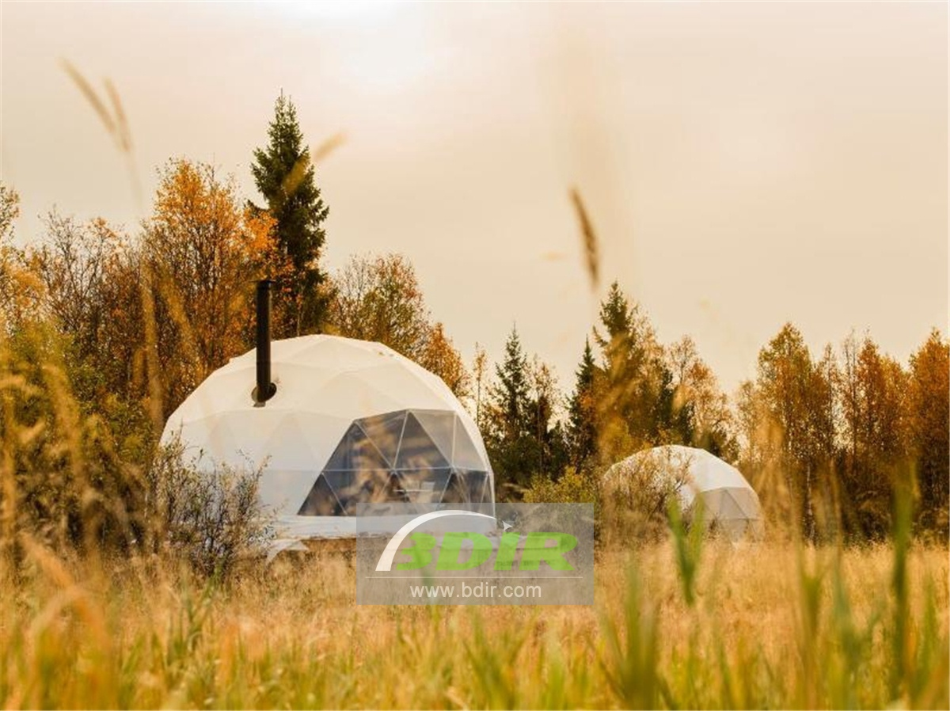
Product specifications:
• Diameter: 3*7 meters
• Base area: 40 square meters
• Entrance: height 180cm x width 70cm
• Maximum height: 3.5 meters
• Quantity: 6 dome tents
Material:
• 950g/m2 Germany imported white PVC film material, 850 g/m2 Germany imported transparent PVC film material
• Windproof up to 80-100km/h, 100% fire retardant, waterproof and snowproof
• Galvanized steel pipe Q235, diameter 20*1.5mm
• Use stainless steel tube as frame material
• Configure insulation, wood burning stove, curtains

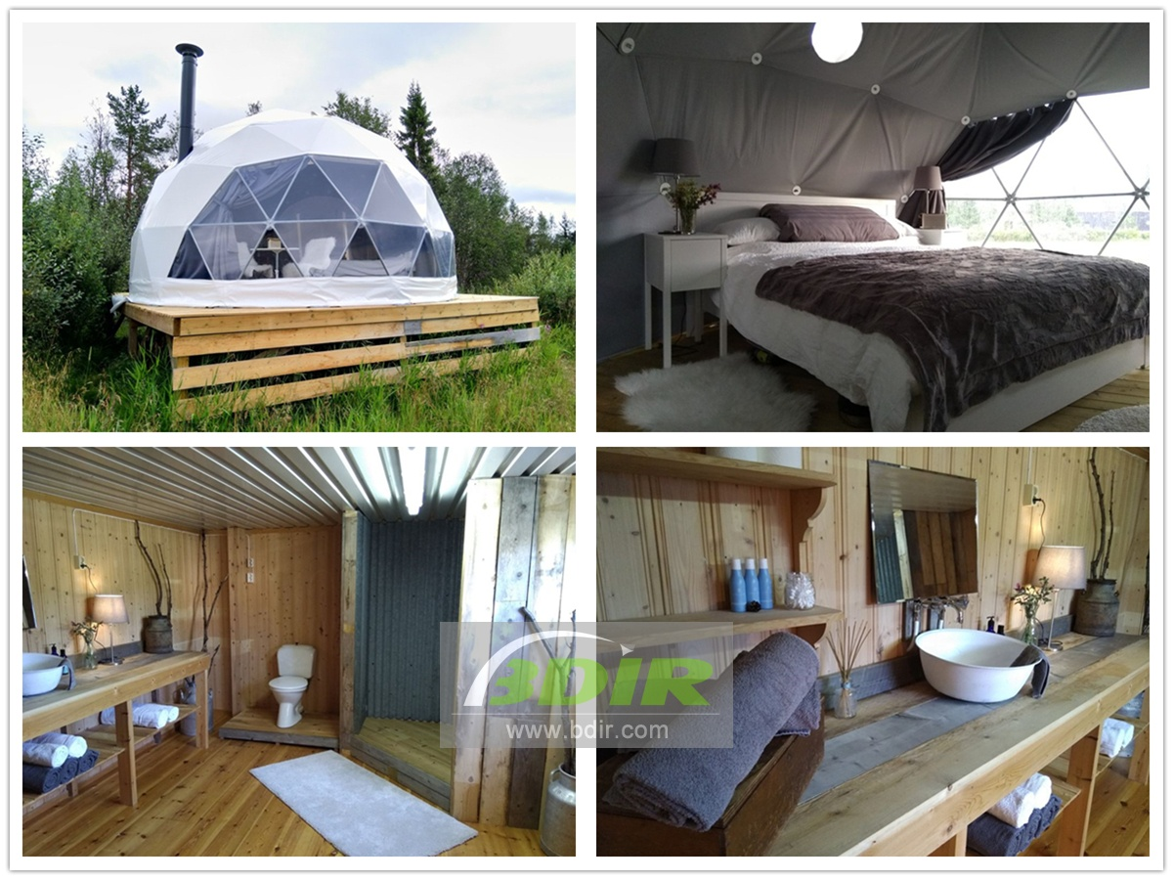
Experience the unique accommodation at the geodesic dome camping hotel and enjoy the fusion of luxury and nature. Another way to explore and immerse yourself in the Norwegian wilderness. The comfortable geodesic dome house is fully equipped with bay windows overlooking the mountains. In fully insulated dome pods, which offers large comfortable beds, power, lighting and extra heated wood burning stoves, which you need it to guarantee comfort and warmth during the day and night. These unique dome tent glamping house are perfect for couples and families.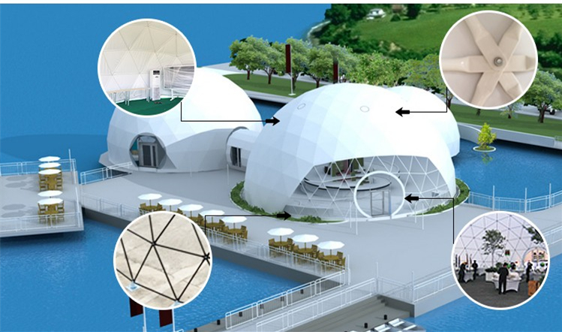
At the luxury dome tent hotel, you will have your own private space to enjoy nature. Each dome house is 20 square meters and is located on the edge of the forest overlooking the mountains. In the winter, a winter wonderland, each eco dome tented lodge has snow trails and snow-capped mountain views. Maybe even seeing the Northern Lights! In the summer, lush green fields and forests can be seen.
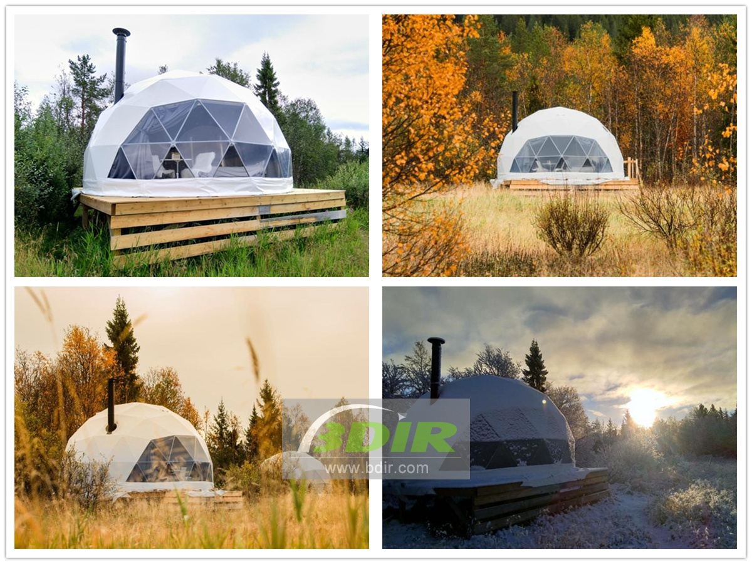
Each eco friendly dome pods has a private deck for cooking and your own personal privacy. The interior of the eco-friendly pods is furnished with a comfortable bed and a double sofa bed. Tea/coffee making facilities and a wood burning stove have a minimalist design and natural touches. Each dome pods can accommodate up to 4 people.
Since the dome hotel are open all year round, the dome house is completely insulated and equipped with electric heaters and wood burning stoves to ensure that you are warm all night, no matter how cold in winter. So that the camper can enjoy the magnificent winter wilderness with the dome tent.
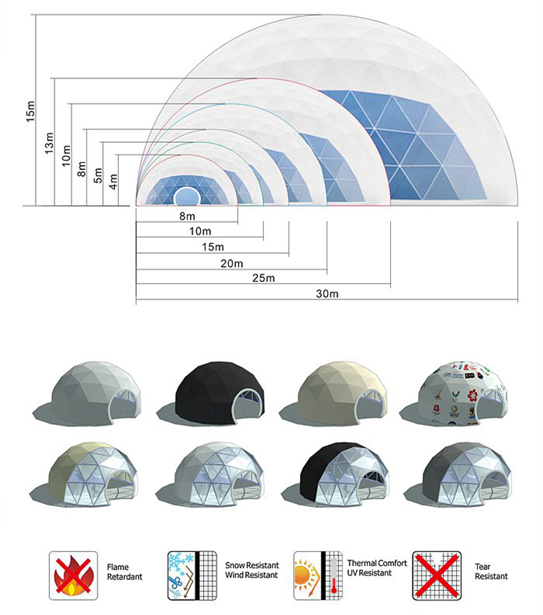
BDiR Inc. is a dome designer and manufacturer, which provides 5m - 100m best quality complete dome tents for living home, glamping tent house, camping pods, greenhouse, branding, product launches, commercial receptions, outdoor concerts and business annual celebrations, festival, performance, trade show booth, corporate events and conferences, product launches and promotions, Art installations, floating domes, igloo and rooftop lounges, movies, private parties, special occasions, etc.

