Luxury Riverside Glamping Tent Resort with Tented Lodge

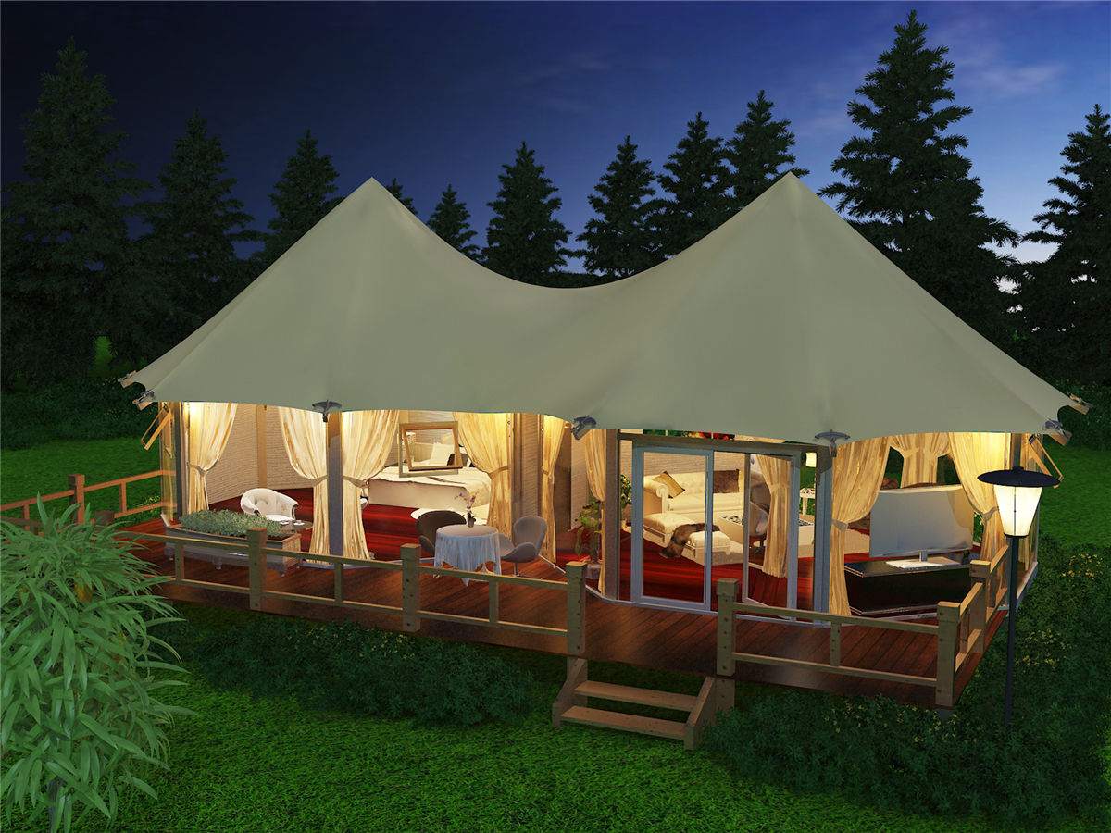
The Tents (Glamping in Style - Make Yourself at Home, Surrounded by Nature’s Wonders)
The Luxury Riverside Glamping Tent Resort, it is designed to blend seamlessly with the surrounding rainforests, mountains and rivers to create a tranquil and idyllic natural environment with all the luxury and uniqueness you've come to expect.
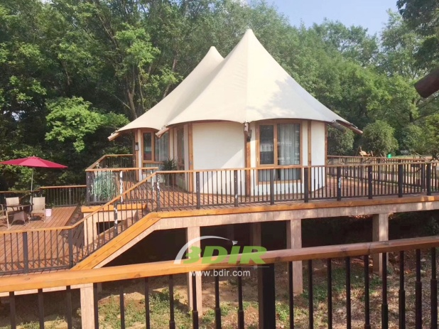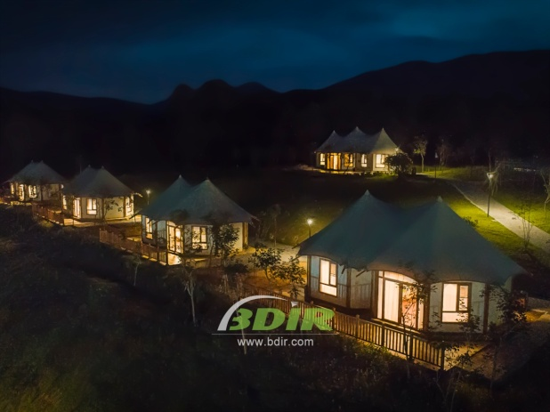
It is built with modern composite environmentally friendly materials, and as little wood as possible protects the beautiful trees in the rainforest. The lodge is also equipped with a unique wastewater treatment system that protects the waters of the Tagay River and marine life known as homes. The tent villas are decorated with top-quality materials, which brings new meaning to the luxury of nature. Enjoy all the comforts a world-class resort has to offer, which includes flat-screen TVs, DVD players and minibars with drinks and snacks. Relax on the large private sun lounger balcony and admire the ever-changing kaleidoscope-like wonderland.
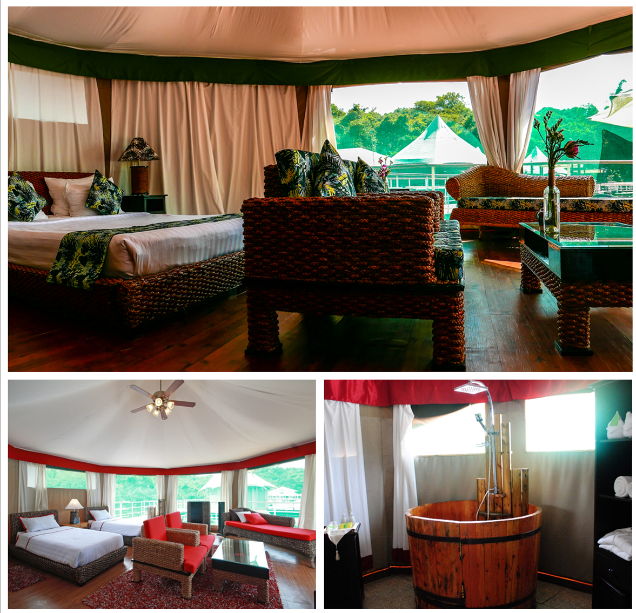
We offer wide range of Luxury canvas safari tents, glamping tents, eco-lodges and resort tents at very reasonable prices. We ship canvas tents worldwide for all purposes. No matter where your tent or camp will be located in - be it on water, rocks, desert, sand, a grassy plain, tropical beach, ice field or in dense rainforest - we will ensure it is built to last.

